Four-Hole Stab Binding Instructions

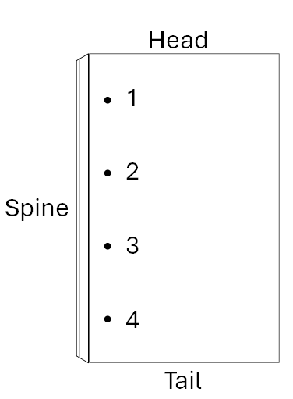 | 1. Punch 4 holes in a straight line near the spine side of the book
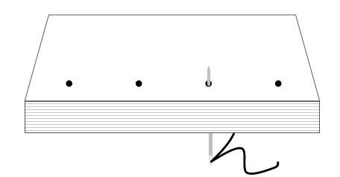 | 2. Sew through hole 3 from back to front
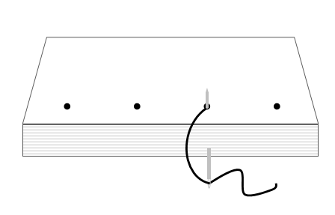 | 3. Wrap thread around the spine and sew through hole 3 from back to front again
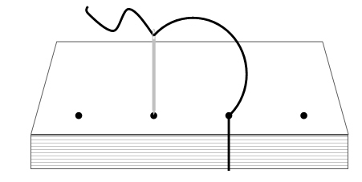 | 4. Sew through hole 2 from font to back
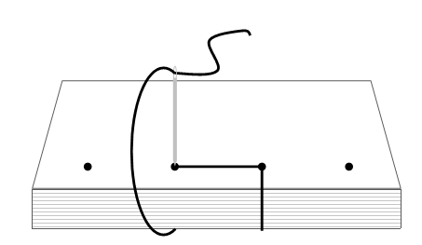 | 5. Wrap thread around the spine and sew through hole 2 from front to back again
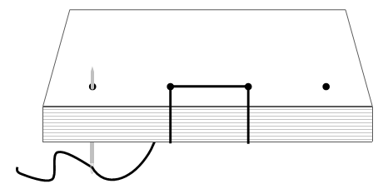 | 6. Sew through hole 1 from back to front
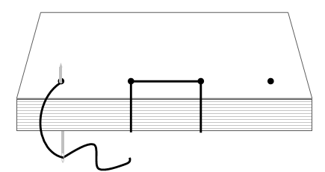 | 7. Wrap around the spine and sew through hole 1 from back to front again
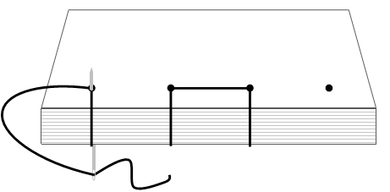 | 8. Wrap thread around the head and sew through hole 1 from back to front again
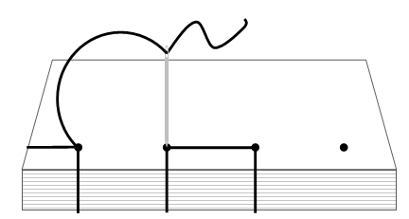 | 9. Sew through hole 2 from front to back
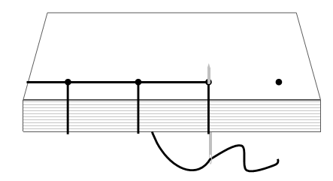 | 10. Sew through hole 3 from back to front
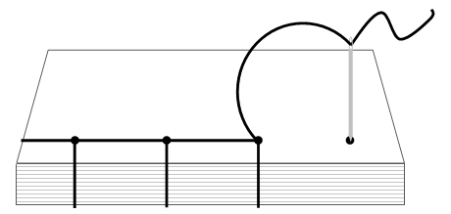 | 11. Sew through hole 4 from front to back
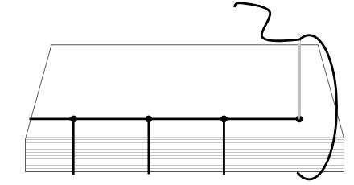 | 12. Wrap around the spine and sew through hole 4 from front to back again
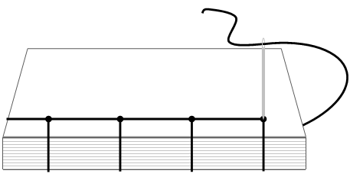 | 13. Wrap around the tail and sew through hold 4 from front to back again
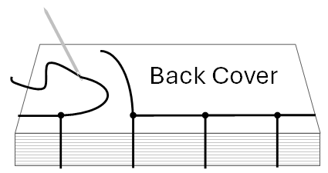 | 14. Flip book over to back cover
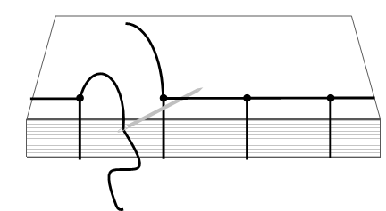 | 15. Thread the needle under the thread running from hole 3 to hold 2
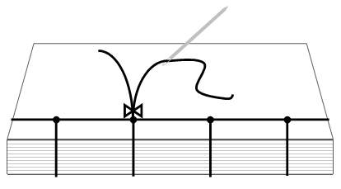 | 16. Tie tails together in a knot
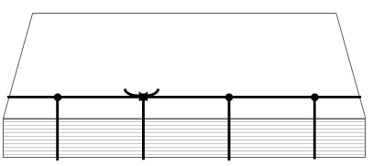 | 17. Trim tails to desired length

Additional Resources
- “Japanese Stab Binding.” Highland Print Studio, https://beccamakingfaces.com/category/japanese-stab-binding/.
  - A great step-by-step tutorial with photographs
- “Theory of Japanese Stab Binding.” Becca Making Faces, https://beccamakingfaces.com/theory-of-japanese-stab-binding.
  - Check out their wide variety of stab binding patterns here: https://beccamakingfaces.com/category/japanese-stab-binding/
- Sea Lemon. “4-Hole Japanese Bookbinding Tutorial.” YouTube, 04 November 2012, https://youtu.be/j-r6c_trSxY?si=wDbu-xDKMiIgJ9sA.
  - See also “More Japanese Bookbinding Tutorials (finaly!)”: https://www.youtube.com/watch?v=CX8qOFis9qA
- “Make it floral – A modified Japanese stab binding.” Cécilia Duminuco, 2018, https://ceciliaduminuco.com/a-modified-japanese-stab-binding/.
  - Hardcover album with a floral pattern that could easily be adapted for a softcover pamphlet
- Ikegami, Kōsanjin, and Barbara B. Stephan. Japanese Bookbinding : Instructions from a Master Craftsman. 1st ed., Weatherhill, 1986.
  - Illustrated instructions for traditional Japanese binding styles

