Withdrawing items so not to show in PRIMO VE (according to Ted’s instructions)
Search for Physical Titles in IZ
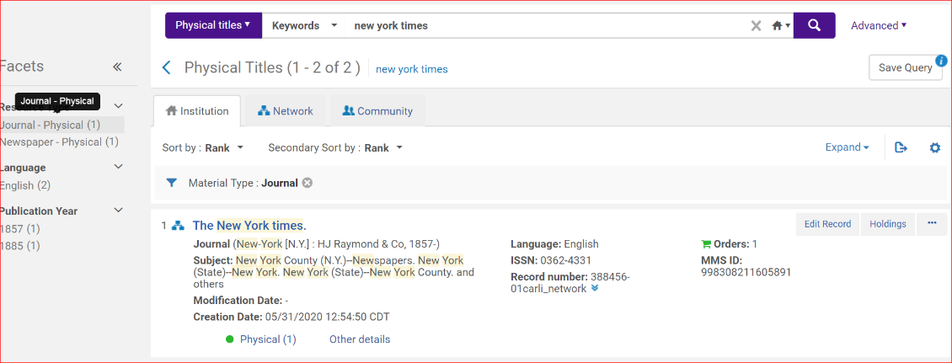
Under Physical dropdown click items Then in title area box View all holdings
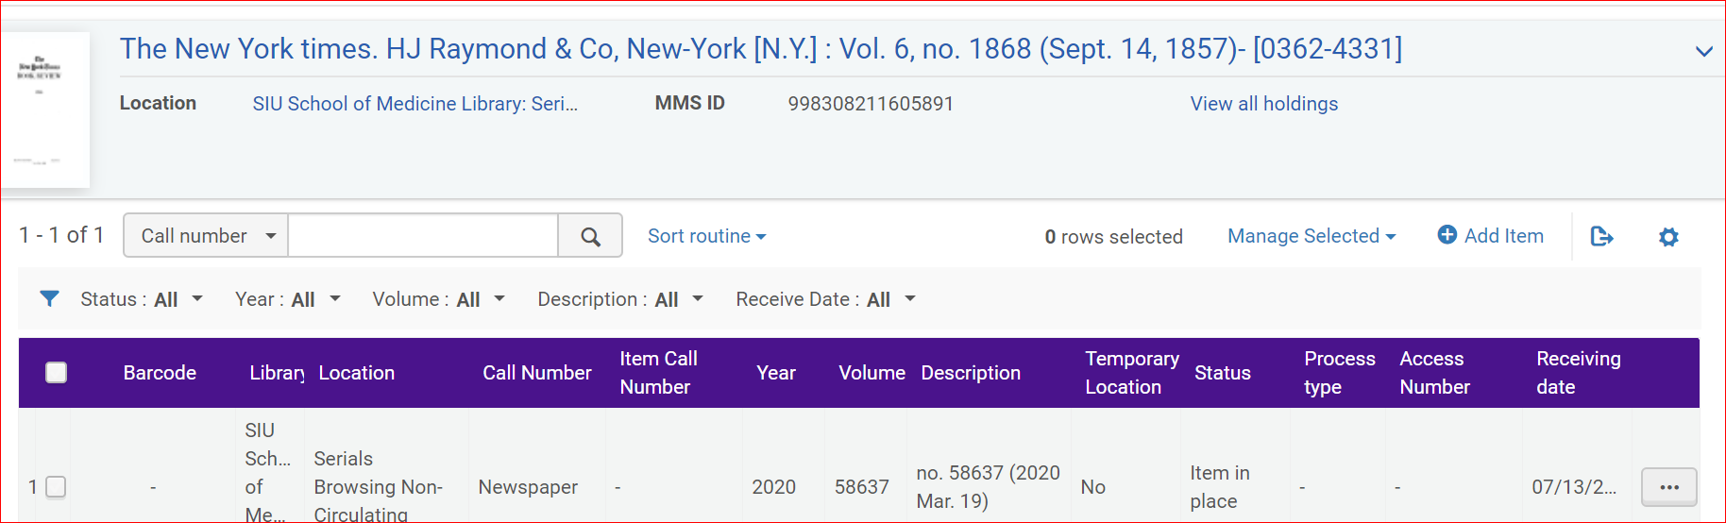
In ellipsis choose Associate a PO Line (This is where you will be able to follow Ted’s instructions)
1c. Choose “Associate a PO Line.”
1d. When the box appears for “Please Select a PO Line” the POL that you do not want to be associated with the holdings will show up.
1e. Click the X to clear the POL from the box (the box will be empty after you do that).
1f. Then click the “Update” button and it will unlink the POL from the holdings.
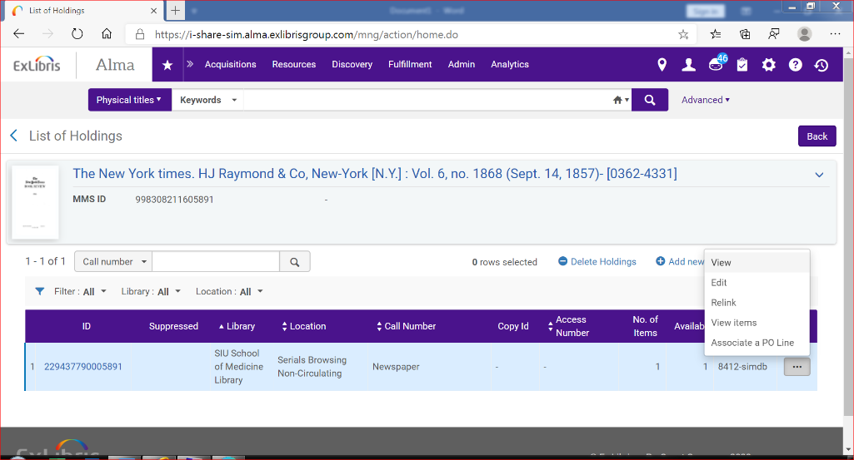
You can then withdraw the item. Which I did. Withdrew the March issue.
Now, it is time to follow the rest of Ted’s instructions. Note the POL is 8412-simdb
3. Re-associate the continuous POL to the holding.
3a. From the list of hldgs, choose the ellipsis to the right of your holding and select Associate a PO Line.
3b. Find your POL and click Update.
3c. This will link the holding and associated items to the POL.
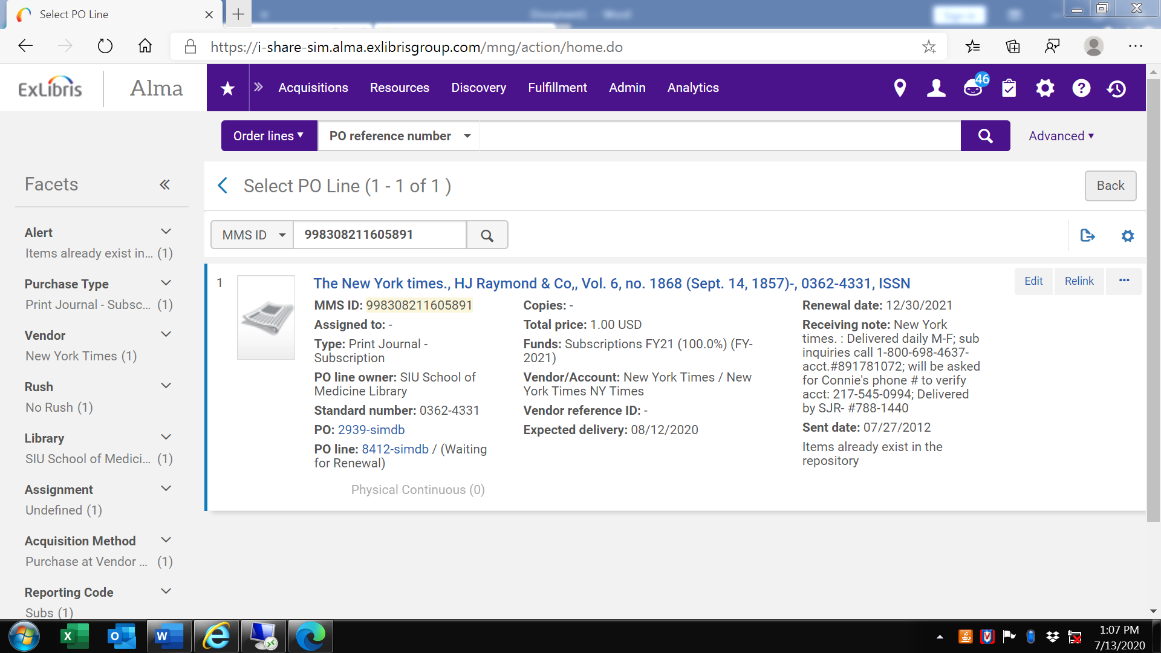
After you do this, the only ones added should be the new ones showing up.

