Fiscal Period Close/Rollover
(Rolling over ledgers creates the new fiscal period.)
Rollover Ledgers
Acquisitions Advanced ToolsRollover Ledgers
Click “+Add Job”
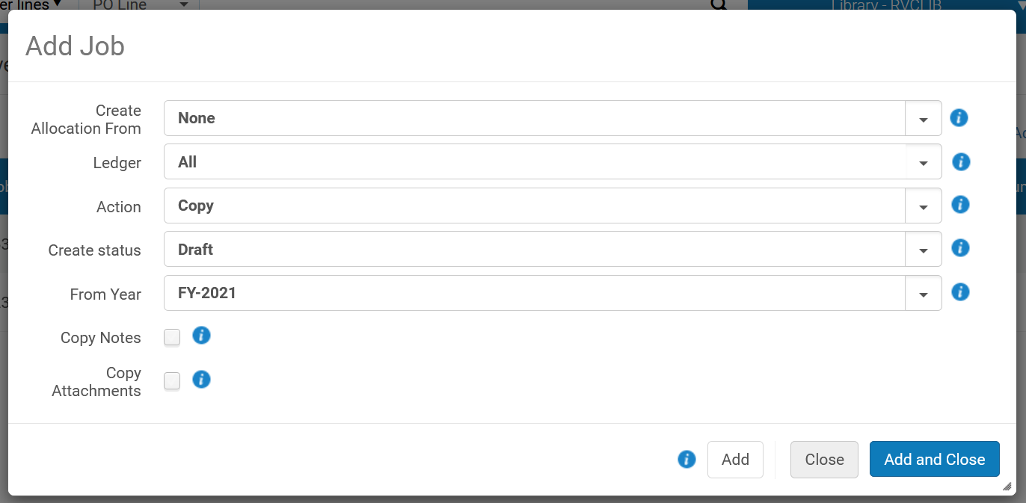

Ledger: choose previous FY
From Year: choose previous FY
Click “Add and Close” which will start the job
Rename Fiscal Period
ConfigurationAcquisitionsGeneralFund and Ledger Fiscal Period
Edit “Description” field to be consistent with previous fiscal periods
Click “Save”
Make Funds Active
AcquisitionsAcquisitions InfrastructureFunds and Ledgers
Click “edit” on the new ledger
Change the name to the new fiscal year
Click “Activate” (this will make the ledger and all the funds active)

Rollover PO Lines
(We don’t rollover PO lines, but running this job in report mode will show if there are any PO lines that are in a status that would make them eligible to rollover.)
AcquisitionsAdvanced ToolsRollover PO Lines
Click “+Add Job”
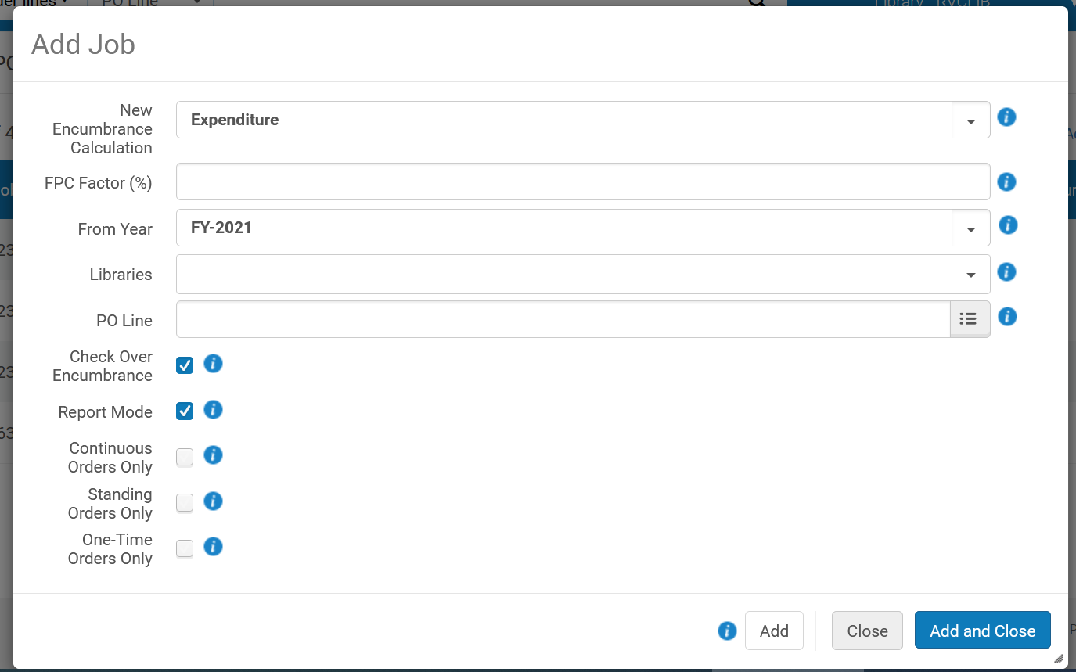

Run in “Report Mode”
From Year: previous FY
Click “Add and Close” which will start the job
After the job finishes, click on the […] and choose “View” to see job report
Deactivate Old Ledger(s)
AcquisitionsAcquisitions InfrastructureFunds and Ledgers
Click “edit” on the previous year’s ledger
Click “Deactivate”
Add Amounts to Funds
Click “edit” on each fund, choose “Transactions” tab, click “Allocate Funds”
Enter amount (without a comma)
Blank out the reporting codes
Click “Add allocation transaction”

