Processing E-books from GOBI
Once you have overlaid the order record, click on “Edit Record.”

Click on “View Inventory” icon

You’ll see a split screen, with the holdings screen on the right.
Click on “View.”

You’ll see the Electronic Portfolio Editor, as below. You’ll be editing information in each tab as follows:
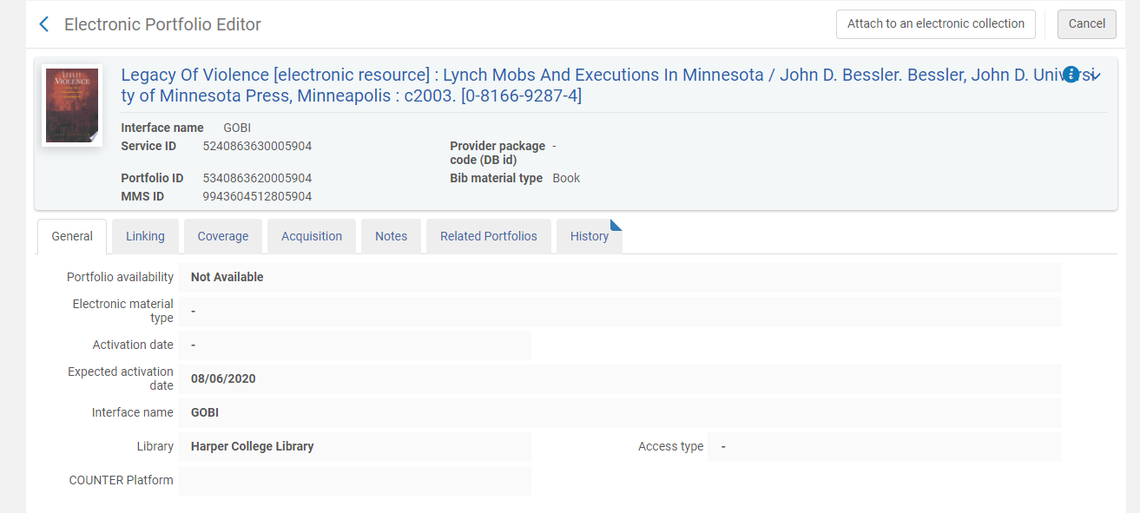

General tab (above): Change “Not Available” to “Available.

“Linking” tab
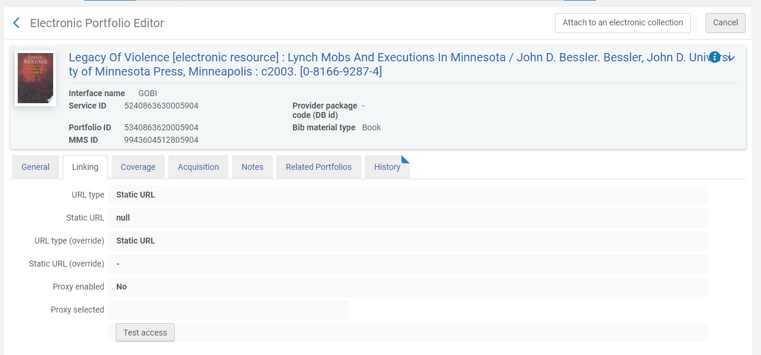

Fill in:
- Static URL—You’ll be using the Permalink to fill in this information. At first the permalink reads:
http://prox.harpercollege.edu/login?url=http://search.ebscohost.com/login.aspx?direct=true&db=nlebk&AN=172901&site=ehost-live

Remove the proxy string from the beginning of the URL. Now it reads:
http://http://search.ebscohost.com/login.aspx?direct=true&db=nlebk&AN=172901&site=ehost-live

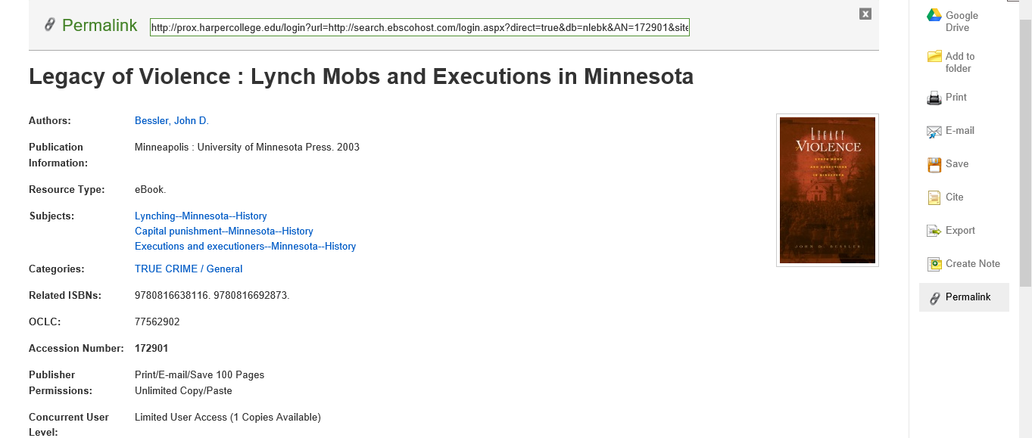

Click here to see the URL
Fill in the rest of the information as follows:

- URL type (override): Static URL
- Proxy enabled: Yes
- Proxy selected: Proxy

“Notes” tab
Fill in Public note: Online access for Harper College users
You can now save the portfolio record.

