ADDING A TOP WARNING BAR TO PRIMO VE

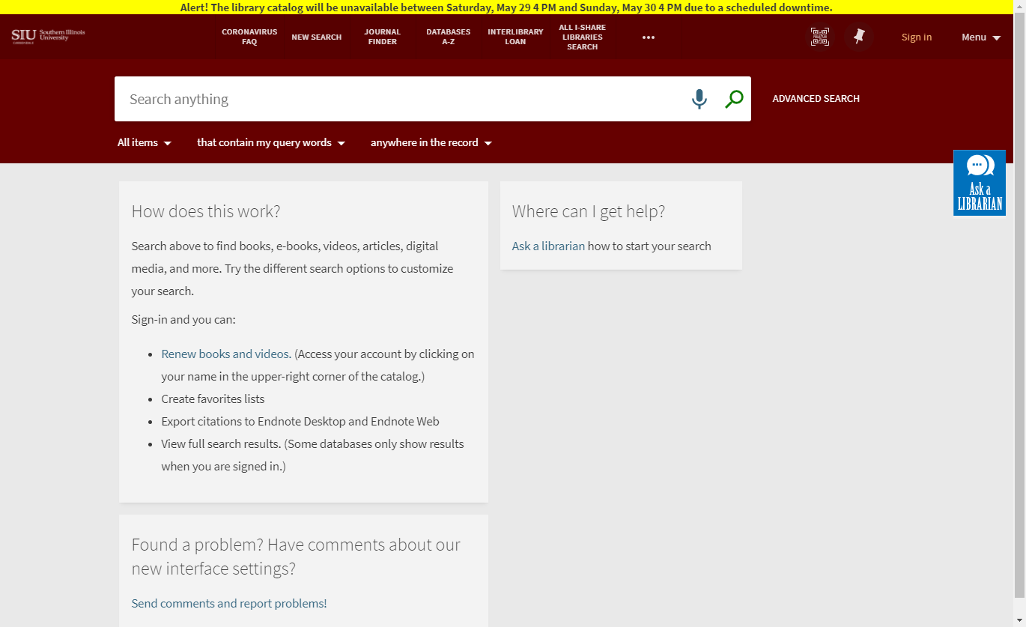

- Alma -> Configurations -> Discovery -> Select Primo VE view you want to edit -> click on ellipses -> Edit ->
- Manage Customization Package ->Download Current View Customization package ->
- Find file on your computer -> Unzip file -> open folders and navigate to css folder -> open custom1.css file ->
- Add this code to the bottom of your CSS file:
/* LOCAL BANNER */
body::before {
content: "ALERT! The library catalog will be unavailable between Saturday, May 29 8 PM and Sunday, May 30 8 PM due to a scheduled downtime.";
display: inline-block;
background: #FFFF00;
text-align: center;
width: 100%;
font-weight: bold;
}
/* END local banner */

- Save custom1.css file -> zip the file ->
- go to ALma and under Upload package select the zip file and upload -> Save -> hit Back button -> on pop up message hit onfirm -> go to view and check if Primo VE has your message.
- Modify css file and remove the snippet when you don't need to display any messages.
- If you don’t like the background color, you can use HTML color picker at https://www.w3schools.com/colors/colors_picker.asp and add a new color code to replace #FFFF00 in code above

