Importing Bibliographic Records from WorldCat to Alma
09/09/2020 Revisions:
- Updated password details for CARLI sandboxes in I.A.2c.
- Added details to check Batch options in I.B.1d.
- Added error conditions to Exporting and Troubleshooting in I.B.1d.
05/20/2020 Revisions:
- Changed recommended setting in I.A.2b. Institution Zone Integration Profile for OCLC Connexion: Management Tags > Synchronize with External Catalog changed to Publish Bibliographic records (instead of Publish holdings only).
- Added I.B.1c. OCLC Connexion Client Gateway Exports to the Sandbox NZ or Sandbox IZs
- Added I.B.2c. OCLC Connexion Web Browser Exports to the Sandbox NZ or Sandbox IZs

03/27/2020 Accompanying Webinar: https://youtu.be/oSR82aHX5Bg

- Import using OCLC Connexion Gateway Export
- Import using Search Resources in the Alma Metadata Editor
There are multiple ways to import records in Alma. The preliminary step in any cataloging workflow should include searching for the presence of an item in your local Institution Zone. If not present, also check the Network Zone and Community Zone. WorldCat can be searched to check if the record is the most recent version, or to add new records. Searching WorldCat is possible via the Search Resources feature in Alma’s Metadata (MD) Editor or via the OCLC Connexion Client or Web Browser.
Search Resources in the MD Editor allows a Z39.50 external search of the WorldCat catalog, which may be used to import records directly to the Alma Network Zone or Institution Zone. This option is appropriate for copy cataloging when no enhancements to the WorldCat record are needed.
OCLC Connexion Client or Web Browser is the appropriate tool to search when edits to the WorldCat record are needed, or, when a record does not yet exist in WorldCat. Original records should first be created in WorldCat, before importing them to the Alma Network Zone or Institution Zone. Note that OCLC Connexion’s Gateway Export option allows direct imports into Alma, without the need of a local save file. Configuration instructions are provided below for both versions of Connexion.
I. Import Using OCLC Connexion Gateway Export
Importing using OCLC Connexion’s Gateway Export requires the configuration of both:
- Alma Integration Profile
- OCLC Connexion Gateway Export
You can set up export connections to both the Network Zone and to your Institution Zone.
- Exporting to the Network Zone is the only option that allows updates to the NZ record with the most current OCLC record. New records will also be added to the NZ. Local inventory is linked directly from the NZ record upon import.
- Exporting to your Institution Zone only is an option for those records that would not be appropriate for the Network Zone shared environment (temporary reserves such as personal copies, unlinked special collections, etc.). Any record adds or updates would only happen at the IZ level.
A. Alma Integration Profile for OCLC Connexion in the Network Zone and your Institution Zone.
An Integration Profile defines how Alma integrates with an external system.
A General System Administrator user role is necessary in order to configure Integration Profiles.
1. CARLI has already configured the Network Zone Integration Profile directly in the Network Zone’s Alma instance. You will be able to set up a Gateway Export from OCLC Connexion directly to the Network Zone, described further in I.B.1a below.
The following screenshot is included for reference only. You will not be responsible for configuring the NZ integration in Alma.
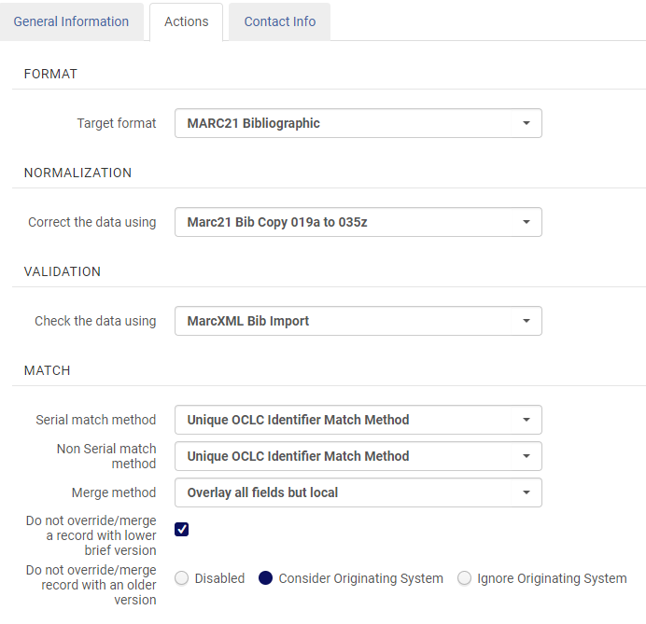
NZ OCLC Connexion Integration Profile > Actions tab settings
2. You only need to review/configure an Institution Zone Integration Profile if you will be importing records to your Institution Zone only. Note that only one OCLC Connexion Integration Profile can be present in your library’s Alma instance for imports to work properly. When multiple OCLC Connexion Integration Profiles are created, errors occur during Connexion export (error example in I.B.1d.ii).
Reviewing and configuring the existing OCLC Connexion Integration Profile for your Institution Zone:

Alma Configuration > General tab > External Systems > Integration Profiles screen,
you will find an OCLC Connexion Profile that exists by default in your environment. The General Information tab of this profile indicates “Managed in Network=No” (new profiles indicate the option to select “Use network zone=No”).

Select the default Connexion profile to review and edit it using the description below. If none is present, select Add Integration Profile to create one as new.
- On the General Information tab, configure the following settings:
Code: | IZ_OCLC
Name: | IZ_OCLC Connexion
Integration Type: | OCLC Connexion
Default: | <This setting is currently non-functional for the OCLC Connexion integration type.>
Description: | <Optional. Example text: For OCLC Connexion imports to the IZ only.>

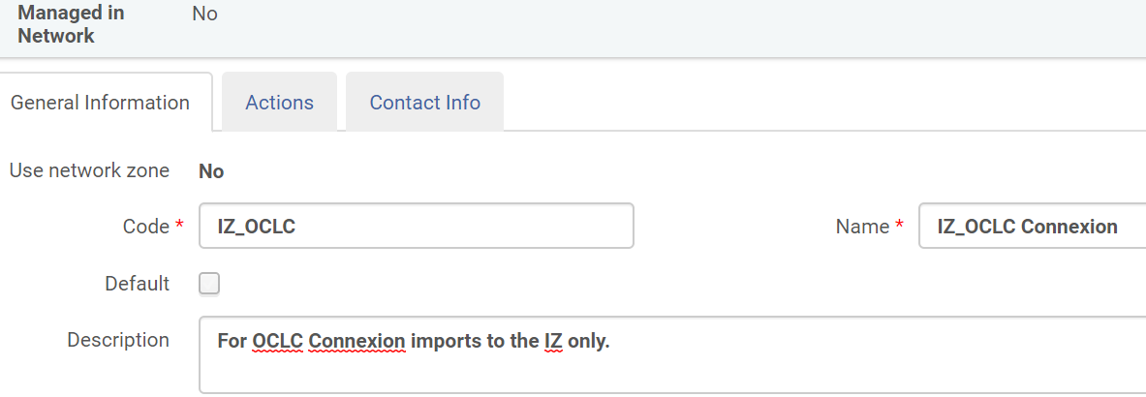
Example IZ OCLC Connexion Integration Profile > General Information tab settings.

- Select the Actions tab to configure the following settings:
Setting | Value
Target format: | MARC21 Bibliographic
Normalization > Correct the data using: | Marc21 Bib Copy 019a to 035z
Validation > Check the data using: | MarcXML Bib Import
Serial match method: | Unique OCLC Identifier
Non Serial match method: | Unique OCLC Identifier
Merge method: | Overlay all fields but local
Do not override/merge a record with lower brief version: | Selected
Do not override/merge record with an older version: | Consider Originating System
Management Tags > Synchronize with External Catalog: | Publish Bibliographic records
Authorization > Password | Create a secure password here. The default profile’s password is alma1234, but can be adjusted to something more secure here.

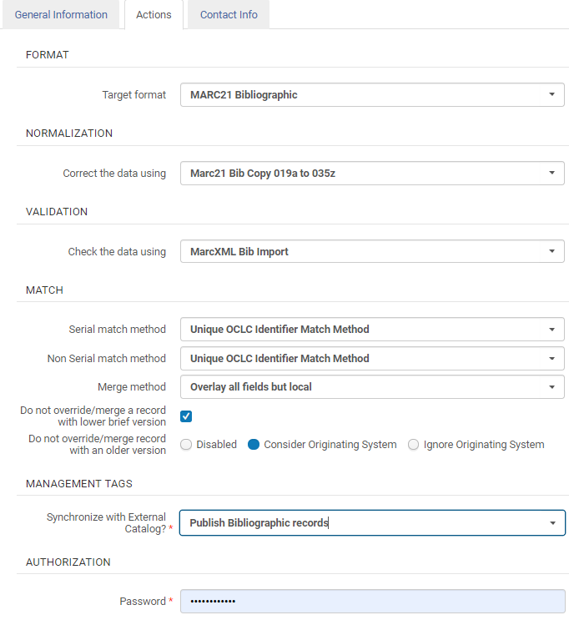
Example IZ OCLC Connexion Integration Profile > Actions tab settings.
- The Contact Information tab settings are optional.
3. Sandbox OCLC Connexion integration profiles have been configured for your testing purposes. The Sandbox Network integration profile is set up with the same integration profile configurations as described in I.A.1 above. Sandbox Institution Zone integration profiles are set up in Sandboxes 01-05 with the same configurations as described in 1.A.2; the password for each sandbox is found in the CARLI Sandbox User Account document, which may be found in your library’s Box folder in the “Credentials” subfolder.
B. Configure OCLC Connexion to Export to Alma
1a. OCLC Connexion Client Gateway Export to the Network Zone
Importing directly to the Network Zone is the only OCLC Connexion import option that will update existing Network Zone records.
Connexion Client allows multiple Gateway Exports when the host URLs differ, so it is fine to have exports set up to both your IZ and NZ.
To set up your NZ Gateway Export in OCLC Connexion client, select:
Tools > Options > Export > Create.
- The New Export Destination box appears. Select Export Destination: OCLC Gateway Export > OK.
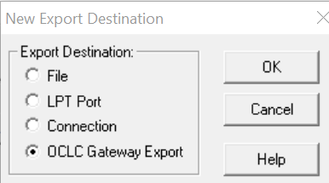
Example OCLC Connexion Client New Export Destination box with OCLC Gateway Export selected.

- In the Local System Settings, enter the following:

Host Name: | i-share-network.alma.exlibrisgroup.com
Port: | 5500
Send Local System Logon ID and Password: | Select to enable the Local System Authorization options.
Logon ID: | 01CARLI_NETWORK
Password: | See the Importing Bibliographic Records from WorldCat to Alma with NZ Password document, located in Box.
Export Destination Name | Gateway Export: Network
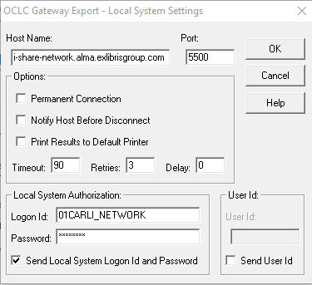
Example OCLC Connexion Client Gateway Export - Local System Settings for the NZ

- Select the Record Characteristics box, and set the following for both Bibliographic and Authority Records:
Record Standard: | MARC 21
Character Set: | UTF-8 Unicode

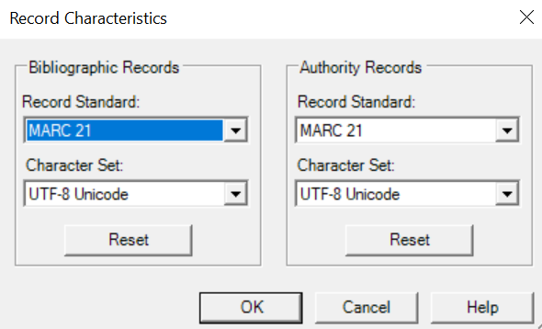
Example OCLC Connexion Client Gateway Export’s Record Characteristics

Note, Alma allows matches between records containing (OCoLC) with or without ocm, ocn, or on. Note Ex Libris’s documentation. We no longer need the delete the 035 (the second OCLC number lacking an ocm, ocn, or on prefix) in the Field Export Options > Fields to Delete which I-Share libraries previously set for Voyager imports. We also no longer recommend removing the 029 since it may include CONTENTdm data.
Select Apply and Close to save these changes.

1b. OCLC Connexion Client Gateway Export to your IZ
To set up your IZ Gateway Export in OCLC Connexion client if needed, select:
Tools > Options > Export > Create.
- The New Export Destination box appears. Select Export Destination: OCLC Gateway Export > OK.
Example OCLC Connexion Client New Export Destination box with OCLC Gateway Export selected.

- In the Local System Settings, enter the following:

Host Name: | i-share-xxx.alma.exlibrisgroup.com where xxx should be replaced with your library’s 3-letter code. This is your library’s Alma domain name.
Port: | 5500
Send Local System Logon ID and Password: | Select to enable the Local System Authorization options.
Logon ID: | 01CARLI_XXX where XXX should be replaced with your library’s 3-letter code.
Password: | <The password you set in your Alma IZ_OCLC Connexion Integration Profile > Action tab > Authorization > Password.>
Gateway Destination Name | Gateway Export: IZ_XXX where XXX should be replaced with your library’s 3-letter code.

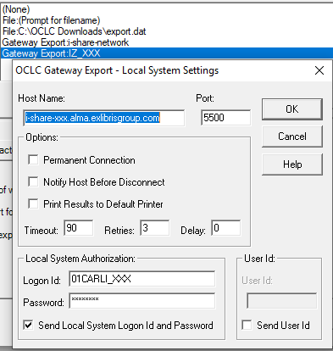
Example OCLC Connexion Client Gateway Export - Local System Settings for IZ only

- Select the Record Characteristics box, and set the following for both Bibliographic and Authority Records:
Record Standard: | MARC 21
Character Set: | UTF-8 Unicode

Example OCLC Connexion Client Gateway Export’s Record Characteristics

Note, Alma allows matches between records containing (OCoLC) with or without ocm, ocn, or on. Note Ex Libris’s documentation. We no longer need to delete the 035 (the second OCLC number lacking an ocm, ocn, or on prefix) in the Field Export Options > Fields to Delete which I-Share libraries previously set for Voyager imports. We also no longer recommend removing the 029 since it may include CONTENTdm data.
Select Apply and Close to save these changes.

1c. OCLC Connexion Client Gateway Exports to the Sandbox NZ or Sandbox IZs

- Sandbox NZ Gateway Export
To set up your Sandbox NZ Gateway Export in OCLC Connexion client, follow the same directions as I.B.1a OCLC Connexion Client Gateway Export to the Network Zone for steps i and iii, with modifications to step ii indicated below for host name and export destination name:

Host Name: | sandbox02-na.alma.exlibrisgroup.com
Port: | 5500
Send Local System Logon ID and Password: | Select to enable the Local System Authorization options.
Logon ID: | 01CARLI_NETWORK
Password: | See the Importing Bibliographic Records from WorldCat to Alma with NZ Password document, located in Box.
Export Destination Name | Gateway Export: Sandbox Network

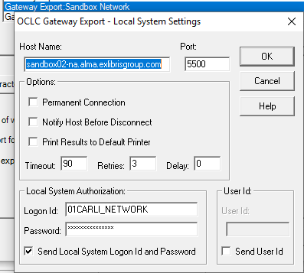
Example OCLC Connexion Client Gateway Export - Local System Settings for the Sandbox NZ

- Sandbox IZ Gateway Export for Sandboxes 1-5

If needed, set up a Sandbox IZ Gateway Export in OCLC Connexion client to a specified Sandbox following the same directions as I.B.1b OCLC Connexion Client Gateway Export to your IZ for steps i and iii, with modifications to step ii only for host name, default credentials, and export destination name:
Host Name: | sandbox02-na.alma.exlibrisgroup.com
Port: | 5500
Send Local System Logon ID and Password: | Select to enable the Local System Authorization options.
Logon ID: | 01CARLI_XXX (where XXX is the 3-letter code assigned to the sandbox; see the CARLI Sandbox User Account document, located in Box, “Credentials” subfolder)
Password: | See the CARLI Sandbox User Account document, located in Box, “Credentials” subfolder
Export Destination Name | Gateway Export: Sandbox # (where # is Sandbox 1-5)

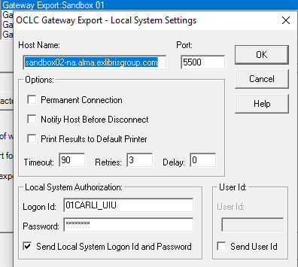
Example OCLC Connexion Client Gateway Export - Local System Settings for Sandbox 1 IZ

1d. Exporting and Troubleshooting

- Before exporting any records,
  - Go to Tools > Options
  - Select the Batch tab
  - Under Record Actions > Perform local actions in batch, make sure that Bibliographic Record Export is unchecked.
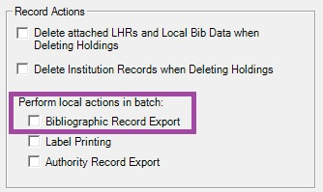
The Record Actions section of Connexion's Batch options tab.
  - Select Apply and Close to save these changes.
- To export a record from OCLC Connexion Client to Alma, with the identified WorldCat record in the highlighted window, select Action > Export.
- If successful, the report will indicate the Alma MMS ID of the imported record. Search for the record in Alma by this MMS ID, add your local holding and item inventory, then Save and Release Record.
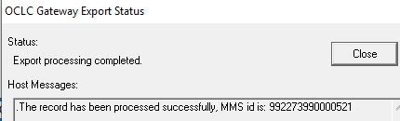
Example OCLC Connexion Client Gateway Export Status report.

- Confirm the record imported in Alma by completing an All Titles search in the Zone to which you imported. Search by either the MMS id from the Connexion Client report or search by OCLC number.
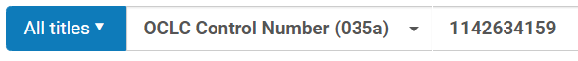
Example OCLC Connexion Client All Titles search query for imported record.

- If the record imported is found in the search results of the All Titles search query and correctly lists the Modification Date as the appropriate import date and time, the import was successful. Edit the record to add your institution’s holdings and items inventory.
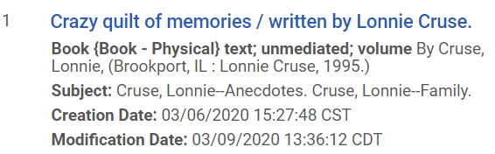
Example OCLC Connexion Imported Record in Alma All Titles Search Result Listing Modification Date.

- If unsuccessful, you may receive one of the following OCLC Connexion Client Export errors:
- “Import failed. Reason: no integration profile found for institution 01CARLI_XXX.” This error appears if you have multiple OCLC Connexion integration profiles created in your Alma environment. It seems to cause system confusion. Delete the integration profile you are not using to resolve this issue.
- “Import failed. Reason: Logon failed – the Logon ID and/or password is/are not valid.” If a password is changed in the Alma OCLC Connexion integration profile and in the Gateway Export settings after the Gateway Export was created, it is likely the change did not save correctly in Connexion. Delete and recreate the Gateway Export with the new password.
- “The local system has closed the connection, retries exceeded.” Host Message repeated three times: “The TCP/IP connection has been closed by the remote host.” Delete and recreate the Gateway Export, re-entering the Host Name and Port information. If this does not resolve the issue, a local firewall issue may be causing the problem. Contact your local IT and request they add port 5500 to their list of allowed ports.
- “Import failed. Reason: Multi matches found for this record.” This error appears when either the IZ or NZ includes more than one record containing the OCLC record number of the exported record. To resolve this, you should locate and merge the records in the repository before retrying the export. The merged record must contain the OCLC record number of the current WorldCat master record in an 035 $a.
- “Import failed. Reason: NOT_ADDED_BRIEF.” The import profile for the Connexion integration prevents a record in the repository from being overlaid or merged with an incoming record that Alma considers as a lower brief record level. Brief record levels are currently calculated based on MARC record encoding levels (LDR/17). You will need to elevate the encoding level of the WorldCat record to a level equal to the record in the repository. Care should be taken to ensure that the incoming record does not overwrite or remove accurate and useful data in the existing record.
- “Import failed. Reason: NOT_ADDED_LOCKED.” Alma will block import of a record if it finds a matching record in the repository that is locked by a cataloger in that zone.
  - If you are importing to an IZ, then you or a colleague may have the record active in the metadata editor. Save and release the record from the MDE before attempting to export again.
  - If you are importing to the NZ, then a cataloger at any institution may have the record active and locked in the metadata editor. Locked records will become unlocked 60 minutes after the cataloger leaves the MDE. You may choose to wait one hour for the record to unlock. If you have waited longer than one hour, you may contact the institution or CARLI.
- “Import failed. Reason: NOT_ADDED_OLD.” The import profile for the Connexion integration prevents a record in the repository from being overlaid or merged with an incoming record that Alma considers as a newer record, per each record’s respective 005 tag. If appropriate, e.g., when the WorldCat master record is more complete than the record in the repository, lock and replace the record in Connexion before exporting. Care should be taken to ensure that the incoming record does not overwrite or remove accurate and useful data in the existing record.

2a. OCLC Connexion Web Browser Export to the Network Zone
Importing directly to the Network Zone is the only OCLC Connexion import option that will update existing Network Zone records.
Unlike OCLC Connexion Client, Connexion Web Browser does not allow multiple export configurations. You will need to change these settings if you need to switch between connecting to the Network and connecting to your IZ only.
Configure Export preferences on the General tab > Admin > Export Options menu.
Set the following Export Options:
Flagged Bibliographic Record Export Format: | MARC
Export Destination: | Export to a TCP/IP Connection
Fields to Delete on Export: | (Note comment below*)
TCP/IP Connexion Options > Host Name: | i-share-network.alma.exlibrisgroup.com
TCP/IP Connexion Options > Port Number: | 5500
TCP/IP Host Settings > Notify Host before Disconnect | Select
TCP/IP Local System User Information > Send Logon ID | Select
TCP/IP Local System User Information > Logon ID: | 01CARLI_NETWORK (This is case sensitive!)
TCP/IP Local System User Information > Password: | See the Importing Bibliographic Records from WorldCat to Alma with NZ Password document, located in Box.

*Note, Alma allows matches between records containing (OCoLC) with or without ocm, ocn, or on. Note Ex Libris’s documentation. We no longer need the delete the 035 (the second OCLC number lacking an ocm, ocn, or on prefix) in the Fields to Delete on Export which I-Share libraries previously set for Voyager imports. We also no longer recommend removing the 029 since it may include CONTENTdm data.
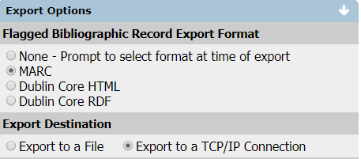
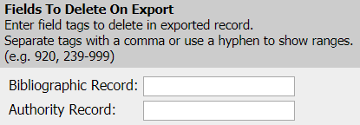
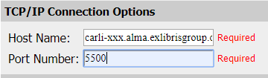
i-share-network.alma.exlibrisgroup.com

5500

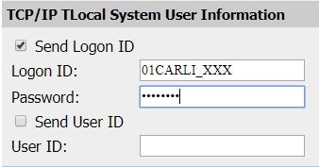
01CARLI_NETWORK
Example OCLC Connexion Web Browser Gateway Export Options for NZ
Other settings may be set as the default or adjusted for your preferences.
Save all preferences either for this session or as your default.

2b. OCLC Connexion Web Browser Export to your IZ
Configure Export preferences on the General tab > Admin > Export Options menu.
Flagged Bibliographic Record Export Format: | MARC
Export Destination: | Export to a TCP/IP Connection
Fields to Delete on Export: | (Note comment below*)
TCP/IP Connexion Options > Host Name: | i-share-xxx.alma.exlibrisgroup.com where xxx should be replaced with your library’s 3-letter code. This is your library’s Alma domain name.
TCP/IP Connexion Options > Port Number: | 5500
TCP/IP Host Settings > Notify Host before Disconnect | Select
TCP/IP Local System User Information > Send Logon ID | Select
TCP/IP Local System User Information > Logon ID: | 01CARLI_XXX where XXX should be replaced with your library’s 3-letter code.
TCP/IP Local System User Information > Password: | <The password you set in your Alma IZ_OCLC Connexion Integration Profile > Action tab > Authorization > Password.>

*Note, Alma allows matches between records containing (OCoLC) with or without ocm, ocn, or on. Note Ex Libris’s documentation. We no longer need the delete the 035 (the second OCLC number lacking an ocm, ocn, or on prefix) in the Fields to Delete on Export which I-Share libraries previously set for Voyager imports. We also no longer recommend removing the 029 since it may include CONTENTdm data.

i-share-xxx.alma.exlibrisgroup.com

5500

Example Connexion Web Browser Gateway Export Options for IZ only

Other settings may be set as the default or adjusted for your preferences.
Save all preferences either for this session or as your default.
2c. OCLC Connexion Web Browser Gateway Export to the Sandboxes
- Sandbox NZ Gateway Export

Setting up your Sandbox NZ Gateway Export in OCLC Connexion Web Browser will follow the same directions as I.B.2a OCLC Connexion Web Browser Export to the Network Zone with the following modification for host name only:

Flagged Bibliographic Record Export Format: | MARC
Export Destination: | Export to a TCP/IP Connection
Fields to Delete on Export: | (Note comment in 1.B.2a*)
TCP/IP Connexion Options > Host Name: | sandbox02-na.alma.exlibrisgroup.com
TCP/IP Connexion Options > Port Number: | 5500
TCP/IP Host Settings > Notify Host before Disconnect | Select
TCP/IP Local System User Information > Send Logon ID | Select
TCP/IP Local System User Information > Logon ID: | 01CARLI_NETWORK (This is case sensitive!)
TCP/IP Local System User Information > Password: | See the Importing Bibliographic Records from WorldCat to Alma with NZ Password document, located in Box.

sandbox02-na.alma.exlibrisgroup.com

Example OCLC Connexion Web Browser Gateway Export Option: TCP/IP Connection Option for the Sandbox NZ

- Sandbox IZ Gateway Export

If needed, setting up your Sandbox IZ Gateway Export in OCLC Connexion client for Sandboxes 1-5 will follow the same directions as I.B.1b, with modifications to Export preferences for host name and default credentials indicated below:
Flagged Bibliographic Record Export Format: | MARC
Export Destination: | Export to a TCP/IP Connection
Fields to Delete on Export: | (Note comment in 1.B.2b*)
TCP/IP Connexion Options > Host Name: | sandbox02-na.alma.exlibrisgroup.com
TCP/IP Connexion Options > Port Number: | 5500
TCP/IP Host Settings > Notify Host before Disconnect | Select
TCP/IP Local System User Information > Send Logon ID | Select
TCP/IP Local System User Information > Logon ID: | 01CARLI_XXX (where XXX is the 3-letter code assigned to the sandbox; see the CARLI Sandbox User Account document, located in Box, “Credentials” subfolder)
TCP/IP Local System User Information > Password: | See the CARLI Sandbox User Account document, located in Box, “Credentials” subfolder

sandbox02-na.alma.exlibrisgroup.com

Example Connexion Web Browser Gateway Export Options: TCP/IP settings for Sandbox IZs

2d. Exporting and Troubleshooting
- With a record pulled up on the Cataloging tab in Connexion Web Browser, select Action > Export Record in MARC to export the record to Alma.

- No progress report appears when exporting from Connexion Web Browser. Even when an export appears to have been successful via Connexion’s confirmation message “record exported”, the record may not have imported into Alma. Be sure to search for the OCLC number in the Alma Network Zone as you work.

- Confirm the record imported in Alma by completing an All Titles search in the Zone to which you imported. Search by either the MMS id from the Connexion Client report or search by OCLC number.
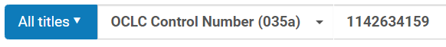
Example OCLC Connexion Client All Titles search query for imported record.

- If the record imported is found in the search results of the All Titles search query and correctly lists the Modification Date as the appropriate import date and time, the import was successful. Edit the record to add your institution’s holdings and items inventory.
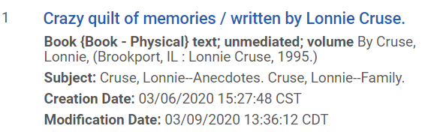
Example OCLC Connexion Imported Record in Alma All Titles Search Result Listing Modification Date.
- When no record is found in Alma, consider the following issues:
  - No error is given in OCLC Connexion Browser, the import appeared to be successful but no record imported. Confirm that the “Send Logon ID” checkbox is selected on the TCP/IP Local System User Information in the Export options configuration. If it is already checked, clear the Logon ID and Password boxes and re-enter the credentials, ensuring the password matches what was set up in your OCLC Connexion Integration Profile.

  - “An error occurred while attempting to make a connection to your local system. Check with your system administrator to make sure your firewall is configured to allow the OCLC Connexion server to connect to your local system”. First, clear the Host Name and Port Number fields and re-enter the details in case this is caused by a typo and not a firewall issue. If this does not resolve the issue, contact your local IT and request they add port 5500 to their list of allowed ports.

II. Import using Search Resources in the Alma Metadata Editor
Alma allows external databases such as WorldCat to be searched directly in the MD Editor under Tools > Search Resources. The WorldCat database should already be configured as an option for your use on the Search Cataloging Profile dropdown.
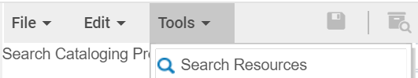
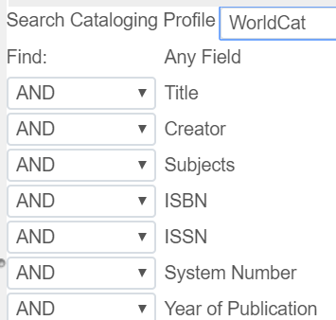
Imported records by default will be added to the NZ.
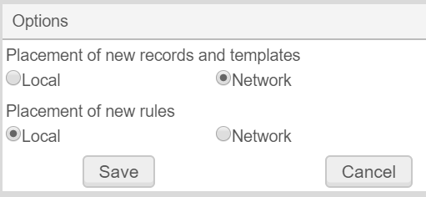
If a record should only be imported to your IZ, in the MD Editor, change the File > Options > Placement of new records and templates from Network to Local.
If the incoming record matches an existing record in the repository, you have the option to view existing records before saving and determine any special actions that should take place including:
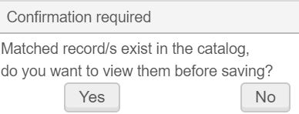
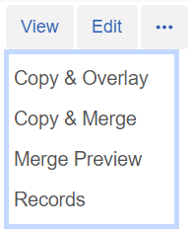
- Copy & Merge will merge fields from the existing record in Alma with the imported record. Test this ahead of time using the Merge Preview function.
- View > Edit > Execute allows manual copying of specific data from an existing record to an incoming record.
- Copy & Overlay will overlay the imported record with the existing record in Alma (probably not what you want to happen!).
Match methods in use:
- serials= ISSN (exact subfield match) 024/034
- non-serials= 035 (Other System Identifier) Match Method

