It is Known Issue in PRIMO VE! SO, WHAT CAN I DO? IS THERE A WAY FOR ME TO HELP? WHY, YES, THERE IS!

Primo VE My Library Card does not display all loans or requests on one page (posted 8/12/2021)

Problem: When a user logs into My Library Card through Primo VE, not all the user's loans or requests from all I-Share libraries are listed on one page. The user must click through each institution name to see the loans and requests from that specific library. Many users would like to see all their loans or requests--no matter which institution they are from--listed on one page.

Solution: Currently, there is no way to customize the My Library Card to change this behavior; the default is the only option for displaying loans and requests. AGAIN, SO, WHAT CAN I PERSONALLY DO TO HELP?

There is an Ex Libris Idea Exchange topic that requests better design of the My Library Card page, specifically so users can see all their loans/requests from all institutions on one page.
Vote and comment on this Idea Exchange topic at: https://ideas.exlibrisgroup.com/forums/308176-primo/suggestions/40091278-library-card-page

Q: How do I login to Idea Exchange?

A: Previously login to Ideas Exchange used an email address. Users were be required to click a link in their email to complete the authentication process. See the “magic link” below*
There is now a change in the authentication method. If you previously authenticated with your email, you will be required to set a new password before providing feedback.
Authentication is also possible through social accounts such as Google or Facebook.
We highly encourage our customers to login using your business email.

Q: How do I show support for ideas I like? {Or that CARLI suggests for votes, as shown above}

A: You support an idea by clicking the Vote button next to the idea's title and description.
The total number of votes that an idea has earned appears just above the Vote button.

* 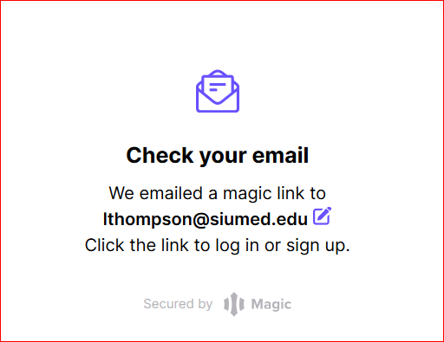 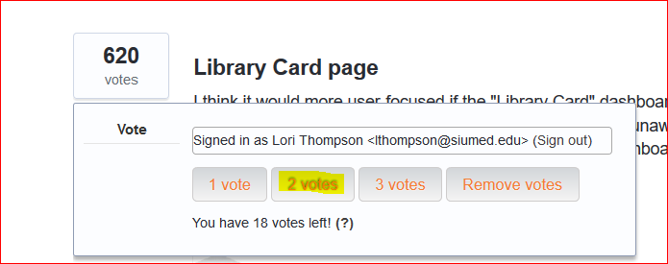

Q: How many ideas may I support?

A: You start out with 25 points available for your use. This limitation helps us understand which ideas are the most important to our users.

