Borrowing Library Materials in I-Share

If you are enrolled at, or employed by, an I-Share member institution, you may use your account to borrow library materials from any I-Share library.
View the list of I-Share members here: https://www.carli.illinois.edu/membership/i-share_part
Please contact your library with any questions.

Steps for Borrowing
- In your internet browser, open the link to the library catalog.
  - Your library may provide a link to the library catalog from their website.
  - Or visit https://vufind.carli.illinois.edu/all/vf/ for the I-Share version of the catalog.

- Select the “Login” link in the upper right corner of the screen and log in with your username and password. Refer to the I-Share Handout on “Creating Your I-Share Account,” if needed.
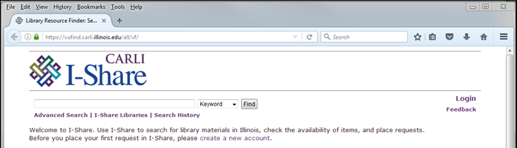

- Enter terms to search for library material, then select the “Find” button.
- Enter terms in the search box.
- The search-type menu allows you to designate the type of terms you entered.
The options are Keyword, Title, Author, Subject, and ISBN/ISSN.
- Switch between searching your library’s collection, or the combined collection of all I-Share Libraries.

- Narrow your search results using the options in the right-side menu, if desired.
- Choose the title for the desired material. The detailed record will open.
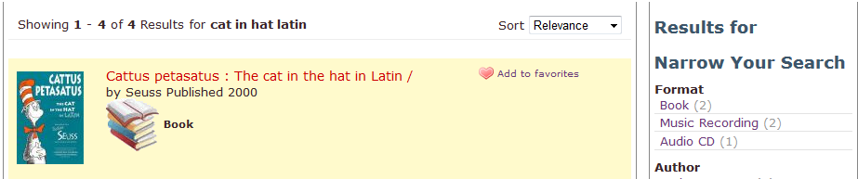
- To request the material, select the “Request 1st Available” button.
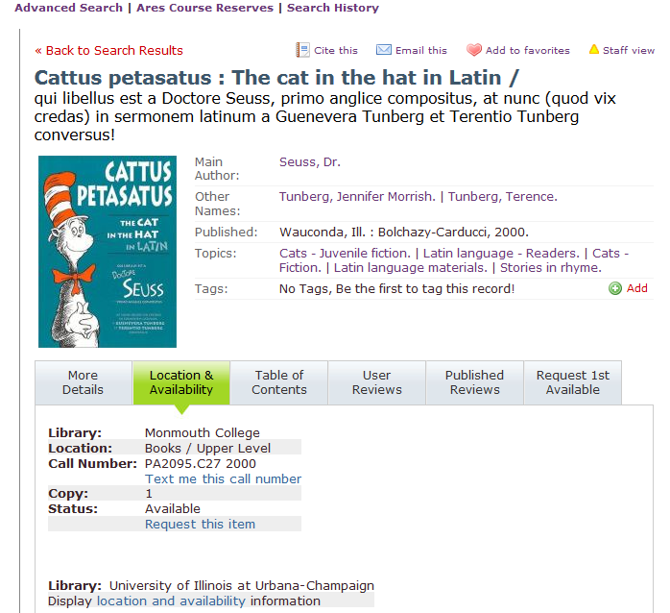
- Choose your desired pick-up library and desired pick-up location at that library.
Select the “Request” button.
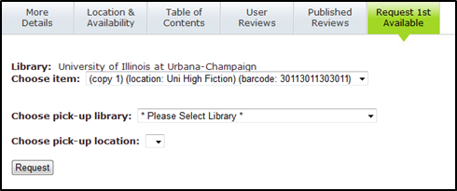
- The screen will confirm “Request submitted.”
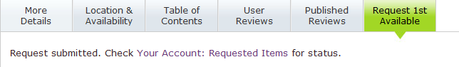

- If your borrowing request was unsuccessful, review the provided message and contact your library with any questions.
- Note that some requests cannot be filled.
- Most requested material will be delivered to the pick-up location in 3-5 business days.
- You may check your account for the current status of your request.

