Creating your I-Share Account

If you are enrolled at, or employed by, an I-Share member institution, you may create an account that will allow you to borrow library materials from any I-Share library.
View the list of I-Share members here: https://www.carli.illinois.edu/membership/i-share_part
Please contact your library with any questions.

Creating Your Account
- In your internet browser, open the link to the library catalog.
  - Your library may provide a link to the library catalog from their website.
  - Or visit https://vufind.carli.illinois.edu/all/vf/ for the I-Share version of the catalog.
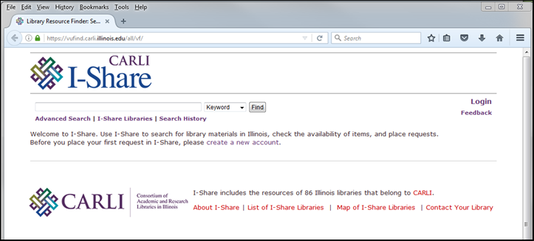

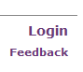
- Select the “Login” link in the upper right corner of the screen.

- The Login page will open. Select the “Create New Account” link.
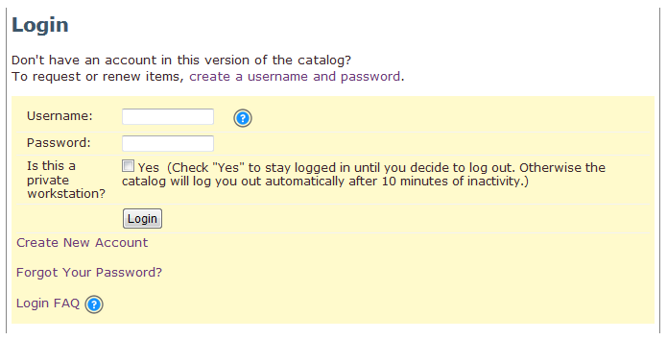

- The User Account creation page will open. Fill out the form with your personal information.
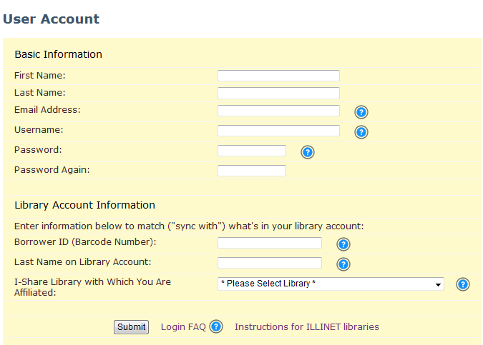
  - Choose a username; the username must be unique.
  - Your Borrower ID is your library barcode number; it is usually printed on your campus ID card.
  - Select your library from the “I-Share Library with Which You Are Affiliated” drop-down menu.
- Select the “Submit” button when finished; if you see your name displayed in the upper right corner of the screen, your account was successfully created.
- Contact your library with any questions.

