How to Change a Loan Status in ALMA
On your Alma homepage, click on Fulfillment, and click on Manage Patron Services under Checkout/Checkin.
Pull up the account of who checked out the book by putting their barcode in the space below, or looking them up under Users in the search bar at the top.
Go into their account profile, and click on Manage Fulfillment Activities on the top right.
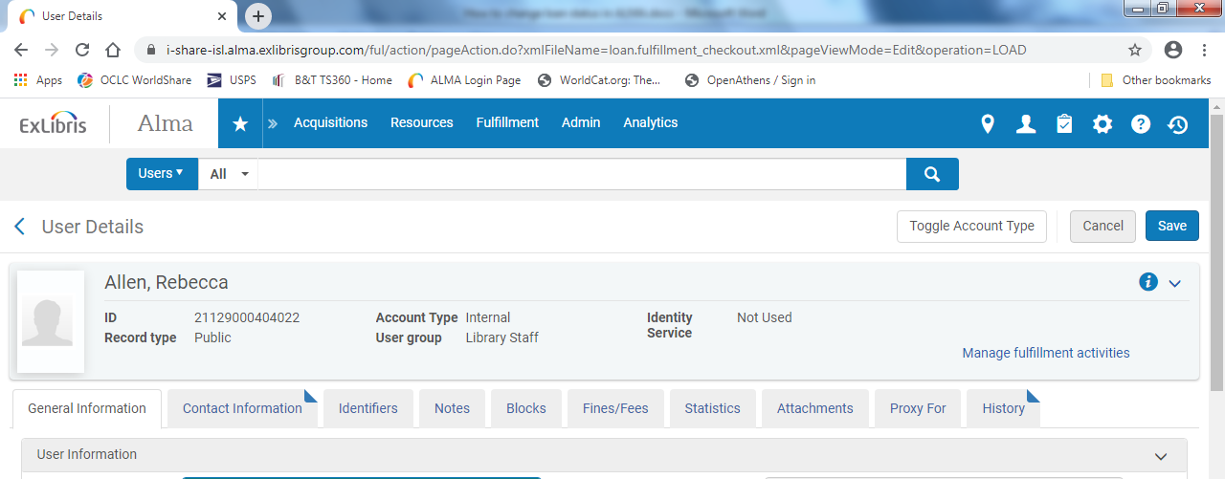
This will take you to a page with the patron’s loan information. Click on the Loans tab on the left. The Loans tab shows materials that belong to us, while the Network Activity tab shows materials that belong to other libraries.
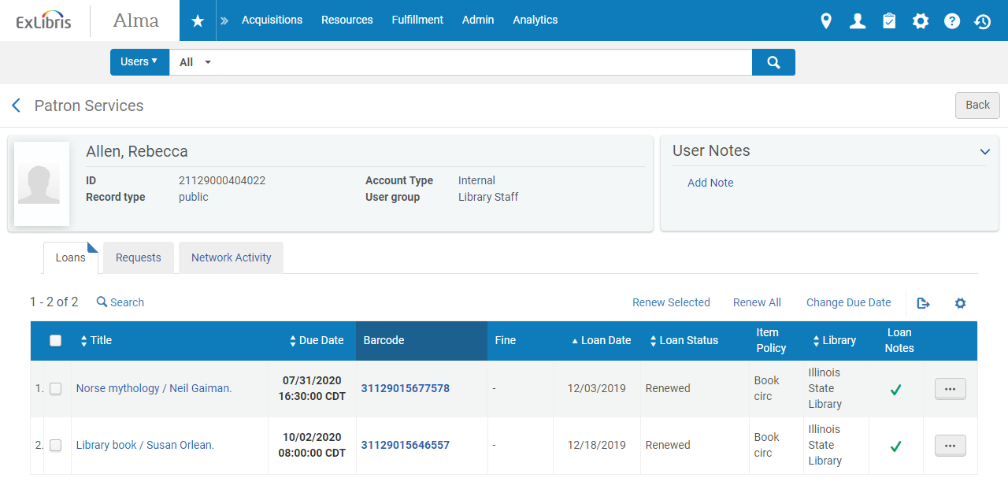
Checkmark any books that have changed status.
Change loan status to normal.
You also have the options of renewing a single or all the marked books and changing due date.
Once process is completed return to patron services.

