HOW TO REMOVE A FULFILLMENT NOTE
Fulfillment Scan in Items Scan Item

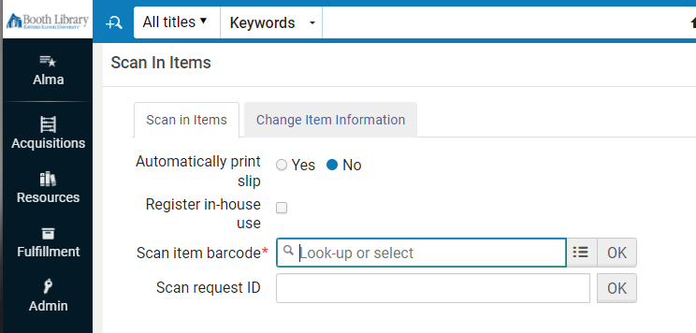

After you scan in a barcode a pop appears. Select Confirm.
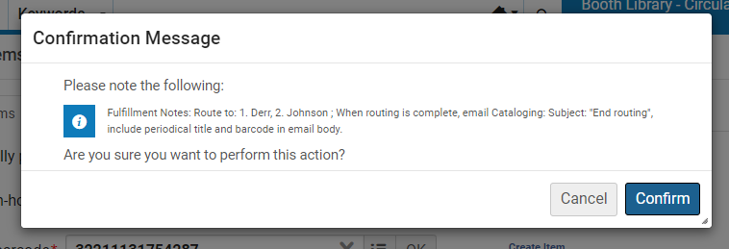
Select …Edit Item
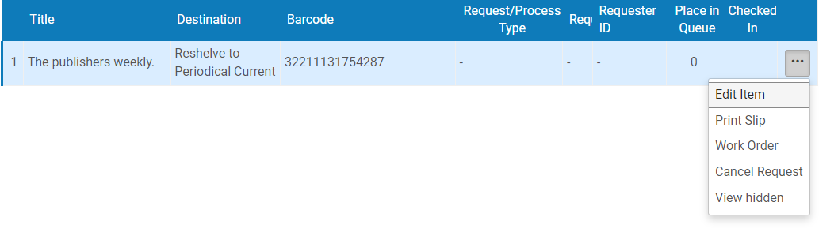
Select Notes tab and highlight and delete Fulfillment note.
