Moving Items to Other Holdings

Item records can be moved to other holdings attached to the same bib record. To move items to other bibs, move the holding instead. Attached items will be moved with the holding.
To move an item from one holding to another, start with a bib that has multiple holdings attached. In the example below, the most recent issue is kept in Reference. When a newer issue is received, the previous one is moved from Reference to Stacks.
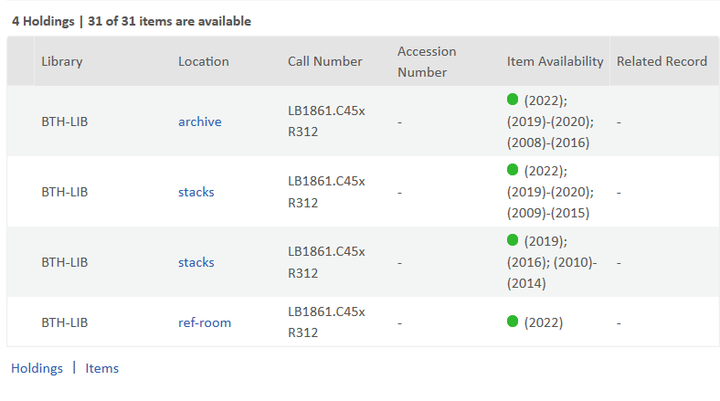
When the 2023 issue arrives, we will want to move the item in ref-room to the second stacks holding as copy 2. The first stacks holding already has a 2022 issue. To do this, open Items at the lower left of the screen and find the 2022 item that is in Reference.

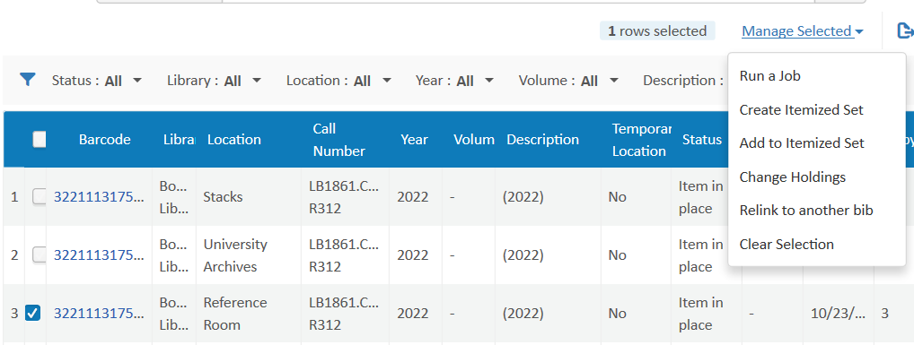
Check the box at the left of the row of the item you want to move to another holding. Click Manage Selected in the upper right, and choose Change Holdings from the drop-down choices.
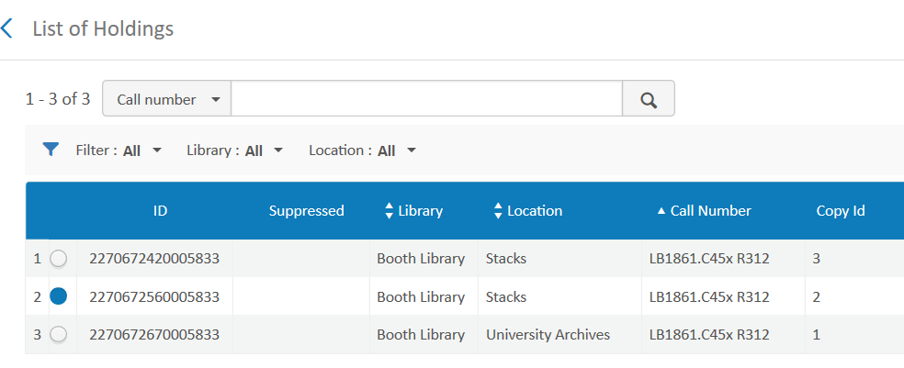
You will be presented with the option to choose the other holding to which you would like to move the item. I’ve selected Stacks, copy 2 with the blue dot on the left. To complete the move, I’d click Select in the upper right corner of the screen (not shown in the snip above). You should get a message that the item was successfully moved.
We would want to edit the 866 fields of both holdings to reflect the new items present or not present in each holding. If moving the item to a new holding affects its copy number, that should be edited in the item record to match the copy of the holding. Re-label if necessary.

Contact:
Bill Schultz – Eastern Illinois University
4/20/21

