Charging an item to Out-of-State Library
In Alma click on Fulfillment.
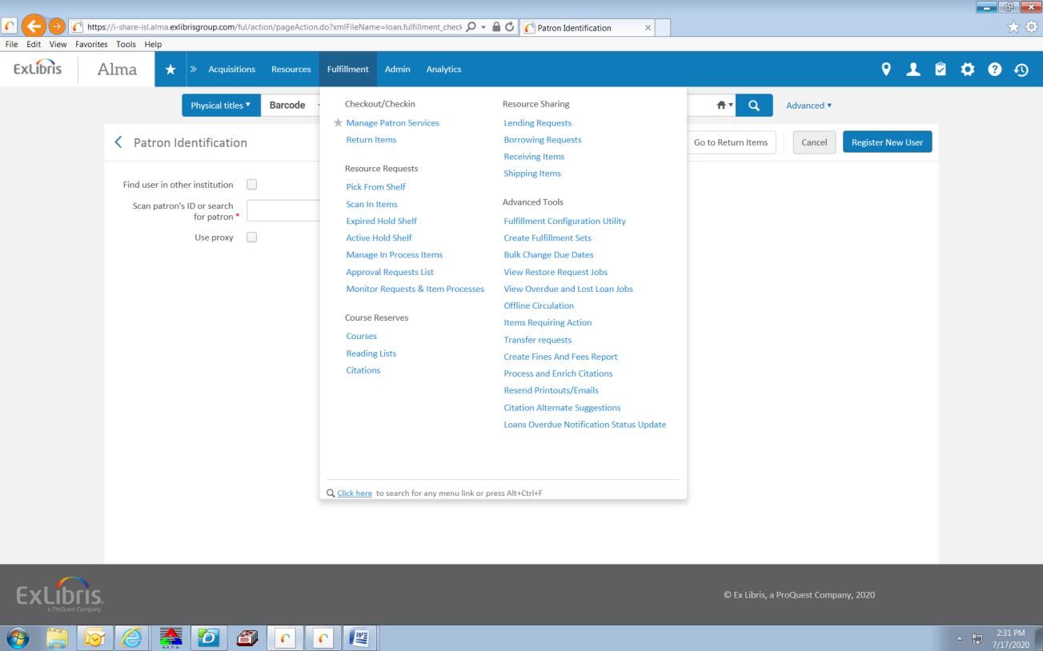
Click on Manage Patron Services.
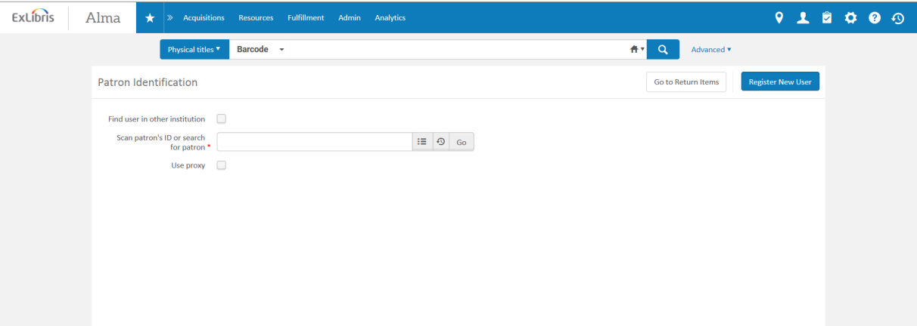

In the Scan patron ID or search box, enter Out of State.
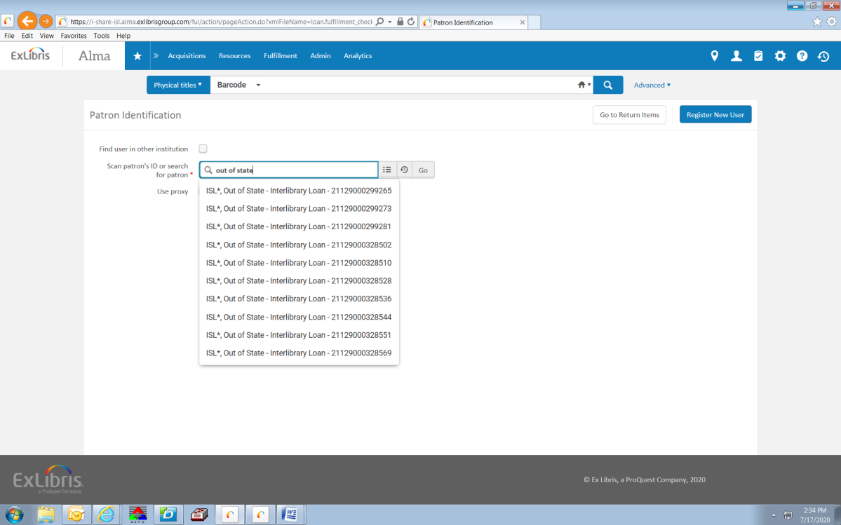
Start with the first Out of State account listed, click on that account and hit Go.
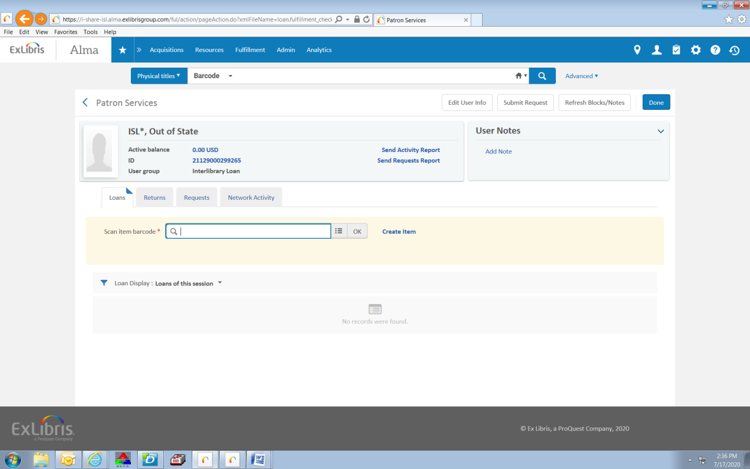

Scan the item’s barcode. The item will appear under the account.
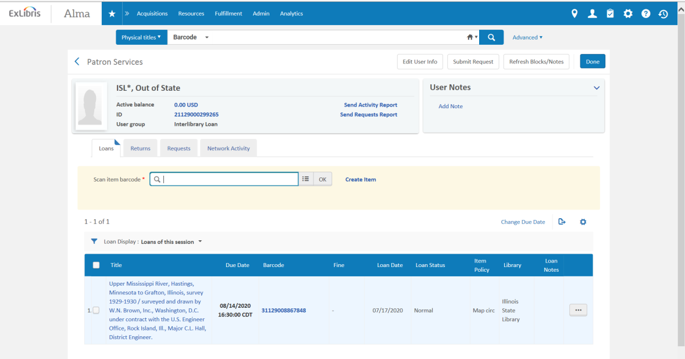
To add the Note pertaining to OCLC, go back to the top search bar, choose Physical Titles- Barcode and scan the charged item.
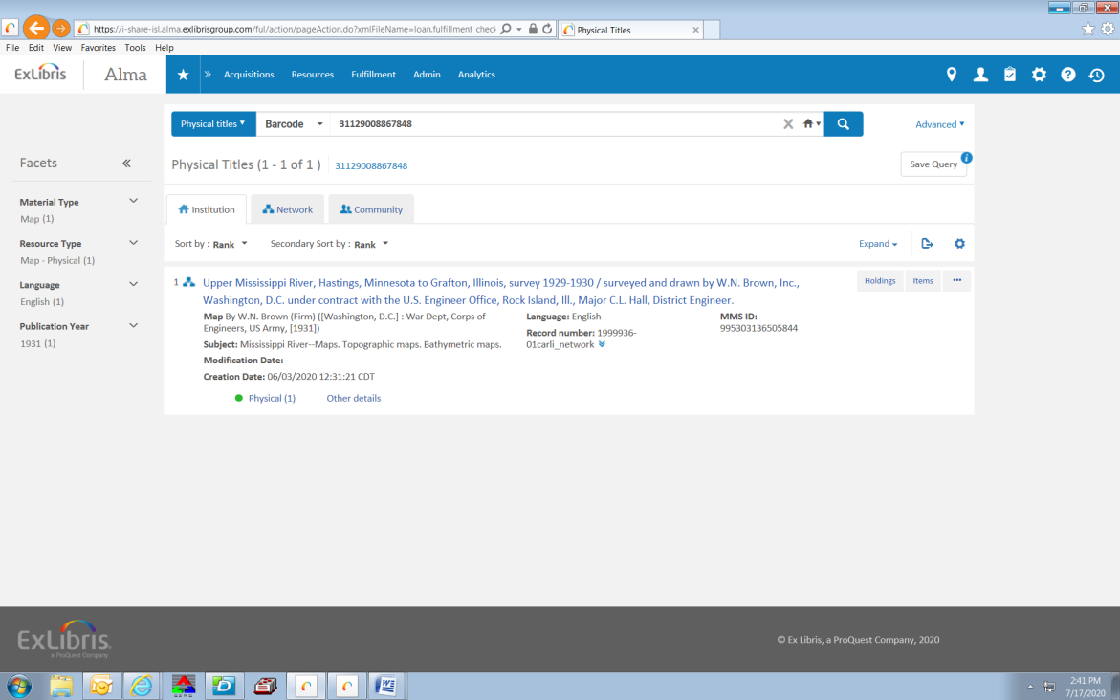

Click on Items
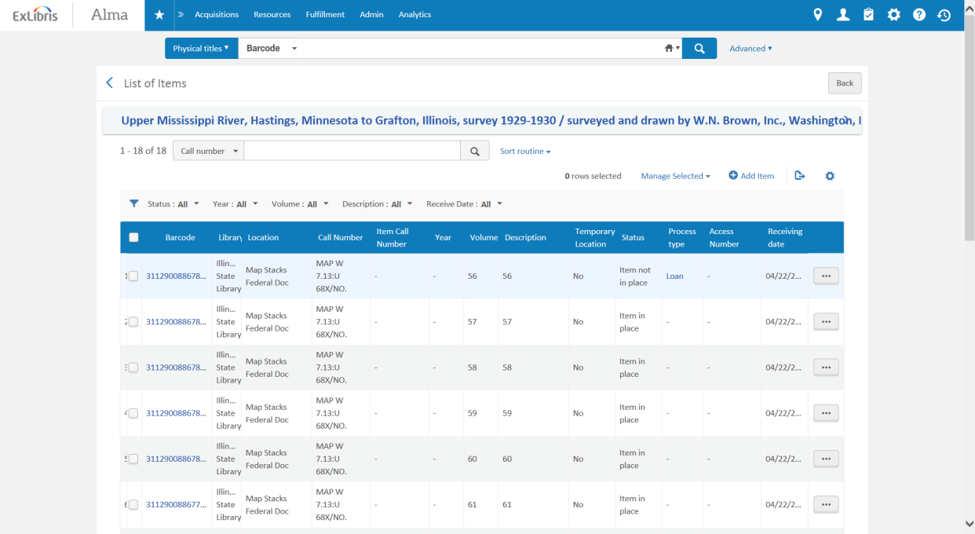
Click on the Ellipses next to the Loan item/ Item not in Place.
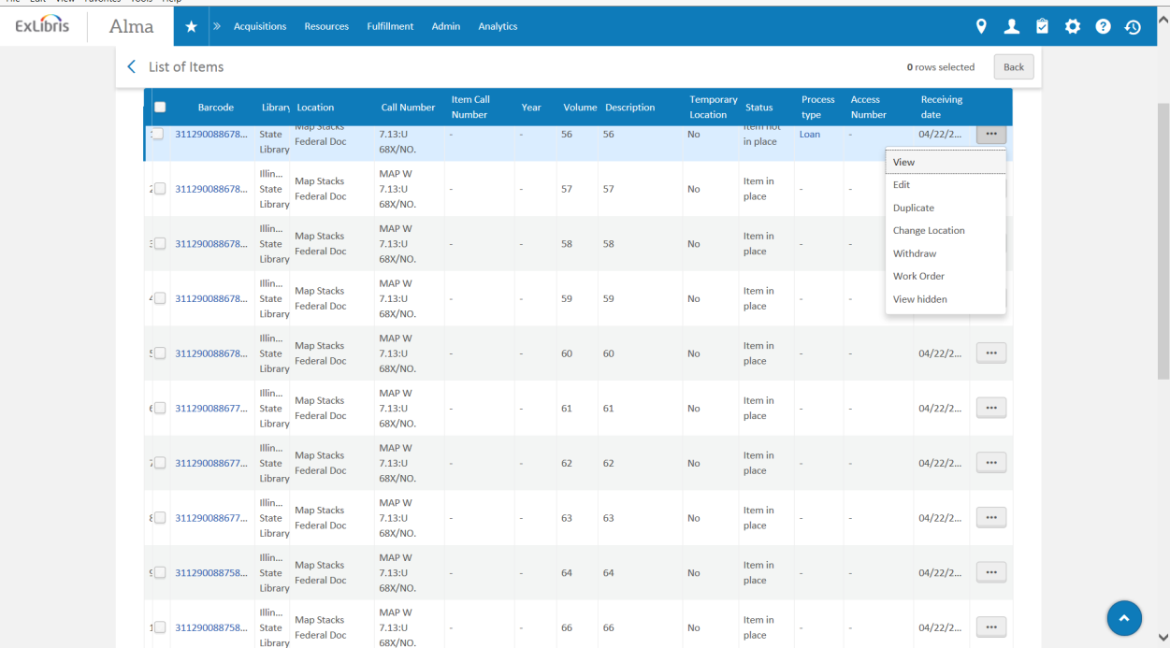

Click on Edit.
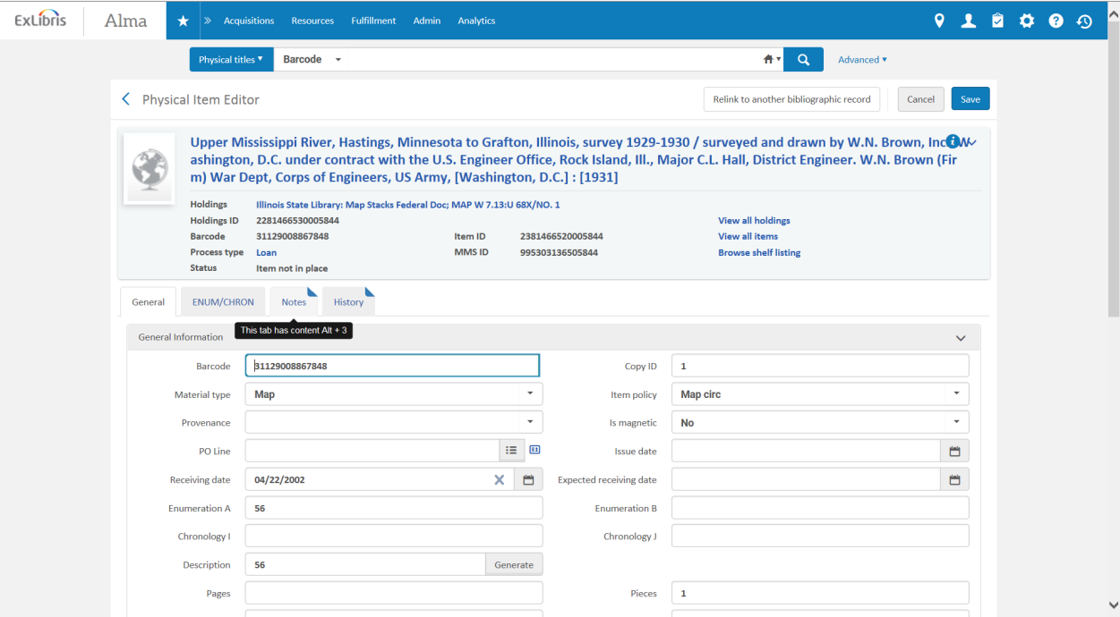
Click on the Notes tab.
Add your note including ILL number, the Library the item was sent to, and the USPS Tracking number. Click Save.
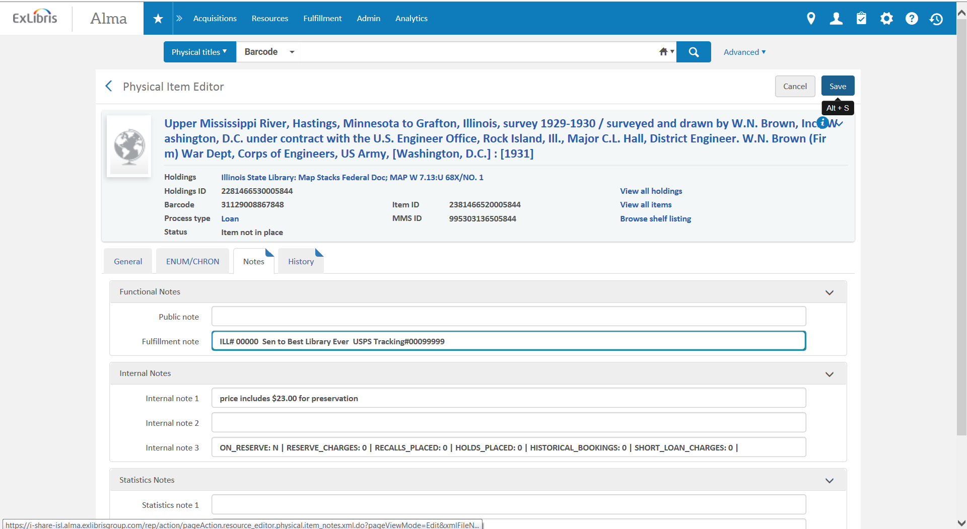
For your next out of state item, use the second out of state account listed and repeat this process. (If you have multiple items for the same out of state library, put them all on one account)
Once the item has been returned and scanned in, the Fulfillment note will need to be removed.
To delete the note once the item has arrived back at the library and been checked in, highlight the text in the Fulfillment Note field. Click “Backspace” or “Delete” on the keyboard.

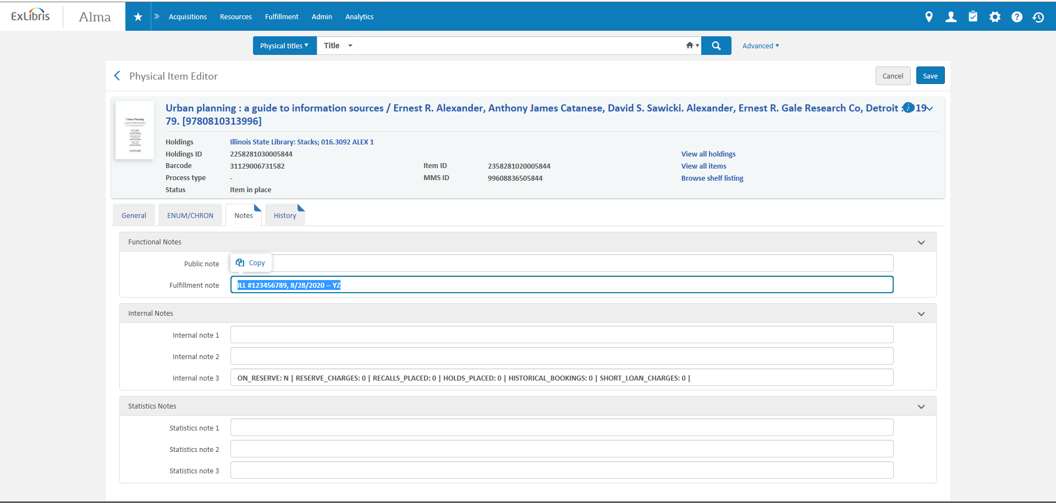
Click Save.

