Charging an Item to an In-State Library
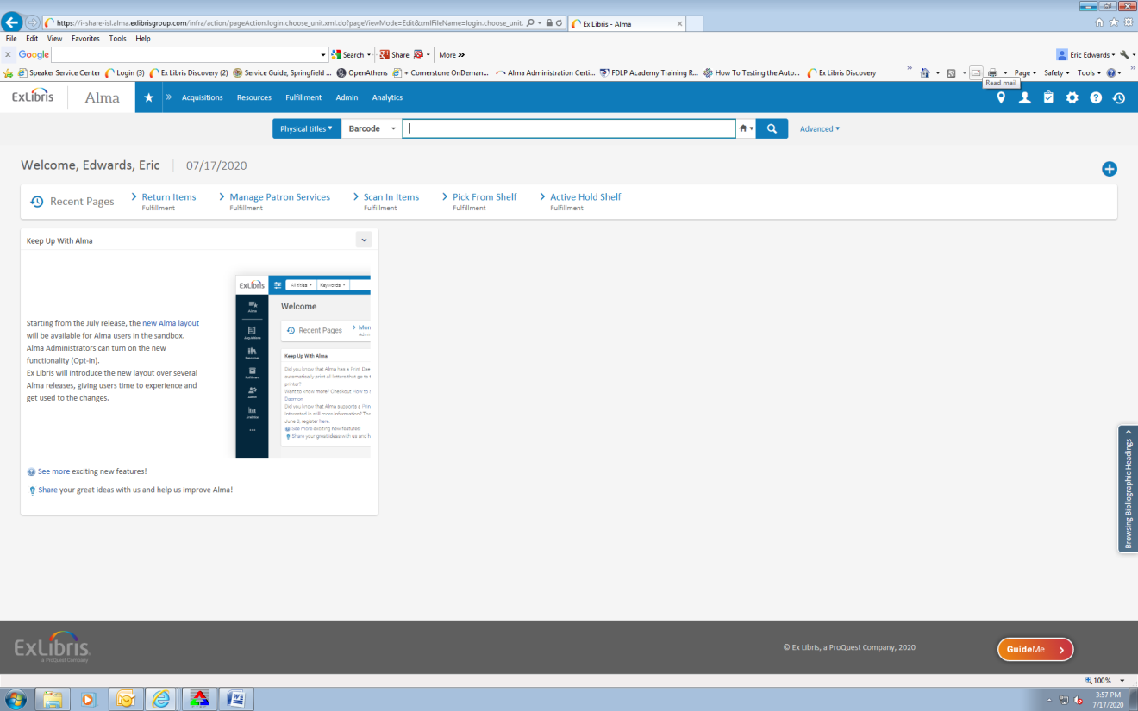
Go to the Fulfillment tab.

Click on Manage Patron Services.

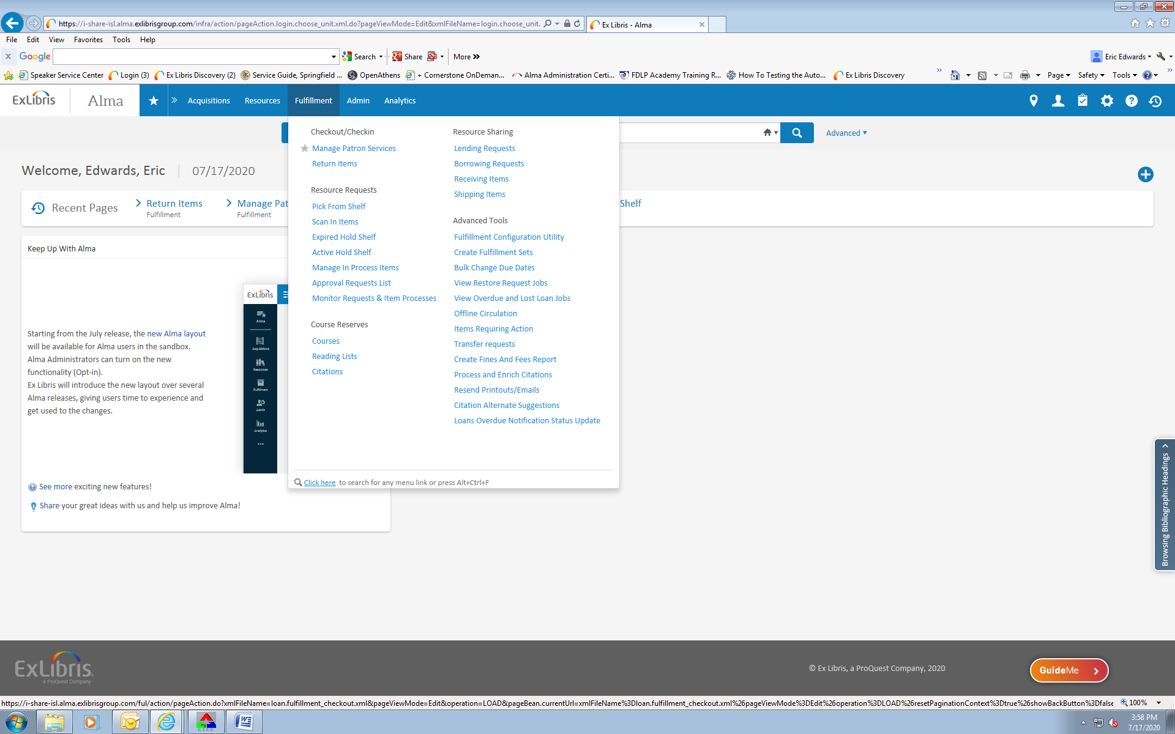

Enter the borrowing library’s name into the search box.

Click on the library’s name in the list of results.

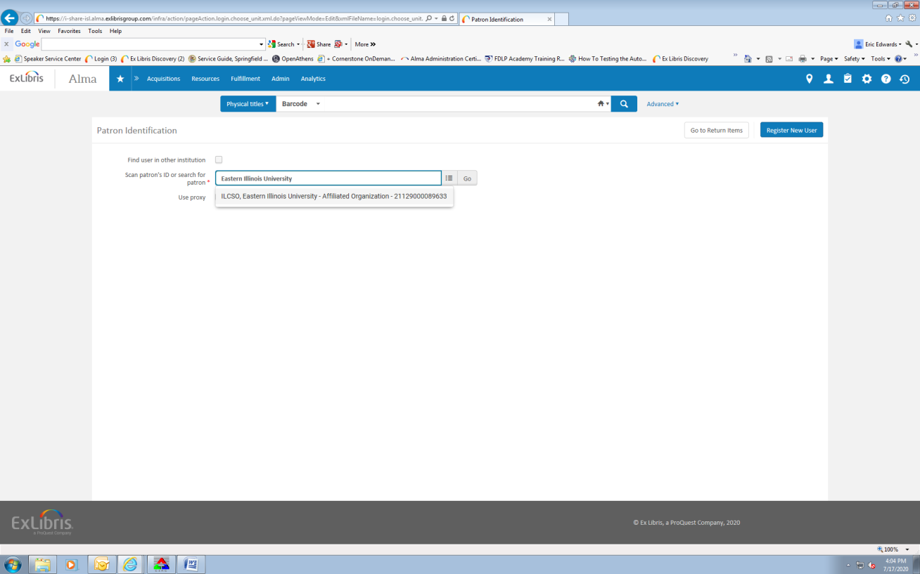

Click on Go.

Scan the item’s barcode.
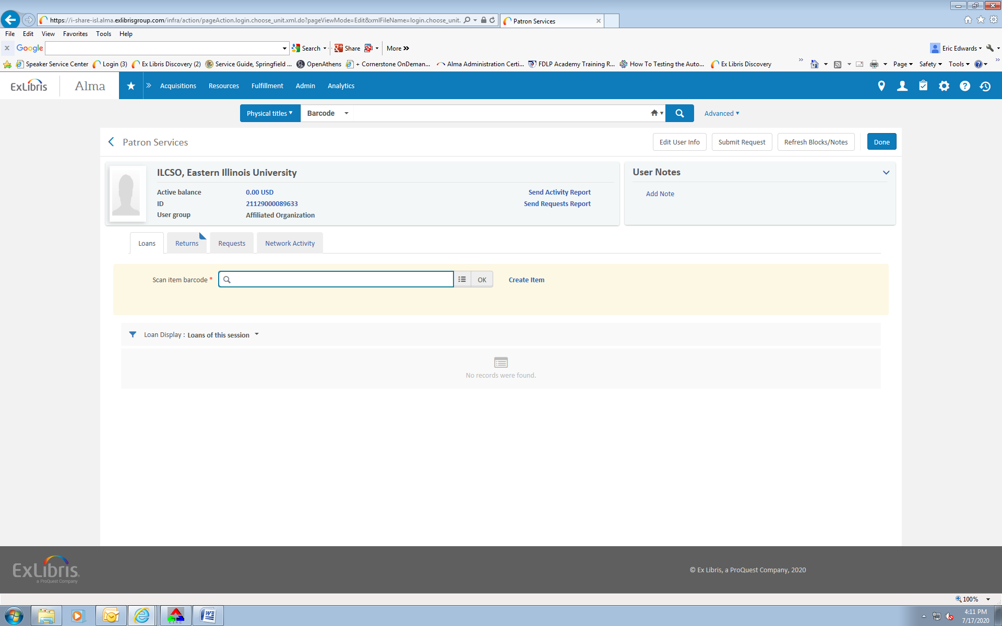

Click “OK”.
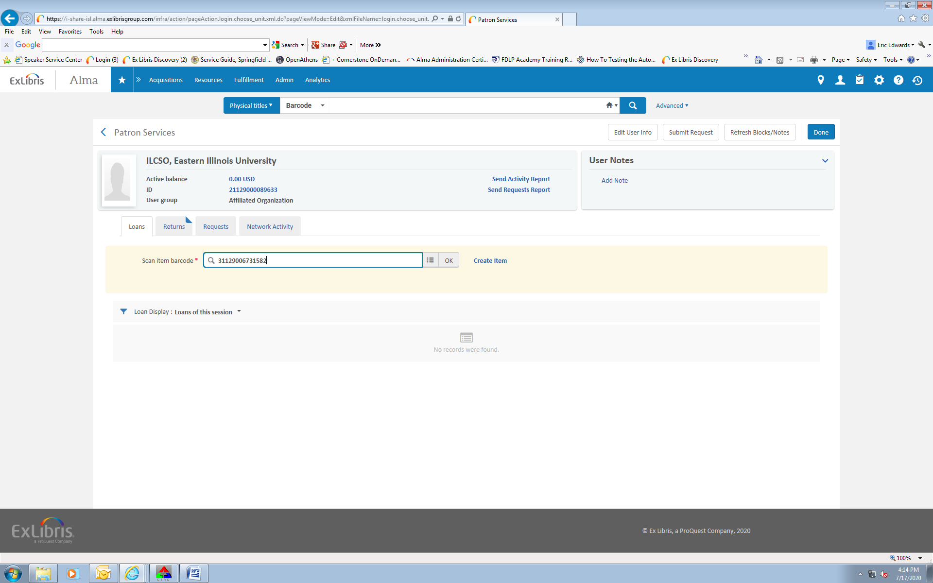

Check that the due date is correct.
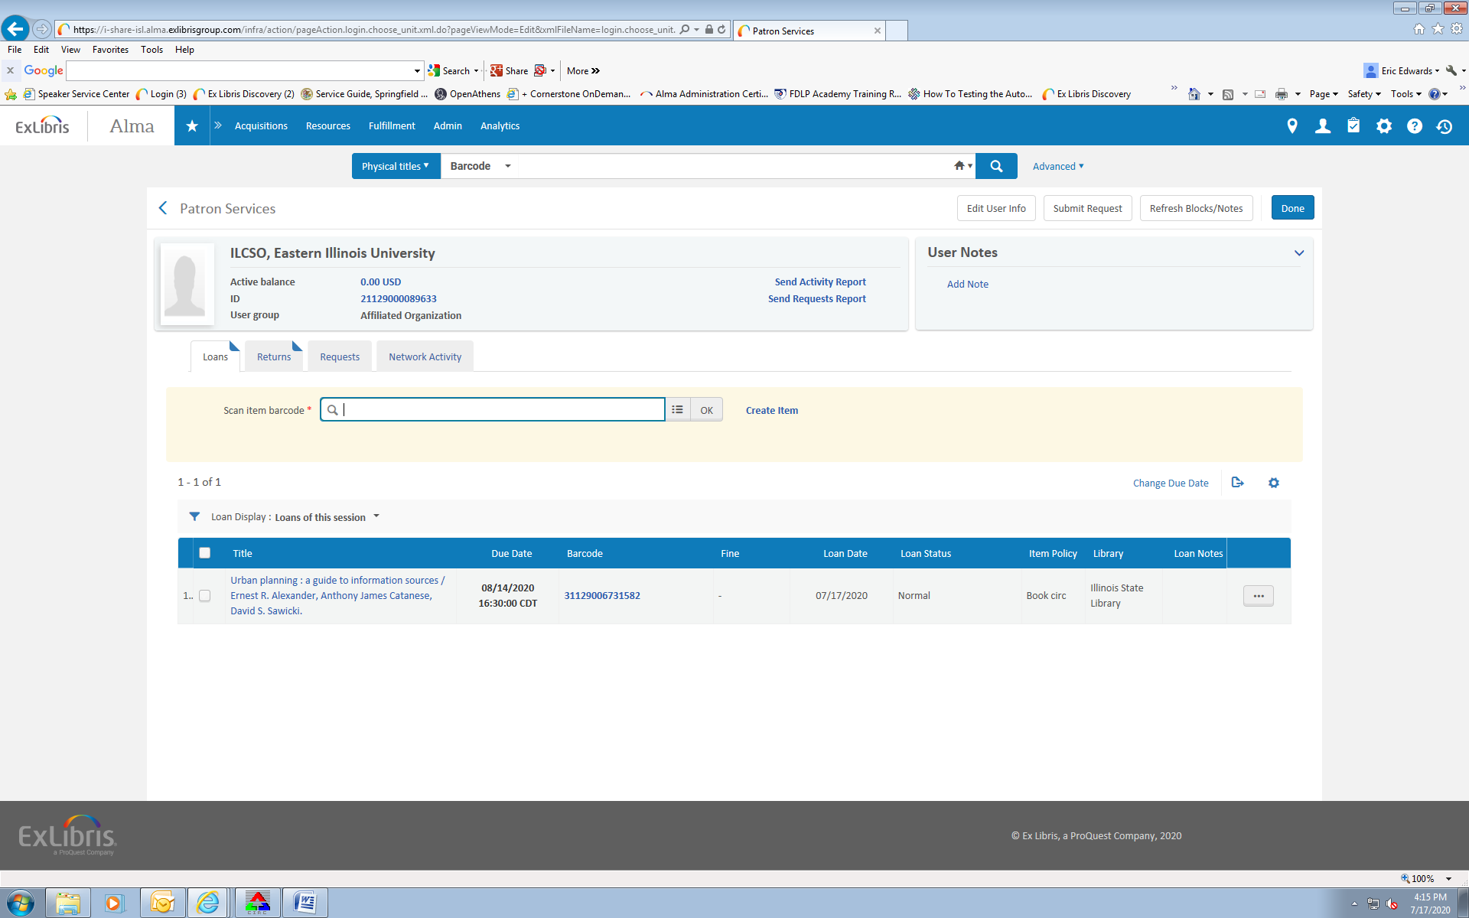

Click on the barcode.

Click on the Notes tab.
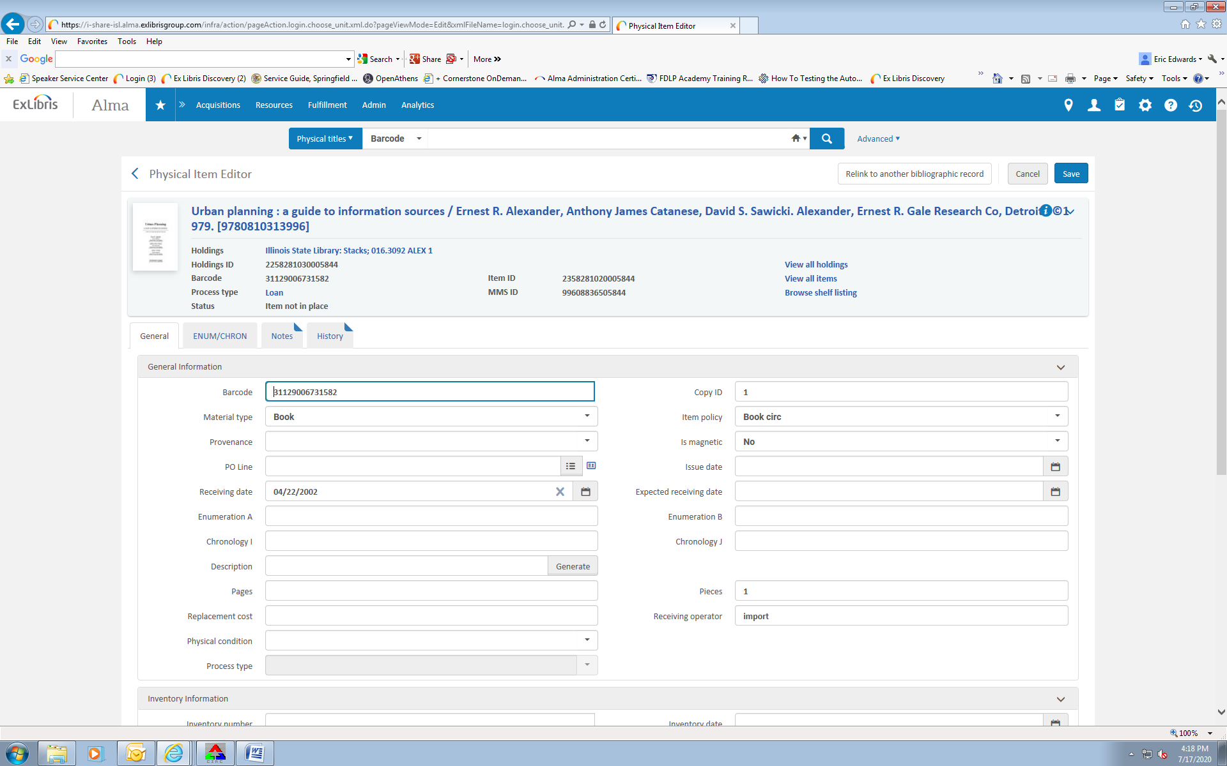

Type the ILL request #, the date, and your initials into the Fulfillment Note field.
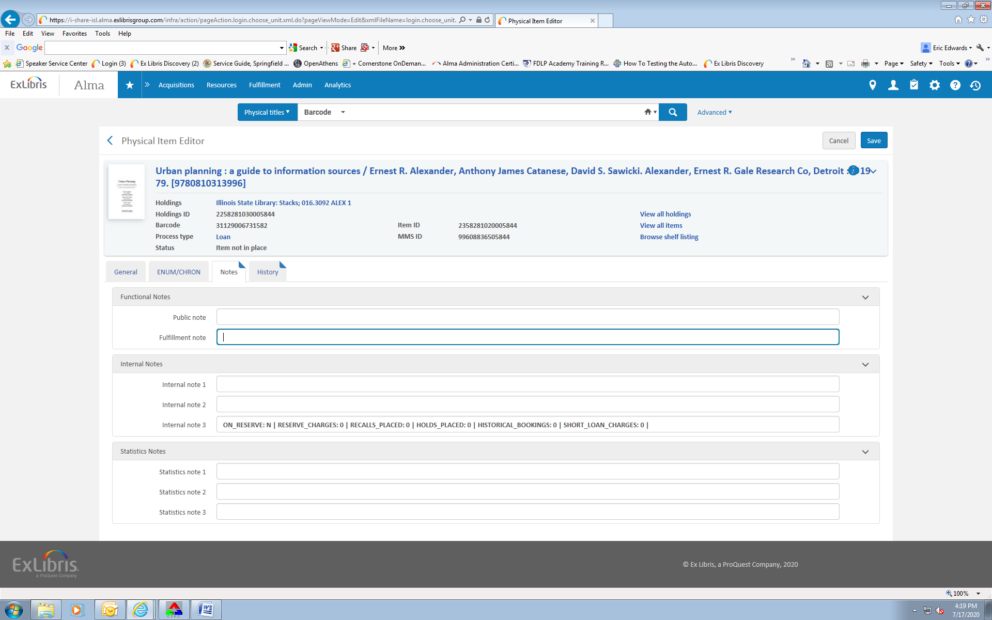

Click Save.
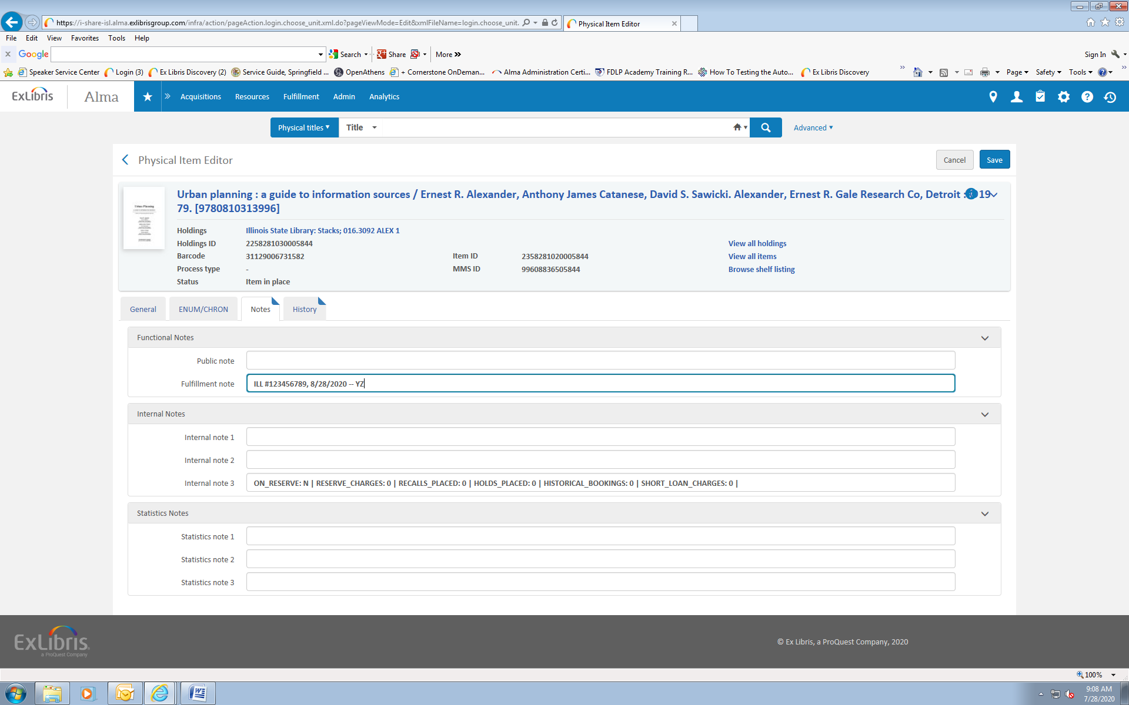
To delete the note once the item has arrived back at the library and been checked in, highlight the text in the Fulfillment Note field. Click “Backspace” or “Delete” on the keyboard. 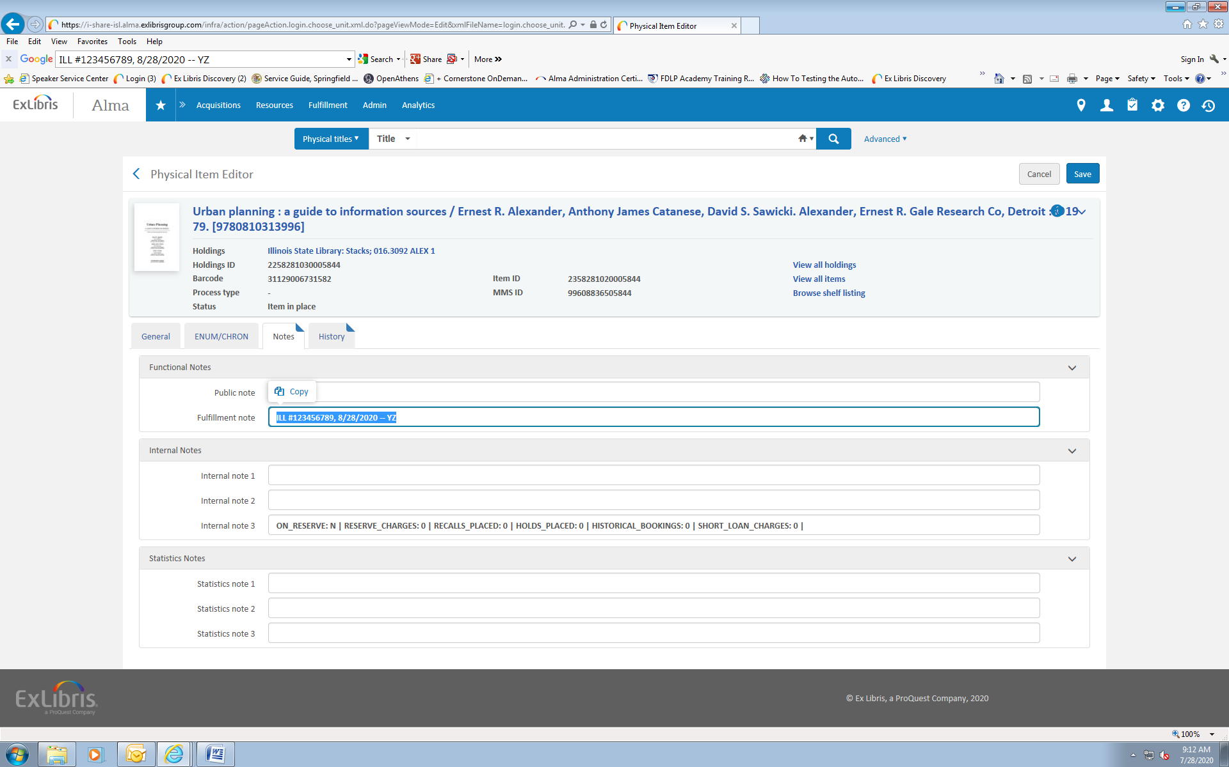

Click Save.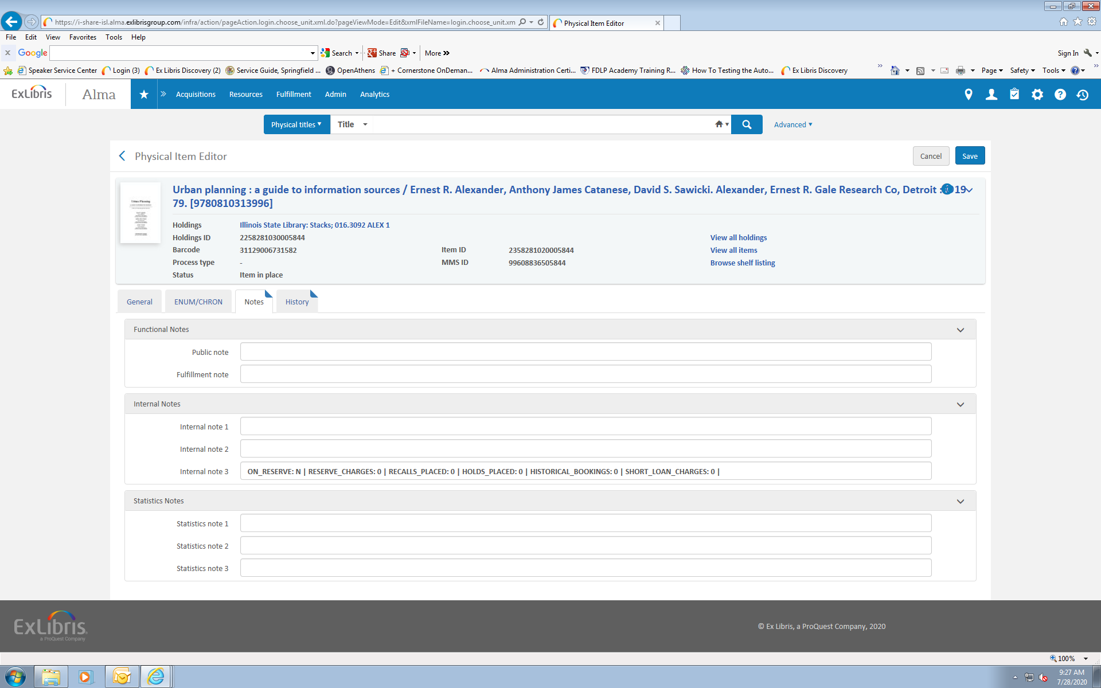

*** If the library is not found under ILLINET or ILCSO, you will need to use the generic In State account to charge items. In the Patron search bar, enter In State and choose the first account, click Go and scan items barcode. A note will need to be added just like for the out of state items indicating the ILL number, and the library it was sent to. All items going to libraries that cannot be located under ILLINET or ILCSO should go in the first In State account. Remember, when discharging items from these libraries, you will need to remove the fulfillment note just like for Out of State items.

