Cataloging Procedures-Search Resources
Searching for Bibliographic Headings using the Browse Bibliographic Headings Function
This function can be found under the Resources tab on your main page.
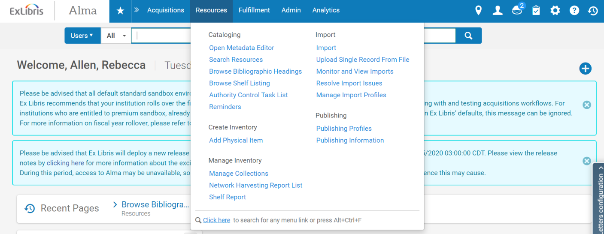
You can browse for headings in both the Institution Zone and Network Zone. Decide which Heading Type (names, subjects, series, series, titles, call number/classifications) you want to search in. Choose the Source Code (chronological term, topical term, geographic name, genre form, and medium of performance). Put the term you are searching in the “search value” field. Look for Library of Congress Subject headings under the Vocabulary field.
After your search is complete, it will bring up display record heading options. Choose the heading you are interested in and click view, and it will bring up both bibliographic records and authority record on the right side of the screen.

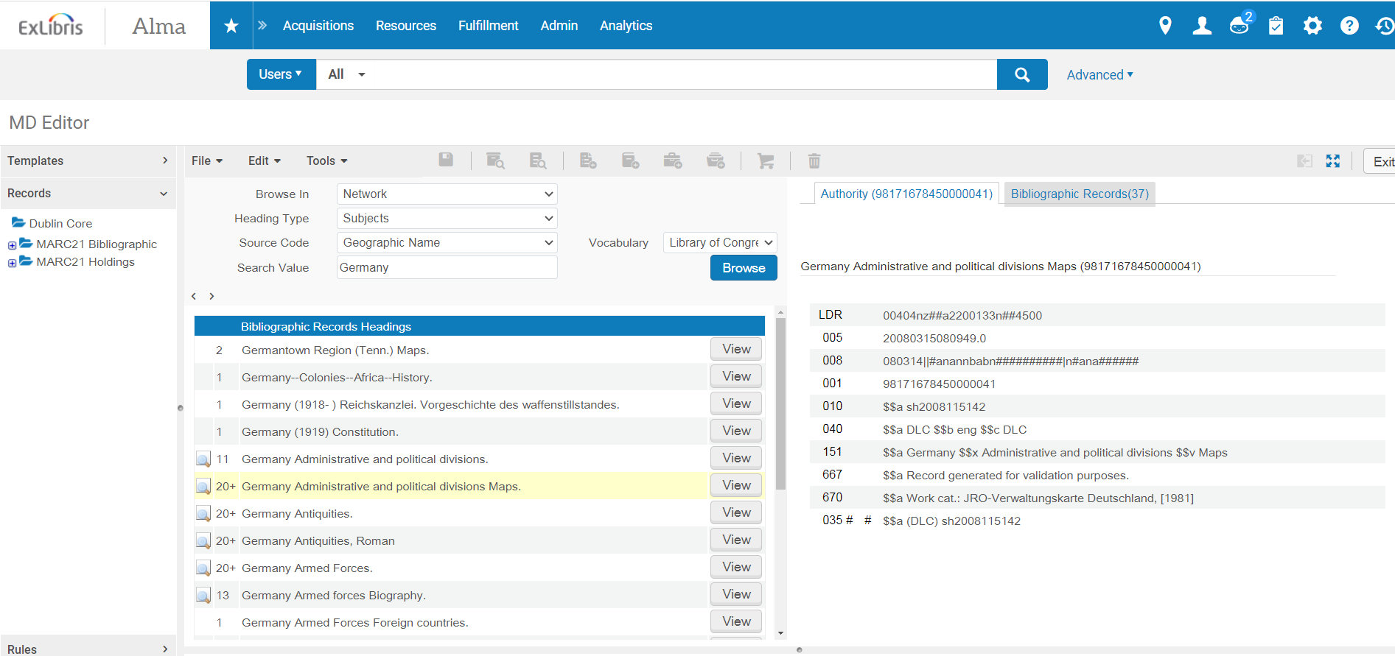

Browsing Shelf Listings Function
This tool can be found under the Cataloging heading under the Resources tab. It is very similar to the Browse Bibliographic Headings function.
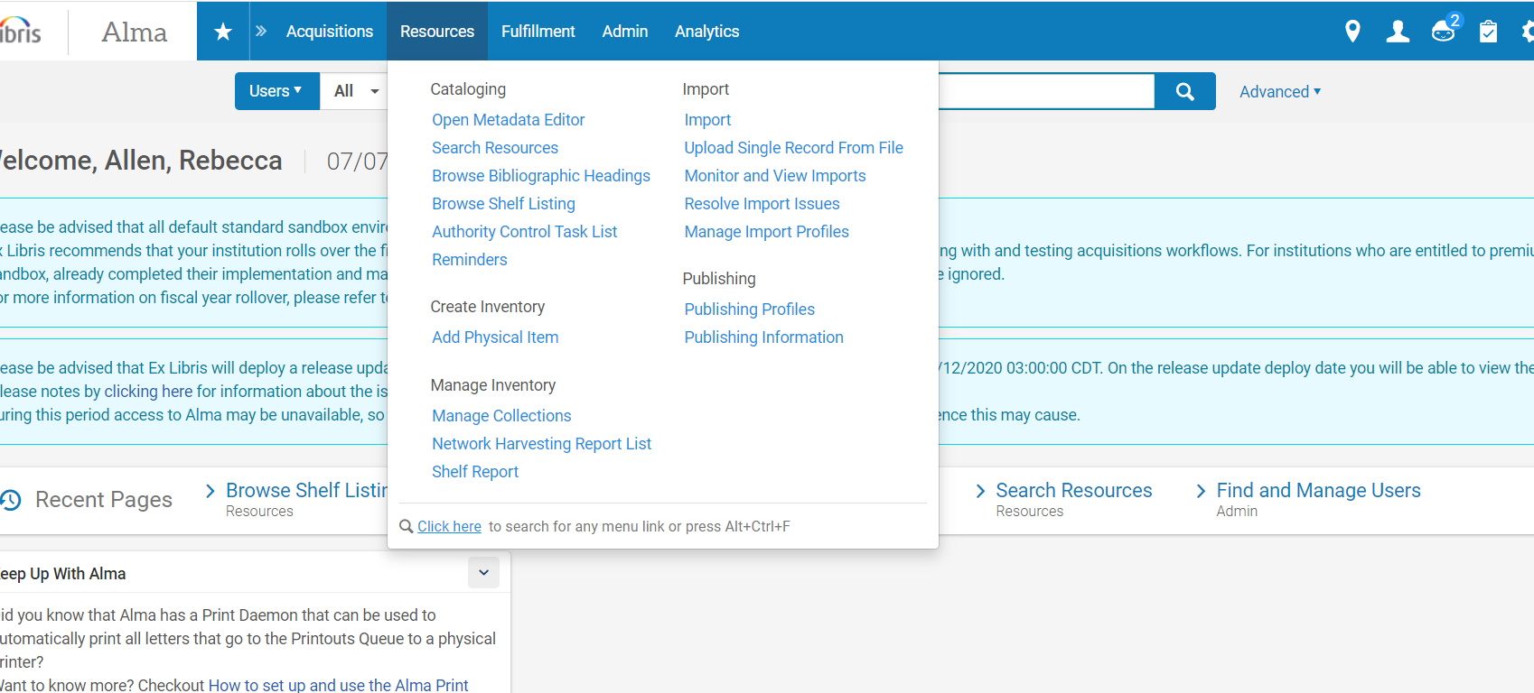

This function allows you to search for a record at the call number level. You can search the holdings call number, item call number, or temporary call number. Click on SPI (our code) for the library. You can choose between several call number types, such as the Dewey decimal classification or Library of Congress classification. You can narrow down the locations to specific locations in the library, such the general stacks or the map room. Choose what you want to find, and it will display every record whose holdings include that call number. You will need to use the small arrows on the right side of the screen to navigate through the list of results.
