Adding a LibWizard ILL Form to PrimoVE

Note: This is a work-in-progress, and every institution is different, so you will have to figure out what works for you, but I hope this gives you the basic framework for how it works.

Primary Resources:
- Adding a General Electronic Service: https://knowledge.exlibrisgroup.com/Primo/Product_Documentation/020Primo_VE/034Get_It_Configuration/Configuring_Discovery_Interface_Display_Logic_for_Primo_VE#Configuring_General_Electronic_Services
- Springshare documentation: https://ask.springshare.com/libwizard/faq/2054
- Adding Display Logic Rules: https://knowledge.exlibrisgroup.com/Primo/Product_Documentation/020Primo_VE/034Get_It_Configuration/Configuring_Discovery_Interface_Display_Logic_for_Primo_VE#Adding_Display_Logic_Rules

----------------------------------------------------------------

In LibWizard

- Decide what fields you want to include in your LibWizard form and create the basic form. Here is ours as an example: https://lewisu.libwizard.com/f/Primo-ILL

Tip: Do not overload the form with too many fields. LibWizard will capture the referring URL in Primo, so you will have the link back to the article record in Primo. Just add enough fields to provide basic citation information and whatever user information you want your patrons to provide.

- Using the Springshare documentation above, use the “Map OpenURL parameters” instructions to map the citation fields in your form to the corresponding OpenURL parameters. See the Alma General Electronic Service documentation for a table of common OpenURL parameters and their definitions. Here is a screenshot of our form with the mapping:

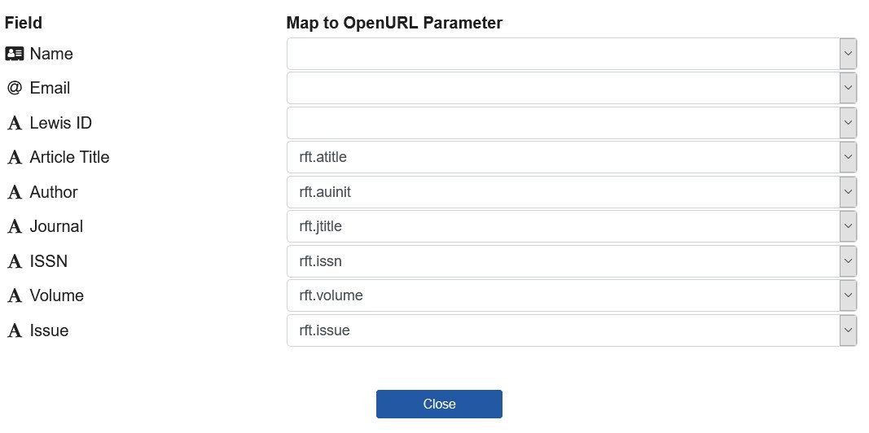

In Alma: General Electronic Services

- In Alma, follow the documentation above for adding a General Electronic Service.

Tips:
- For Is this Document Delivery/ILL Service, choose Yes.
- For Display Location, we chose “Viewit and How To GetIt”

MOST IMPORTANT TIP: In the URL Template, you LibWizard URL should follow this format:

https://lewisu.libwizard.com/f/Primo-ILL?&rft.issn={rft.issn}&rft.volume={rft.volume}&rft.issue={rft.issue}&rft.jtitle={rft.jtitle}&rft.atitle={rft.atitle}&rft.auinit={rft.au}&linktype=openurl&url_ver=Z39.88-2004

This is what will pass the citation information automatically to the LibWizard form.

Yellow = the URL for your LibWizard form. Be sure to include the “?” at the end.
Blue = the OpenURL parameters you have mapped in your LibWizard form

Notice that for rft.auinit, I mapped it to rft.au because that is the author field I wanted to capture in Primo, and there was no direct match for it in the limited options that Springshare provides. So, this is flexible. See the Alma General Electronic Service documentation for a table of common OpenURL parameters and their definitions.

- For the Disable Service options, we chose “When the resource is owned by the institution” to prevent the form from appearing in physical inventory in our collection. You will be able to refine this further with Display Logic Rules.

- In the Service Availability Rules tab, I left the default general electronic services rule in place. Make sure you toggle the IsDisplay to “True” otherwise the link will not display in Primo.

- Finally, assuming this ILL form is for article requests only, you are going to Add a Rule in the Service Availability Rules to hide the display of the ILL form on the records of most physical materials and ebooks.

- Click Add Rule.
- Give it a name and description. I called ours “Is Book” and “Hide display where item is a book.”
- Click Add Parameter.
- Search for rft.genre in the Name field and select it.
- Operator is: =
- Value is: book
- Save parameter.
- Toggle IsDisplay to False.

Screenshot:

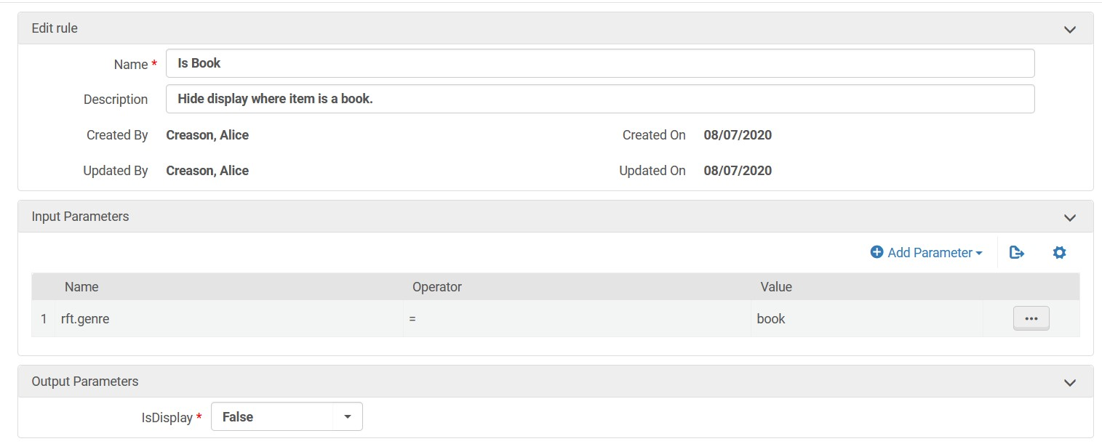

In Alma: Display Logic Rules

- Finally, we want to make sure we hide the ILL form where we have full-text access to the item. So we are going to create a Display Logic Rule following the Alma documentation linked at the top.

- From Configuration > Fulfillment > Discovery Interface Display Logic > Display Logic Rules, click Add Rule.
- In the hide service field, select General Electronic Service.
- with = Service
- with value = your ILL form
- if exists service = Full Text
- Click Save and Close.

Congratulations! You should now have a working LibWizard ILL form for article requests in Primo. Test it out in your instance and adjust as necessary!

Examples in the Lewis University Primo instance:

Article with no online access, ILL form displays: https://i-share-lew.primo.exlibrisgroup.com/permalink/01CARLI_LEW/1iohn49/cdi_crossref_primary_10_1097_ALN_0000000000001151

Full-text available, no display: https://i-share-lew.primo.exlibrisgroup.com/permalink/01CARLI_LEW/1iohn49/cdi_crossref_primary_10_1097_ALN_0000000000001151

Item is physical book not owned by institution, no display: https://i-share-lew.primo.exlibrisgroup.com/permalink/01CARLI_LEW/1025pmc/alma991117850989705816

Alice Creason, Head of Library Technology and Technical Services, Lewis University
creasoal@lewisu.edu
08/07/2020

