Adding a Note to an Item or Patron Record
Due to various circumstances, sometimes a note will have to be placed on an item or patron record. These circumstances can include: noting damage, noting a mistake in the record, putting a charge-and-send notice for a state employee, or when a patron lost an item.
To put a note on an item record:
Pull up the item record in Alma by clicking on Physical Items in the search bar and scanning the barcode, then click on Edit Item.
You are now in the Physical Item Editor page, which will open on the General Information page. You will place the note on the Notes page, so click on the Notes tab.
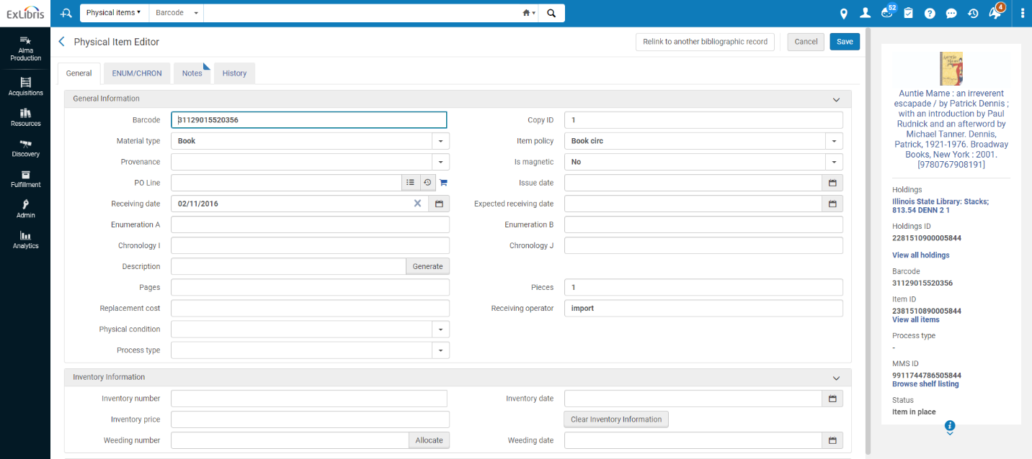
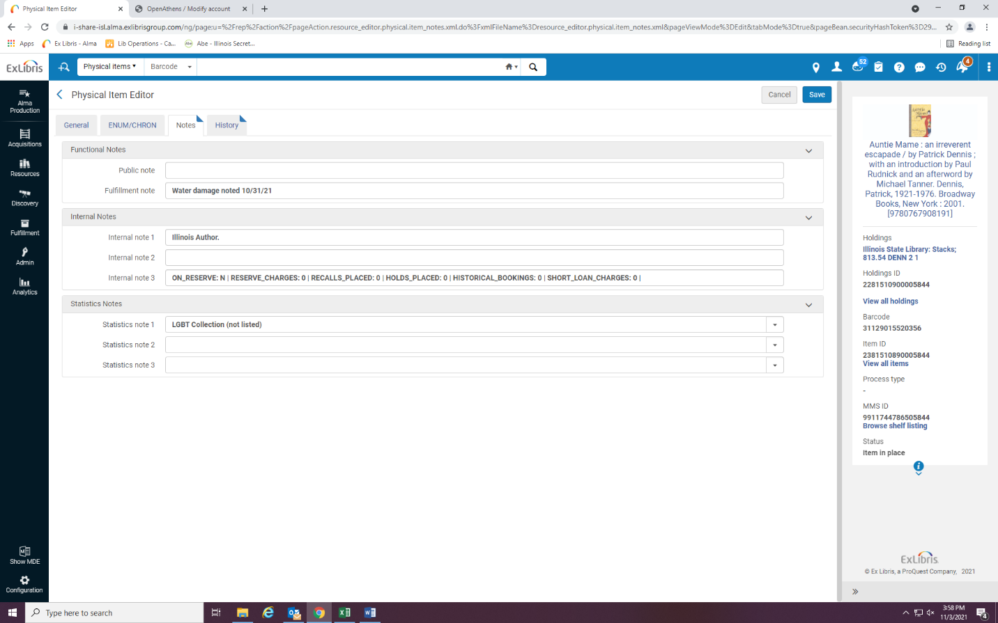
Write the note in the Fulfillment Note field, and press Save.

To put a Note on a Patron Record:
Go to the Fulfillment tab, and click on Manage Patron Services.

Look up the patron by their name or number.

Click on the Add Note link in the User Notes box.

Many of the notes you will put on a patron’s record will be pop-up notes- such as one stating the patron’s request to have their materials sent to their workplace. Our notes are for staff viewing only, make sure that you do not click on the User Viewable box. Put the date on the note, as well as your initials, so we can keep track of when changes are made to accounts, and by whom. Click on Add and Close, and then Save.
Choose Circulation in Type, Select the pop-up note box so it appears when the patron’s items are scanned, and are sent to the correct place.

