Adding New Employees and Patrons to ALMA
Written by: Rebecca Allen and Daniel Dixon
Procedure:
To add a new Staff or Patron User
1. On your home page, click on Admin in the blue bar, and under User Management, click on Manage Users. Before starting a new application, search for the patron by name to make sure that they don’t already have an older account in the system.
2. Click on Staff, and then click on Add User.

3. The top of the screen will say Quick User Management. Enter the information into the fields. This page will allow you to enter the basic information about the account, but only one set of the phone number and addresses associated with the account. You will have to complete this first page, then go in and enter the second set after the account has been saved and created, as the following example will demonstrate. Any fields marked with a red asterisk must be filled in before you are allowed to press Save and Continue.
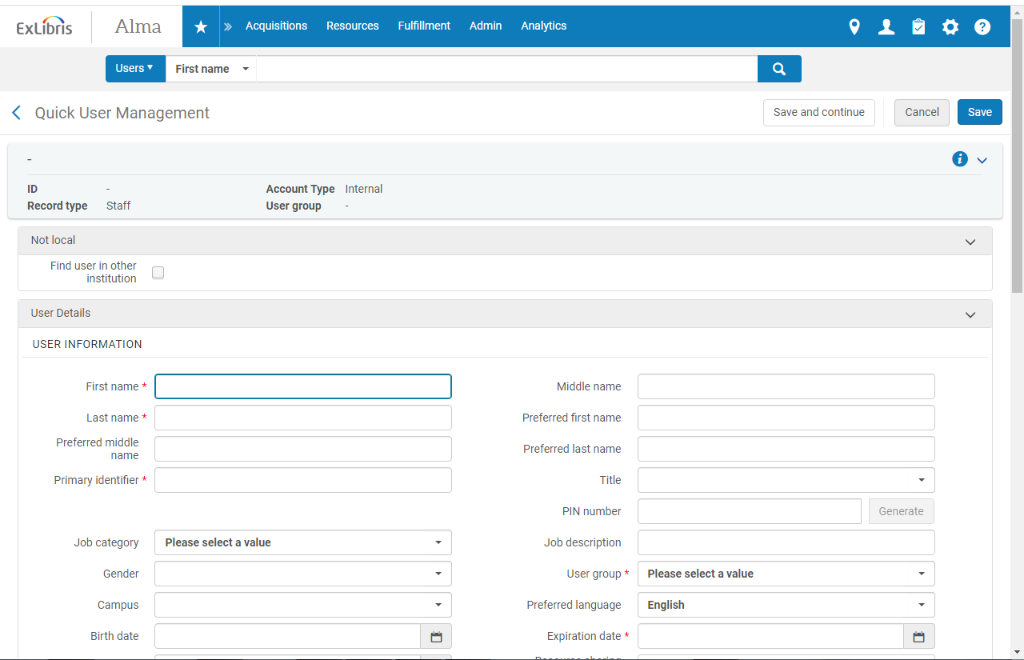
Choose library staff, state gov. staff, or local/high privileges under User Group.
Exp. Date is always three years from the date of creation.
The Primary Identifier is the user’s library card barcode. This will be their username when logging into Alma.
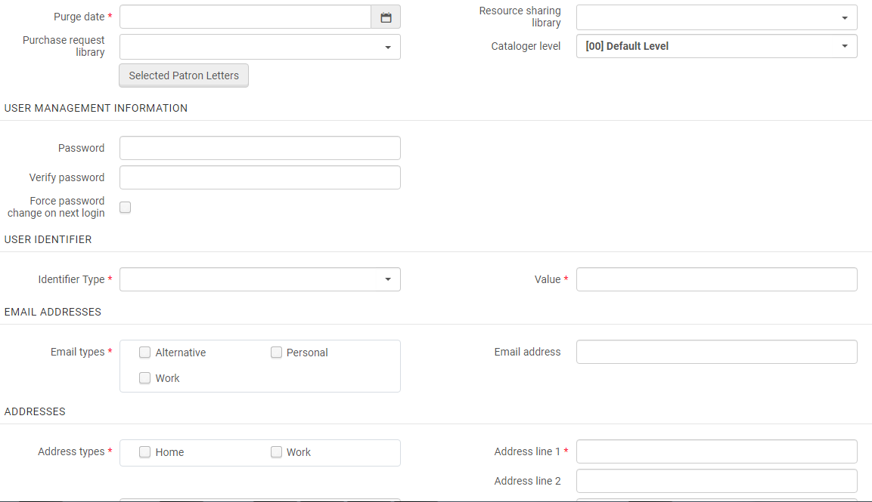
Give the person a temporary password, and click the “force password change on next login box.” The first time a person logs into their account, they will be prompted to change it to a word only that person will know.
The expiration date is three years after a person received their library card. The purge date is also three years.
This is for libraries where people have more than one identifier, like a student information system. It doesn’t apply to our library.

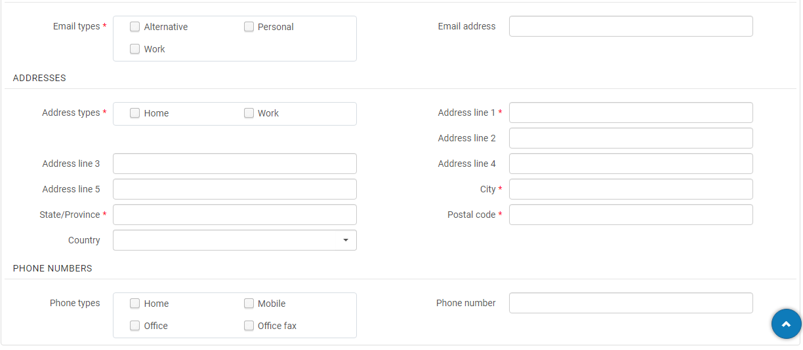
Add the work e-mail address of the patron, and click on the box next to Work on Email Types. If a courtesy card patron doesn’t have an e-mail account, give them the circulation e-mail address. If we get an e-mail about a problem, give them a call.

Our applications have both a home and work address attached to them. You will only be able to add one while finishing this page. So, click on Work, and add in the information.

You also may only include one phone number at a time. So, choose one box to click, and enter the number.

Then, go back up to the top and click Save and Continue.
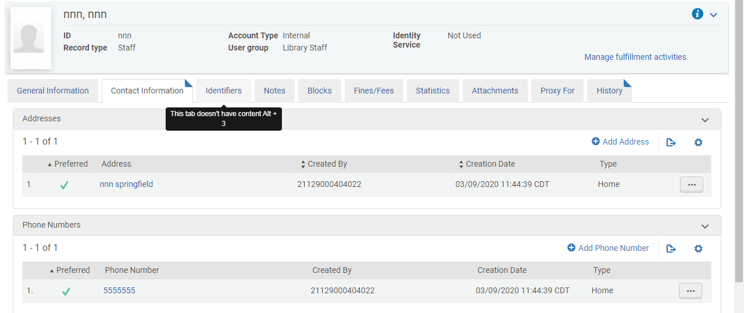
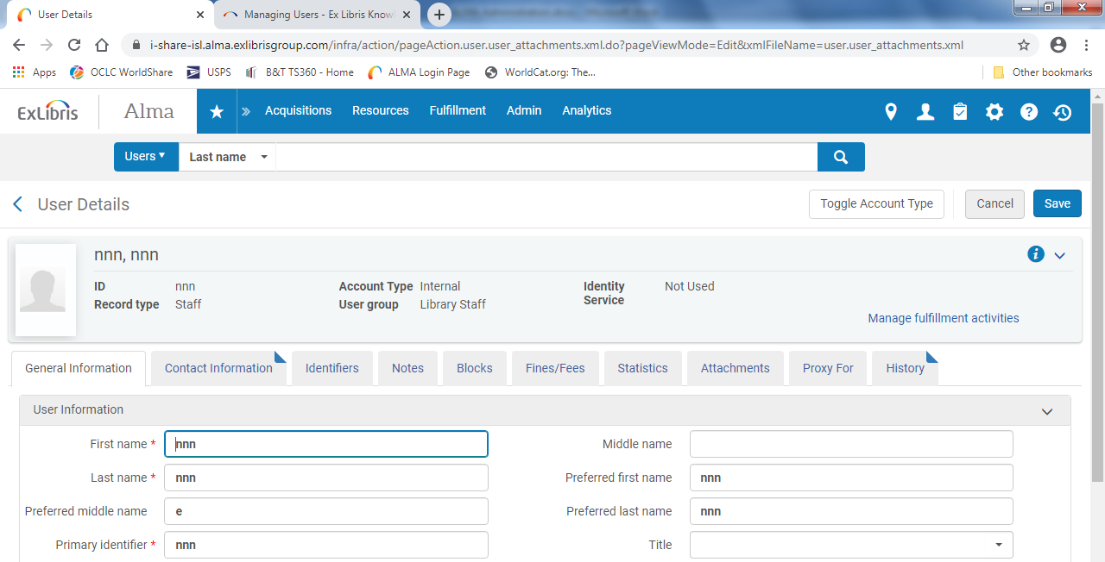
Click on Add Address or Add Phone Number.
Your profile should now look like this at the top. The next step is adding in the other addresses and phone numbers associated with the account. You can do this by clicking on the box that says Contact Information.

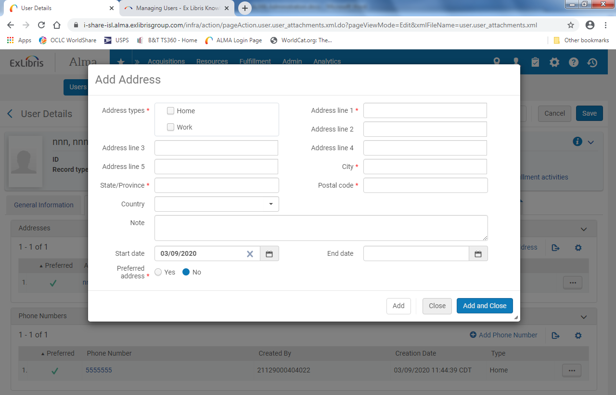
Add the information in, and then click Add and Close. Do the same with the additional phone numbers.

