Adding Extra Books to a Patron’s Request
Sometimes, a patron may want a multi-volume set of materials, but only put it in the note section of an electronic request for one of the books in the set. (We have discovered that not all multi-volume materials have individual barcodes for each book.) Or, they will request a book that comes in two volumes but they are not individually barcoded. This procedure will show you how to check those books out to a patron so that they can get all of the materials that they need. If a record is correct, a multi-volume set will display with each item available to request separately. If you have an issue with a set, make a note to inform a cataloger that the item’s record needs correcting.
Print the request slip as usual, and have the shelver pull all of the items in the series.

Scan in the item, as usual, and do not click off the page.

After getting the number, go to the Fulfillment Tab, and click on Manage Patron Services.
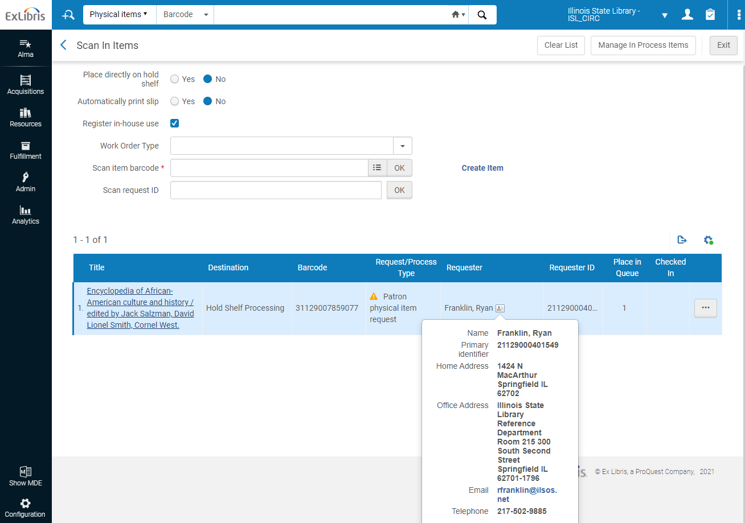
Go to the Fulfillment tab, and click on Manage Patron Services.
Click on the requester information, and copy their Primary Identifier. You can also find this number on the call slip.

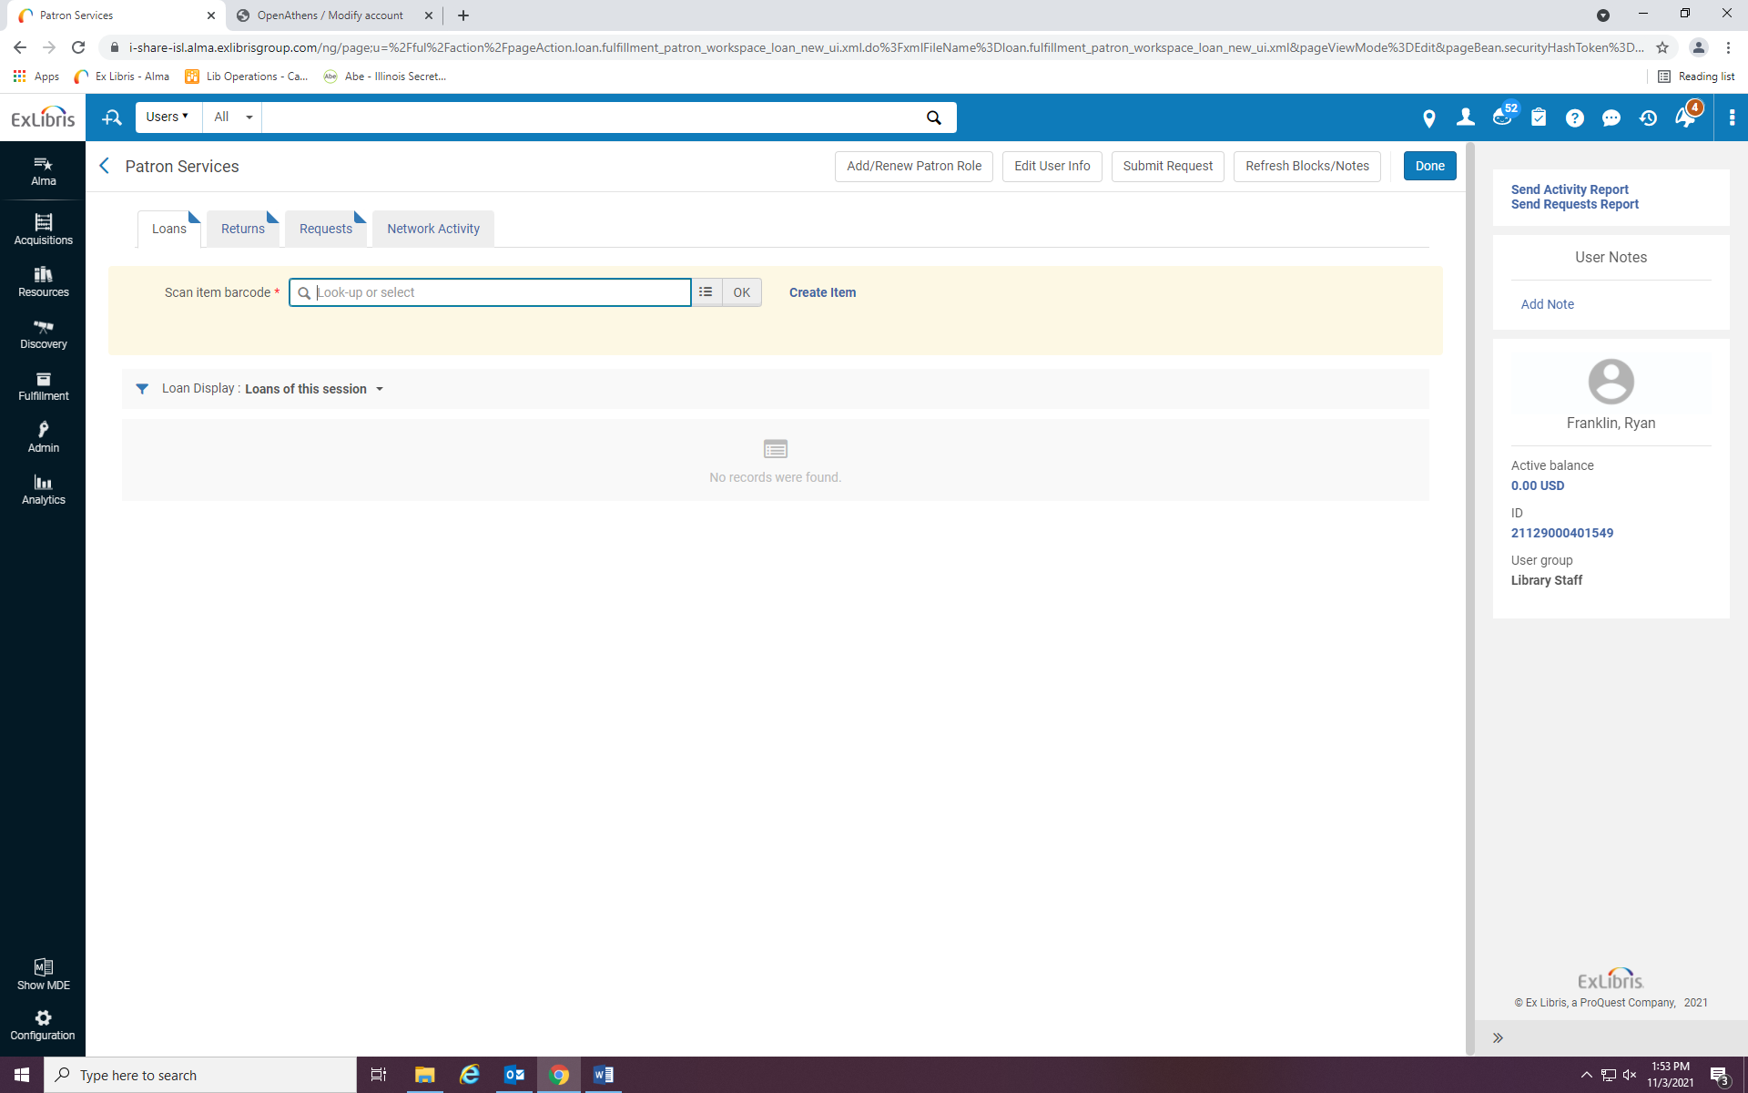
Scan the items in the field, and send them with the first item that has a transit letter to go with it.
Insert the patron’s primary identifier number in the field, and click on the account.

Scan the items into the field, and send the materials with the first item that has the transit slip with it.

