Springer Autoloader Implementation Instructions

1. Obtaining the Institutional Token:
a. Log on to the Springer administration portal with your admin credentials: https://adminportal.springer.com/.
b. Open the Title Lists page.
c. The token is listed under the Automated title list updates / automatic collection loading heading. No action is needed to create the token since it is automatically created for the institution.

2. In KBManager, activate the dedicated targets and their getFullTxt target services:
- SPRINGER_LINK_BOOKS_AUTOLOAD‐getFulltxt
- SPRINGER_LINK_JOURNALS_AUTOLOAD‐getFulltxt

If you only get journals or only ebooks, then just activate the one appropriate target.

3. In the Edit Target Service window, click on the “Autoload tab.”
Edit Target Service Window
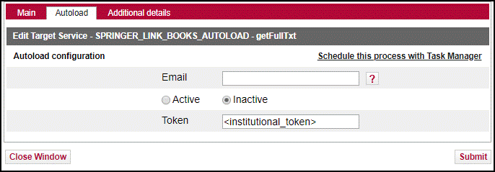
a. Add your email to the section “Email.”
b. Click on circle before “Active.”
c. Enter institutional token from Springer in Token field.
d. Click “Submit” to save.
e. While present, the “Schedule this process…” will do nothing. See #5.

4. Optional but recommended: Set up display logic rule:
If available: SPRINGER_LINK_..._AUTOLOAD_xxx getFullTxt
Do not show: SPRINGER_LINK* getFullTxt

This rule prevents patrons from seeing duplicate targets in the SFX menu during the transition period. XXX is for either the Journals or Books target (or both) you have just activated.

5. Send to support@carli.edu a request to start the autoload process: Answer these questions:
a. Do you want the journals or books load or both?
b. How frequently do you want the loads after the first test load? Once a month is recommended.

6. CARLI staff will run autoload options from the Server Admin Utility. You will get log files of the run to help evaluate the results.

After testing, CARLI staff will set up a scheduled task to run the Automated load regularly.

Note: You can use KBTools > Collection tool from the SFX Admin Center to compare the activation and thresholds between the new autoload targets and the previously manually activated targets. This allows you to check that all activations are now in place in the new dedicated Springer targets.
Deactivate the old, manually activated targets and portfolios after successful testing and implementing the autoloading targets.

More info in: SFX General Users Guide, Target services editing starting on p. 59, as of 11/7/2018. Available at
https://knowledge.exlibrisgroup.com/SFX/Product_Documentation/01_Version_4.0
Or https://knowledge.exlibrisgroup.com/SFX/Knowledge_Articles/Using_the_Springer_AutoLoader_for_SFX

