Reporting Agency Data: Reporting Period and Data Due Dates

Factbook [Internal SIUE]
Reporting Period: FY – Alma Analytics data could be ran out on July 1, or scheduled for July 1 for the coming years

Due to SIUE Institutional Research by mid-December every year, he emails us in advance of the data needing reported.

Definitions/Instructions: Provided by SIUE Institutional Research via email to LIS Administration ([mostly] matches the data points needed for IPEDS reporting)

ACRL
Reporting Period: Report all data for fiscal year (FY) 2021. Fiscal year 2021 is defined as the most recent 12-month period that ends before October 1, 2021, that corresponds to the institution’s fiscal year.

Due: Data due to ACRL by February 28, 2022

Definitions/Instructions: https://acrl.libguides.com/ld.php?content_id=64701014

IPEDS
Reporting Period: FY, although they slice the categories of data to be turned in by institutions to be turned in various yearly quarters.

Due: March 25, 2022 internally at SIUE

Definitions/Instructions: https://surveys.nces.ed.gov/ipeds/public/survey-materials/instructions?instructionid=30103

IL Traffic Survey
FY reporting period, due March 31, 2022

https://www.ilsos.gov/departments/library/libraries/ill_survey.html

ACRL/IPEDS: Physical and Electronic Collections and Materials Data In Alma Analytics 202202

Books – Titles:
ACRL Definition: 40 Column A. Physical Books (Include Government Documents)
Report physical book titles owned or leased by the library if individual titles are cataloged and/or searchable through the
library catalog or discovery system. Exclude serials, microforms, maps, nonprint materials, and uncatalogued items.
Include music scores if searchable by title through the library catalog or discovery system.
Include government documents that are accessible through the library's catalogs regardless of whether they are separately classified and/or shelved. “Cataloged” includes documents for which records are provided by the library or downloaded from other sources into the library’s card or online catalogs or discovery system. Government documents include local, state, regional, federal, and international.
Include open access titles if the individual titles are searchable through the library’s catalog or discovery system.

IPEDS Definition: Physical Books (include government documents) - Report physical book titles owned or leased by the library if individual titles are cataloged and/or searchable through the library catalog or discovery system. Exclude serials, microforms, maps, nonprint materials, and uncataloged items. Include music scores if searchable by title through the library catalog or discovery system. Include government documents that are accessible through the library's catalogs regardless of whether they are separately classified and/or shelved. "Cataloged" includes documents for which records are provided by the library or downloaded from other sources into the library catalog or discovery system.

Location, Type, Name
Alma Analytics, SIUE Folder, Dashboards, ACRL/IPEDS Dashboard

Alma Analytics Report Used:
ACRL 40a.Column1: Library Collections, Books [volume count] Physical
Location: Alma Analytics, SIUE shared folder, ACRL/IPEDS folder --> Report shown below:

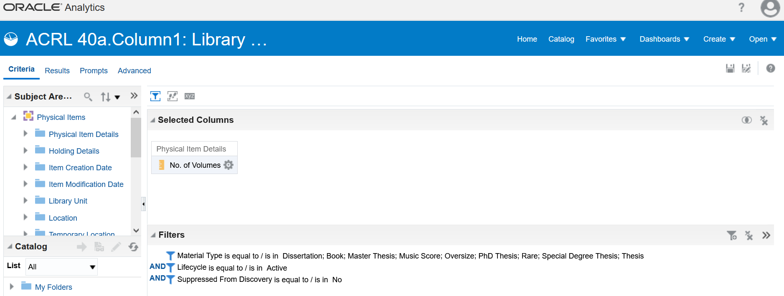

Media – Titles
ACRL Definition: 42 Column A. Physical Media
Report the number of titles of media materials. Include microforms, audiovisual materials, cartographic materials, graphic materials, and three-dimensional artifacts realia.
Additional guidance:
● IPEDS and ACRL view physical media as more inclusive than just audio and visual resources. For example,
IPEDS identifies microforms as physical media rather than physical books. Maps in print are also counted inthis
section as physical media rather than physical books. Microforms and maps are specifically excluded from the
physical books count in question 40.
● Count microform titles not, for example, the number of boxes of microfilm rolls.
● If your library has any media serials, do not include them here; include them only in the serials count.
● If a media title is broken into two containers for circulation purposes, it would count as one title forphysical
media collection.
● Microforms are photographic reproduction of textual, tabular, or graphic material reduced in size so that theycan
be used only with magnification. Examples of microforms are roll microfilm, aperture cards, microfiche,
ultrafiche, and reproductions on opaque material.
● Cartographic materials represent in whole or in part the earth or any celestial body at any scale (e.g., maps and
charts).
● Graphic materials are defined as: “Opaque (e.g., two-dimensional) art originals and reproductions, charts,
photographs or materials intended to be projected or viewed without sound, e.g., filmstrips, transparencies,
photographs, posters, pictures, radiographs, slides, and collections of such materials.” [NISO Z39.7-2013, section
4.6]

IPEDS Definition: Physical Media – Report the number of titles of media materials. Include microforms, audiovisual materials, cartographic, and graphic materials and three-dimensional artifacts and realia.

Location, Type, Name

Alma Analytics Report Used:
ACRL 42.Column 1: Library Collections, Media/Physical:

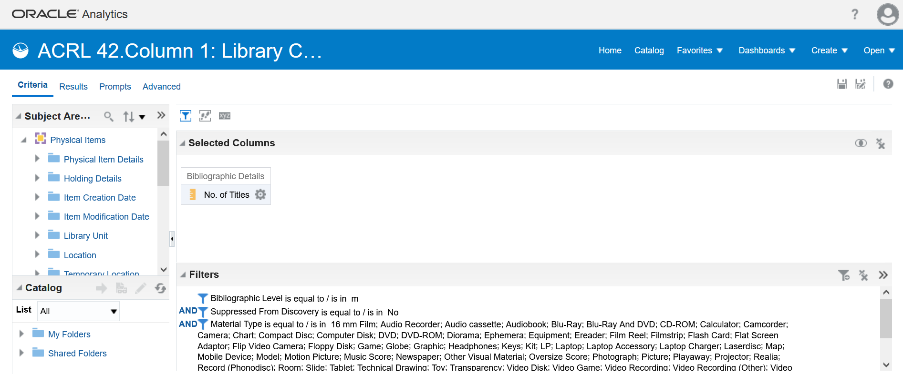

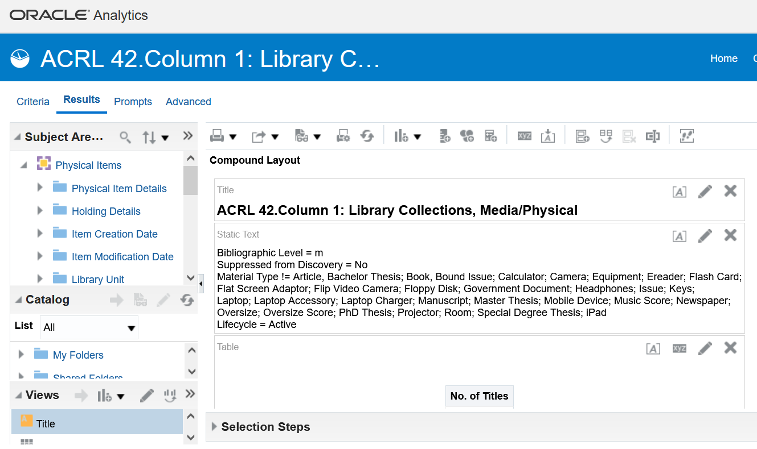

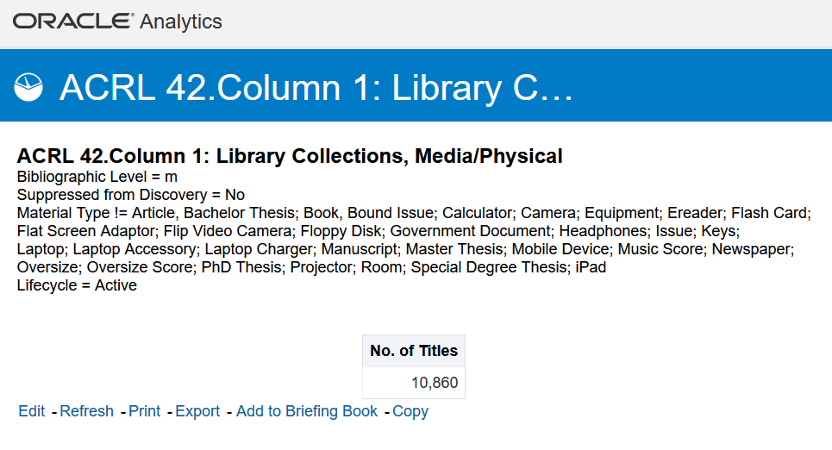
Serials – Titles
ACRL Definition: 43 Column A. Physical Serials
Report the number of current and ceased physical serial titles that are accessible through the library’s catalog or discovery system. A serial is a publication in any medium issued in successive parts bearing numerical or chronological designations and intended to be continued indefinitely. This definition includes, in any physical format, periodicals, serial titles on microform, newspapers, and annuals (reports, yearbooks, etc.); the journals, memoirs, proceedings, transactions, etc. of societies; and numbered monographic series.
Report serial titles, not subscriptions.
If possible, report the count of only those de-duplicated or otherwise unique serial titles searchable through the library’s
catalog or discovery system.
If possible, do not include earlier title changes; however, do not worry about removing them if it is not possible/feasible.

IPEDS Definition: Physical Serials – Report the number of physical serial titles that are accessible through the library's catalog or discovery system. A serial is a publication in any medium issued in successive parts bearing numerical or chronological designations and intended to be continued indefinitely. This definition includes, in any physical format, periodicals, serial titles on microform, newspapers, and annuals (reports, yearbooks, etc.); the journals, memoirs, proceedings, transactions, etc. of societies; and numbered monographic series. Report serial titles, not subscriptions. If possible, report the count of only those de-duplicated or otherwise unique serial titles searchable through the library's catalog or discovery system. If possible, do not include earlier title changes; however, do not worry about removing them if it is not possible/feasible.

Location, Type

Alma Analytics Reports Used:
ACRL 43.Column1: Physical Serials:

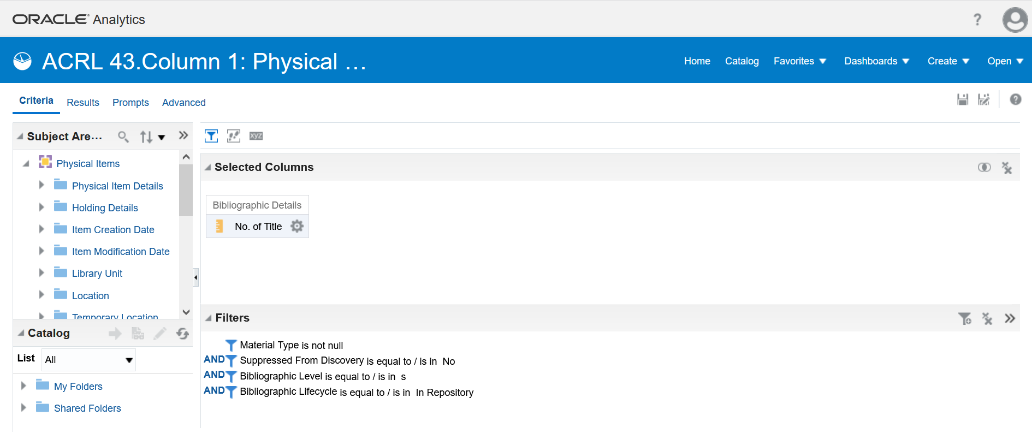

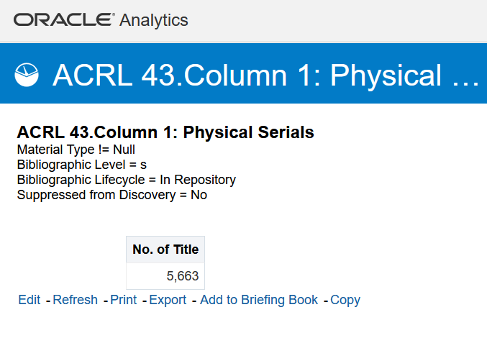

Digital/Electronic Materials: In Alma Analytics

Books – Titles
ACRL Definition: 40 Column B. Digital/Electronic Books (Include Government Documents)
E-books are digital documents (including those digitized by the library), licensed or not, where searchable text is
prevalent, and which can be seen in analogy to a printed book (monograph). Report the number at the administrative
entity level; do not duplicate unit count for each branch.
Include:
● E-book titles owned or leased by the library if individual titles are cataloged and/or searchable through the library
catalog or discovery system.
● E-book titles in aggregated sets in which the library selected the aggregator even if not each individual e-book
title.
● Government documents, locally digitized electronic books and electronic theses and dissertations.
● Digital music scores if searchable by title through the library catalog or discovery system.
● Open access titles if the individual titles are searchable through the library’s catalog or discovery system.
Exclude:
● E-book titles from Hathi Trust, Center for Research Libraries, Internet Archive, and similar collections unless the
library owns the digitized item and it is accessible under current copyright law.
● E-book titles in demand-driven acquisition (DDA) or patron-driven acquisition (PDA) collections until they have
been purchased by the library.
Additional guidance:
● Count each e-book title as a single title, regardless of its number of user seats.
● If possible, do not report duplicate titles even if the titles are in two or more databases or services. Report the titles
based upon the cataloged bibliographic record rather than holdings records attached to the bibliographic record.
● E-book titles may be found through the library’s link resolver knowledge base in addition to the catalog or
discovery system.
● A dissertation database such as ProQuest Dissertation & Theses Database is reported as a database.

IPEDS Definition: Digital/Electronic Books, (include government documents) – Report e-book titles owned or leased by the library if individual titles are cataloged and/or searchable through the library catalog or discovery system. Examples of discovery systems can be found at https://librarytechnology.org/discovery/. E-books are digital documents (including those digitized by the library), licensed or not, where searchable text is prevalent, and which can be seen in analogy to a printed book (monograph). Include e-book titles in aggregated sets in which the library selected the aggregator, even if not listed by each individual e-book title. Report the number at the administrative entity level; do not duplicate unit count for each branch. Include government documents, locally digitized electronic books and electronic theses and dissertations. Include digital music scores if searchable by title through the library catalog or discovery system. Include open access (OA) titles if the individual titles are searchable through the library's catalog or discovery system. Do not count e-book titles from Hathi Trust, Center for Research Libraries, Internet Archive, and similar collections unless the library owns the digitized item and it is accessible under current copyright law. Do not include titles in Demand-Driven Acquisition (DDA) or Patron-Driven Acquisition (PDA) collections until they have been purchased by the library.

Location, Type

Alma Analytics Reports Used:
ACRL 40, Column2: Library Collections, Books (title count) Electronic
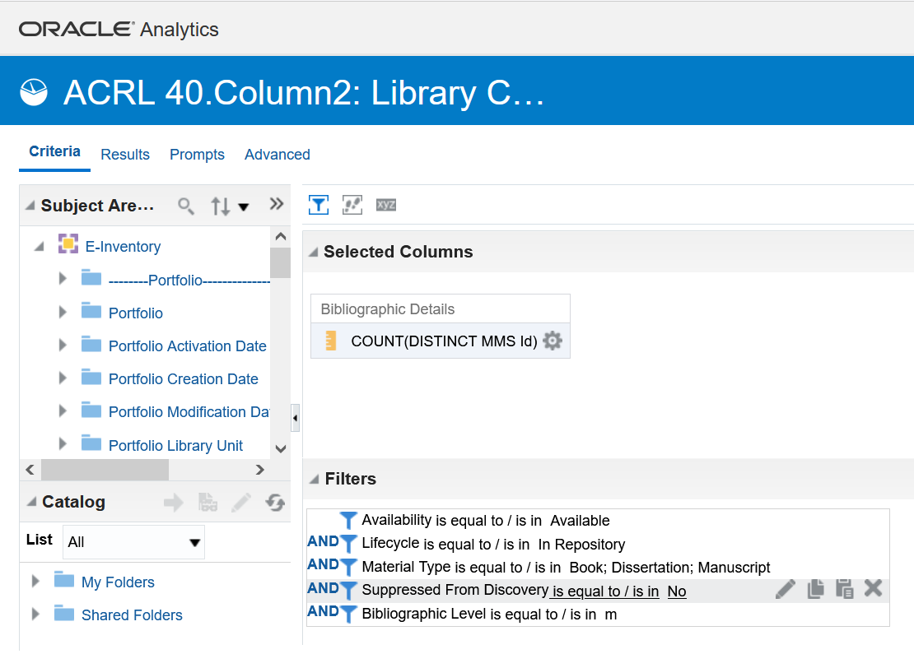
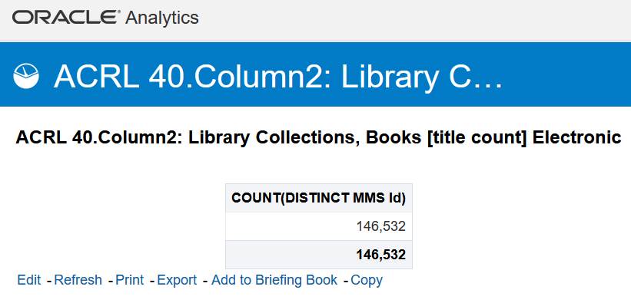

Media – Titles
ACRL Definition: 42 Column B. Digital/Electronic Media
Report titles of e-media materials owned or leased by the library if the individual titles are cataloged and/or searchable
through the library catalog or discovery system. E-media materials are media materials that are in digital format and are
available for download or streaming. For example, titles from Films on Demand or Alexander Street Press should be
reported.
Include digital graphic materials and cartographic materials. Include e-media titles in aggregated sets in which the library
selected the aggregator even if not each individual title.
Report the number at the administrative entity level; do not duplicate unit count for each branch.
Do not count image databases (Artstor, AP Photo Archive) in this category (these resources should be counted as
databases). Do not include titles in demand-driven acquisition (DDA) or patron-driven acquisition (PDA) collections until
they have been purchased or leased by the library.
Additional guidance:
● Include open access titles if they are searchable through the library's catalog or discovery system.
● Exclude serials.
● E-media titles may be found through the library’s link resolver knowledge base in addition to the catalog or discovery system.
IPEDS Definition: Digital/Electronic Media - Report titles of e-media materials owned or leased by the library, if the individual titles are cataloged and/or searchable through the library catalog or discovery system. E-media materials are media materials that are in digital format and are available for download or streaming. For example, titles from Films on Demand or Alexander Street Press should be reported. Include digital graphic materials and cartographic materials. Include e-media titles in aggregated sets in which the library selected the aggregator, even if not listed by each individual title. Report the number at the administrative entity level; do not duplicate unit count for each branch. Do not count image databases (ARTStor, AP Photo Archives) in this category; count as databases. Do not include titles in Demand-Driven Acquisition (DDA) or Patron-Driven Acquisition (PDA) collections until they have been purchased or leased by the library.

Location, Type

Alma Analytics Reports Used:
ACRL 42. Column: 2, Library Collections, Media/Electronic, plus Naxos Music Library titles and Kanopy titles directions from Neil for Retrieving: active Kanopy licenses (documentation from Neil) (Add all three data points together for the total for this data)

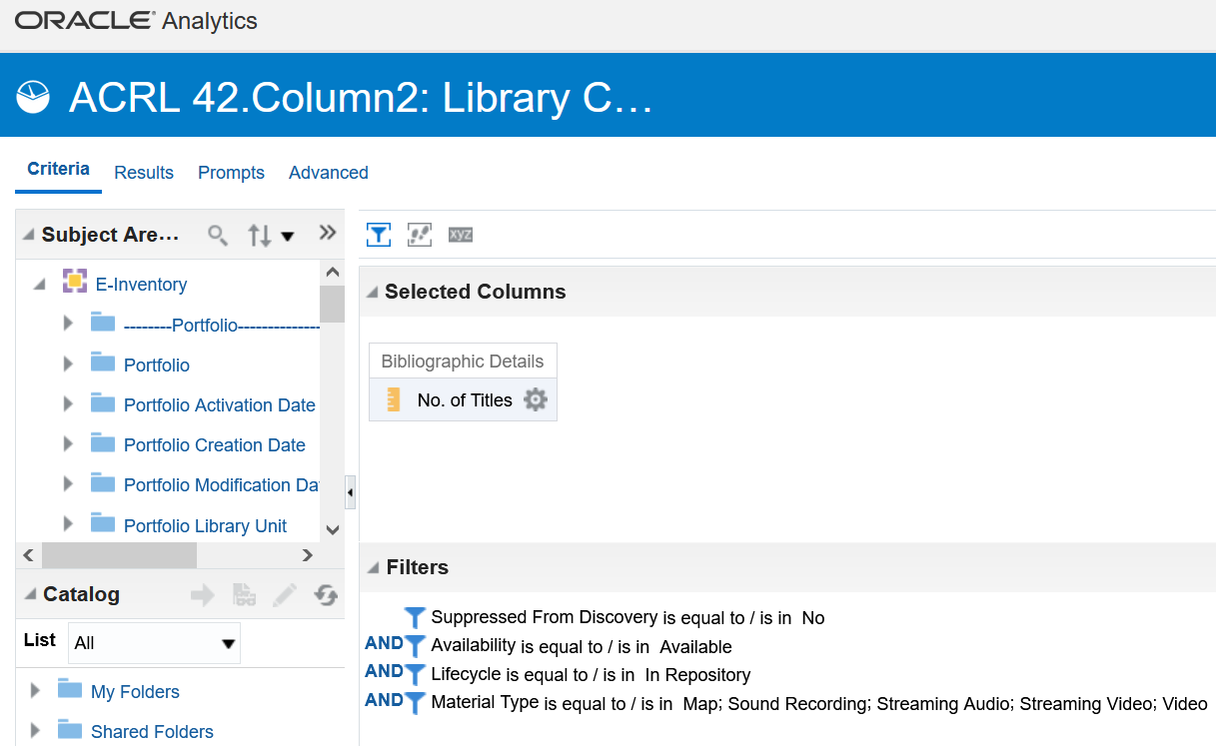

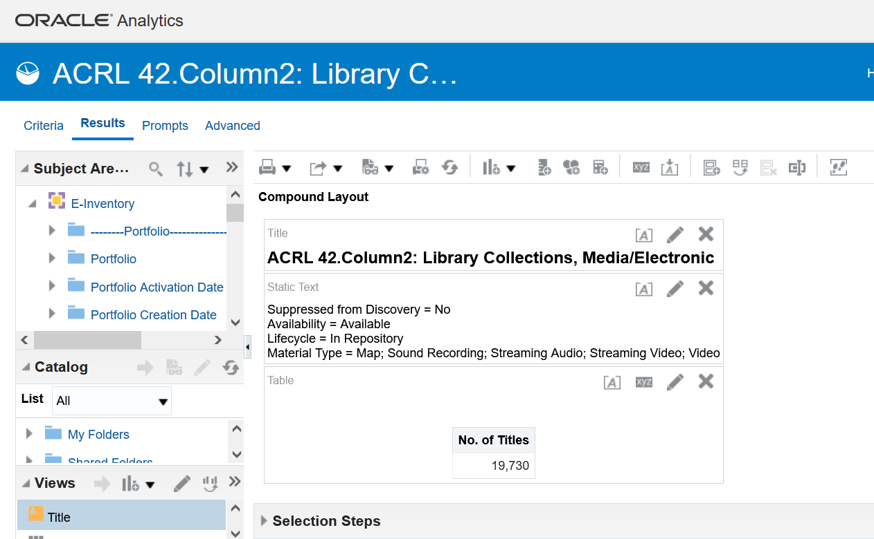

Serials – Titles
ACRL Definition: 43 Column B. Digital/Electronic Serials [** with New IPEDS Instructions **]
Report the number of current and ceased e-serial titles that are accessible through the library’s catalog, discovery system or other technical means.
An e-serial is a periodical publication issued in successive parts bearing numerical or chronological designations, is
intended to be continued indefinitely, and is published in digital form to be displayed on a computer screen in any
medium. This definition includes digital and digitized periodicals, newspapers, and annuals (reports, yearbooks, etc.); the
journals, memoirs, proceedings, transactions, etc. of societies; and numbered monographic series.
If possible,
● report the count of only those de-duplicated or otherwise unique e-serial titles.
● include ceased electronic serial titles.
● do not count earlier title changes; however, do not worry about removing them if it is not possible/feasible. A
source for counting e-serials may be a library- or vendor-developed A-Z title list of e-journals.
Include open access titles if the individual titles are searchable through the library’s catalog or discovery system, except
do not count e-serial titles from Hathi Trust, Center for Research Libraries, Internet Archive, and similar collections unless the library owns the digitized item, and it is accessible under current copyright law.
Report serial titles, not subscriptions. E-serial titles may be found through the library’s link resolver knowledge base in
addition to the catalog or discovery system.
IPEDS Definition: Digital/Electronic Serials - Report the number of e-serial titles that are accessible through the library’s catalog, discovery system or other technical means.
An e-serial is a periodical publication issued in successive parts bearing numerical or chronological designations, is intended to be continued indefinitely, and is published in digital form to be displayed on a computer screen in any medium. This definition includes digital and digitized periodicals, newspapers, and annuals (reports, yearbooks, etc.); the journals, memoirs, proceedings, transactions, etc. of societies; and numbered monographic series.
If possible,
- report the count of only those de-duplicated or otherwise unique e-serial titles.
- include ceased electronic serial titles.
- do not count earlier title changes; however, do not worry about removing them if it is not possible/feasible. A source for counting e-serials may be a library- or vendor-developed A-Z title list of e-journals.
Include open access (OA) titles if the individual titles are searchable through the library's catalog or discovery system, except do not count e-serial titles from HathiTrust Center for Research Libraries, Internet Archive, and similar collections unless the library owns the digitized item and it is accessible under current copyright law.
Location, Type

Alma Analytics Reports Used: ACRL 43. Column 2: Digital/Electronic Serials

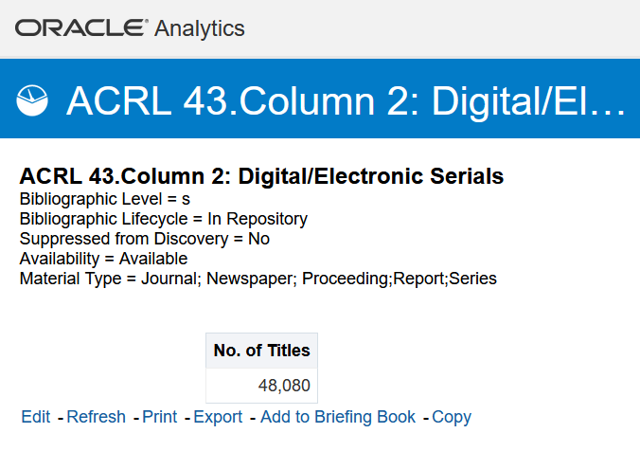

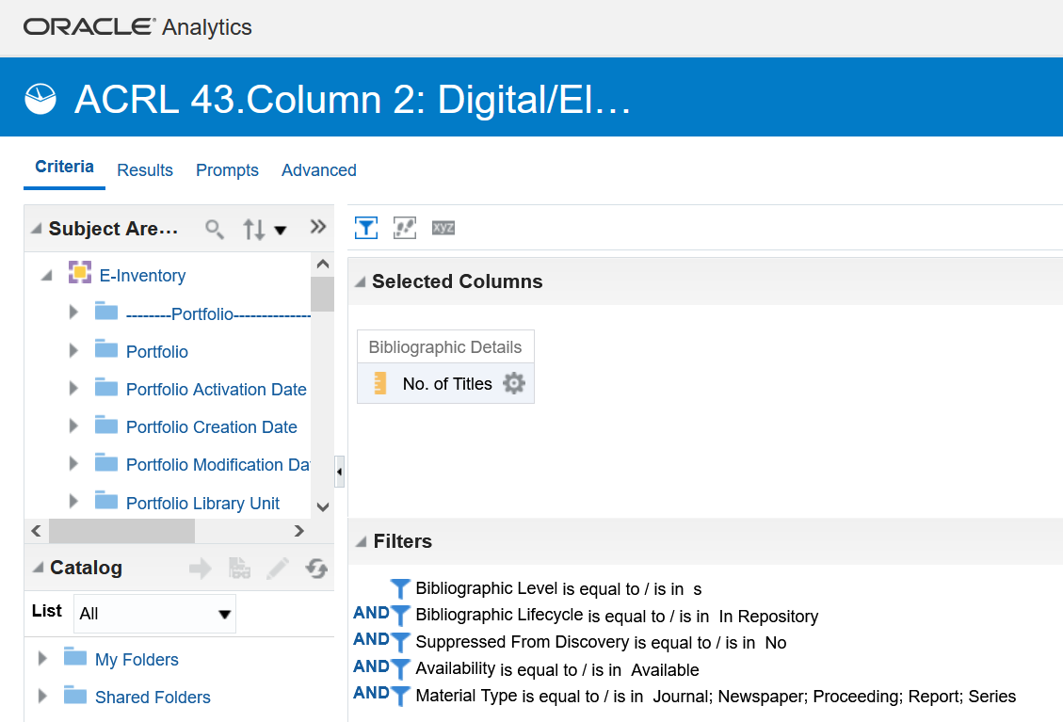

Databases – total count
ACRL Definition: 41. Digital/Electronic Databases
Report the total number of licensed digital/electronic databases in your collection if there is bibliographic or discovery
access at the database level. Each database is counted individually even if access to several databases is supported through the same vendor interface.
A database is a collection of electronically stored data or un it records (facts, bibliographic data, or texts) with a common
user interface and software for the retrieval and manipulation of the data. The data or records are usually collected with
intent and relate to a defined topic.
Do not include discovery systems in the count of databases. Do not include "individual releases" such as annual updates
of content or the migration of the user interface to the next vendor-release (i.e., interface version 3.0 replaces version 2.0) as separate databases.
Additional guidance:
● Include open access databases if they are searchable through the library's catalog or discovery system.
● Consider a resource a database if the user links to the content as a whole and then selects individual resources
within the database that best serves their needs.
● Include e-book databases but also report the individual e-book titles within the database separately under question
40 Column B. Digital/Electronic Books.

IPEDS Definition:

Neil’s communication about how he calculates this number
FY21 Database Count Spreadsheet

Total Circulations (Physical Collections AND Digital Collections, separated)

Physical Collections Circulation
ACRL Definition: 60 Column A. Total Physical Circulation
Report the total number of times physical items are checked out from the general and reserve collections. Include only
initial checkouts (circulation), not renewals. Exclude interlibrary loan lending and borrowing.
Include transactions of books, media, and serials. Do not include transactions of equipment or computers. However,
circulation of electronic reading devices (e.g., Kindles) can be included if the device is pre-loaded with e-books. For
example, if a customer checks out a Kindle that is pre-loaded with 20 e-books, then that transaction counts as 1 physical
circulation, not 20 electronic/digital circulations.
Do not include in-house circulation (items that library personnel pick up from tables and carrels and then scan to track in-house use) with circulation.
IPEDS Definition: Total Physical Circulation - Report the total number of times physical items are checked out from the general and reserve collections. Include only initial checkouts (circulation), not renewals. Exclude interlibrary loan lending and borrowing. Include transactions of books, media, and serials. Do not include transactions of equipment or computers. However, circulation of electronic reading devices (e.g., Kindles) can be included if the device is pre-loaded with e-books. For example, if a customer checks out a Kindle that is pre-loaded with 20 e-books, then that transaction counts as 1 physical circulation, not 20 electronic/digital circulations.

Location/Name

Physical Circulations (FY21): 5943
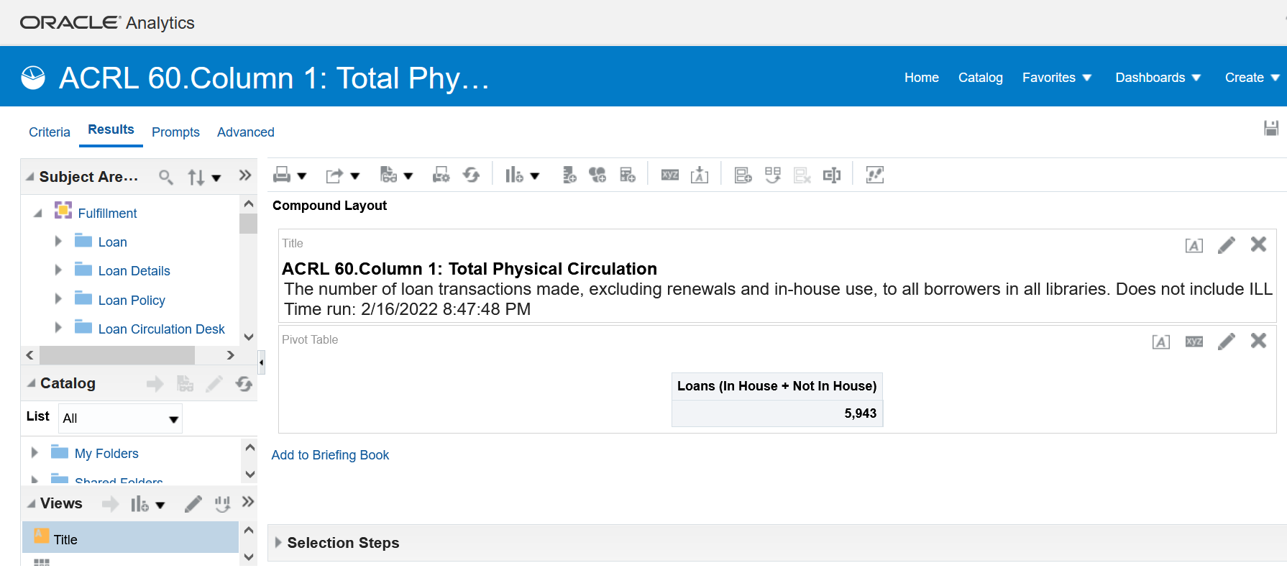

Digital Circulations (FY21):
ACRL Definition: 60 Column B. Total Digital/Electronic Circulation or Usage [** with New IPEDS Instructions **]
Report usage of digital/electronic titles whether viewed, downloaded, or streamed.
Include usage for e-books, e-serials, and e-media titles even if they were purchased as part of a collection or database.
Exclude:
● Institutional repository documents, which are reported separately.
● Usage of titles in demand-driven acquisition (DDA) or patron-driven acquisition (PDA) collections until they have been
purchased or leased by the library.
● Transactions of VHS, CDs, or DVDs, as the transactions of these materials are reported under “physical circulation.”
Most vendors will provide usage statistics in COUNTER reports. As of January 2019, Release 5 became the current Code
of Practice (see Project COUNTER Release 5 Code of Practice
[https://www.projectcounter.org/wpcontent/uploads/2019/11/Release_5_for_Providers_20191030.pdf]). Relevant
COUNTER Release 5 reports for e-books are: TR_B1: Book Requests (Excluding OA_Gold). As to the COUNTER 5
metric type for e-books, report “unique title requests.” For e-media, use IR_M1: Multimedia Item Requests, report metric type for “total_item_requests” is the most relevant. If you have access to COUNTER Release 5 reports and can provide an answer for 60 Column B, skip questions 61 and 62 and leave them blank.
Updated in ACRL Trends & Statistics Instructions on February 26, 2021:
If COUNTER Release 5 reports are unavailable and if COUNTER Release 4 reports are available, IPEDS suggest that
libraries report counts from BR1 and MR1. If BR1 and MR1 statistics are not available, BR2 and MR2 statistics can be
used. In cases where vendors do not provide COUNTER reports, libraries may report using other means for monitoring
digital/electronic circulation/usage (downloads, session views, transaction logs, etc.).
Report usage of e-serial titles whether viewed, downloaded, or streamed. Include usage for e-serial titles only, even if the title was purchased as part of a database. Viewing a document is defined as having the full text of a digital document or electronic resource downloaded. [NISO Z39.7-2013, section 7.7] If available, include the count for open access e-journal usage if the title is accessible through the library’s catalog or discovery system.
Libraries may need to ask vendors for e-serial usage reports; reports may not be delivered automatically or in easily-
understood formats by the vendor to the library. Most vendors will provide usage statistics in COUNTER Release 5
reports. The most relevant COUNTER Release 5 report for e-serial usage is TR_J1: Journal Requests (Excluding
OA_Gold). For the metric type, report “unique item requests.” If COUNTER Release 5 reports are unavailable, the most
relevant COUNTER Release 4 report is JR1 (defined as the "Number of Successful Full-Text Article Requests by Month
and Journal").
Applicable COUNTER Release 5 definitions:
• Article: “An item of original written work published in a journal, other serial publication, or in a book.”
• Database: “A collection of electronically stored data or unit records (facts, bibliographic data, texts) with a
common user interface and software for the retrieval and manipulation of data (NISO)”
• Full-Text Article: "The complete text, including all references, figures and tables, of an article, plus links to
any supplementary material published with it.”
• Open access: “Online research outputs that are free of all restrictions on access (e.g. access tolls) and free of
many restrictions on use (e.g. certain copyright and license restrictions). Open access can be applied to all
forms of published research output, including peer-reviewed and non-peer-reviewed academic journal
articles, conference papers, theses, book chapters, and monographs.
In cases where vendors do not provide COUNTER reports, libraries may report using other means for monitoring digital/
electronic circulation/usage (downloads, session views, transaction logs, etc.), or report zero. An electronic resource
management system (ERMS) and/or a usage consolidation service may be helpful for collecting e-serial usage statistics.
Do not include usage of titles in Demand-Driven Acquisition (DDA) or Patron-Driven Acquisition (PDA) collections
until they have been purchased or leased by the library.
End of updated instructions.
Additional guidance:
● Libraries may need to ask vendors for usage reports; reports may not be delivered automatically or in easily
understood formats by the vendor to the library.
● Viewing documents is defined as having the full text of a digital document or electronic resource downloaded.
[NISO Z39.7-2013, section 7.7]
● An electronic resource management system (ERMS) and/or a usage consolidation service may be helpful for
collecting e-book usage statistics.
● Add notes as appropriate.
IPEDS Definition: Total Digital/Electronic Circulation or Usage – Report usage of digital/electronic titles whether viewed, downloaded, or streamed. Do not include institutional repository documents.
Include usage for e-books and e-media titles only, even if the title was purchased as part of a database. Do not include usage of titles in Demand-Driven Acquisition (DDA) or Patron-Driven Acquisition (PDA) collections until they have been purchased or leased by the library. Do not include transactions of VHS, CDs, or DVDs, as the transactions of these materials are reported under "physical circulation.
Most vendors will provide usage statistics in COUNTER reports. As of January 2019, Release 5 became the current Code of Practice (see Project COUNTER Release 5 Code of Practice [https://www.projectcounter.org/wp-content/uploads/2019/11/Release_5_for_Providers_20191030.pdf]). Relevant COUNTER Release 5 reports for e-books are: TR_B1: Book Requests (Excluding OA_Gold). As to the COUNTER 5 metric type for e-books, report “unique title requests.” For e-media, use IR_M1: Multimedia Item Requests, report metric type for “total_item_requests” is the most relevant.
If COUNTER Release 5 reports are unavailable and if COUNTER Release 4 reports are available, IPEDS suggest that libraries report counts from BR1 and MR1. If BR1 and MR1 statistics are not available, BR2 and MR2 statistics can be used. In cases where vendors do not provide COUNTER reports, libraries may report using other means for monitoring digital/electronic circulation/usage (downloads, session views, transaction logs, etc.).
Report usage of e-serial titles whether viewed, downloaded, or streamed. Include usage for e-serial titles only, even if the title was purchased as part of a database. Viewing a document is defined as having the full text of a digital document or electronic resource downloaded. [NISO Z39.7-2013, section 7.7] If available, include the count for open access e-journal usage if the title is accessible through the library’s catalog or discovery system.
Libraries may need to ask vendors for e-serial usage reports; reports may not be delivered automatically or in easily- understood formats by the vendor to the library. Most vendors will provide usage statistics in COUNTER Release 5 reports. The most relevant COUNTER Release 5 report for e-serial usage is TR_J1: Journal Requests (Excluding OA_Gold). For the metric type, report “unique item requests.” If COUNTER Release 5 reports are unavailable, the most relevant COUNTER Release 4 report is JR1 (defined as the "Number of Successful Full-Text Article Requests by Month and Journal").
Applicable COUNTER Release 5 definitions:
Article: “An item of original written work published in a journal, other serial publication, or in a book.”
Database: “A collection of electronically stored data or unit records (facts, bibliographic data, texts) with a common user interface and software for the retrieval and manipulation of data (NISO)”
Full-Text Article: "The complete text, including all references, figures and tables, of an article, plus links to any supplementary material published with it.”
Open access: “Online research outputs that are free of all restrictions on access (e.g. access tolls) and free of many restrictions on use (e.g. certain copyright and license restrictions). Open access can be applied to all forms of published research output, including peer-reviewed and non-peer-reviewed academic journal articles, conference papers, theses, book chapters, and monographs.
In cases where vendors do not provide COUNTER reports, libraries may report using other means for monitoring digital/ electronic circulation/usage (downloads, session views, transaction logs, etc.), or report zero. An electronic resource management system (ERMS) and/or a usage consolidation service may be helpful for collecting e-serial usage statistics. Do not include usage of titles in Demand-Driven Acquisition (DDA) or Patron-Driven Acquisition (PDA) collections until they have been purchased or leased by the library.

2022 Data Collection: Manual (will need to tie in SUSHI data to achieve utilizing an Alma Analytics report for this one):
This data point will need ran out manually in the database admin modules, per the types of reports available: this spreadsheet will help inform this work: https://siuecougars.sharepoint.com/:x:/t/LibraryandInformationServices/EZWILIO82XlDhREzRX7TXUoB1-Tme1u-6by1-tfEoSZ2zg?e=Il8EkR

Cross unit LIS Data Collections Crosswalk, for Reporting Agency Data: (also noted on the LIS ACRL worksheet for FY21)

LIS Administration: Business Manager: ACRL data points, informs IPEDS data points

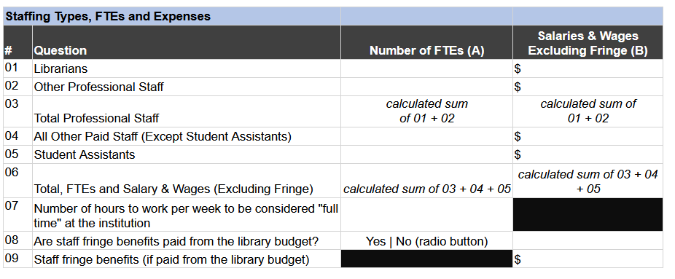
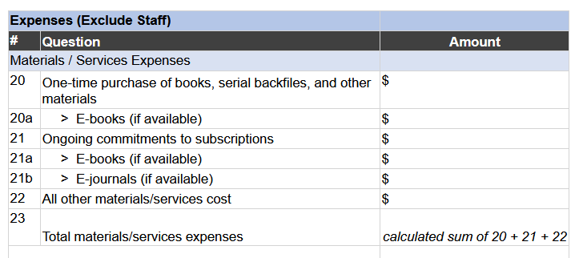
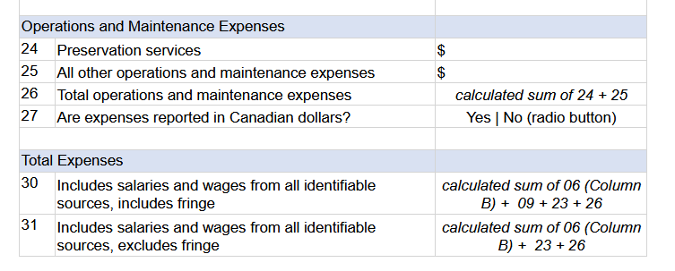

Scholarly Communications: SPARK/IR Data: Tiffany Dvorak supplied this data FY21
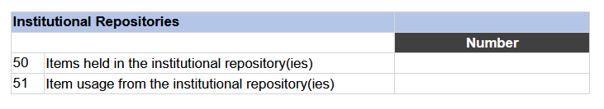
LIS Research, Teaching, and Learning: User Services: Ted and Michele supplied this data FY21

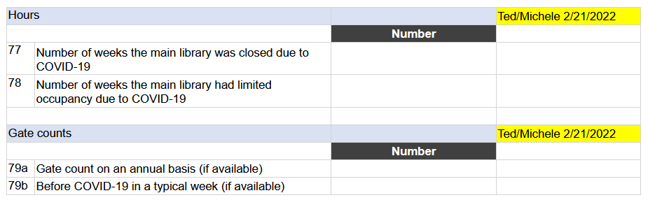
LIS Research, Teaching, and Learning: Instruction Services, emailed Director of area, Lora Del Rio, for data collection FY21:
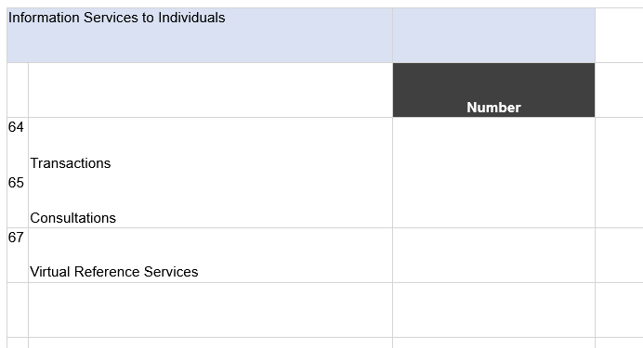

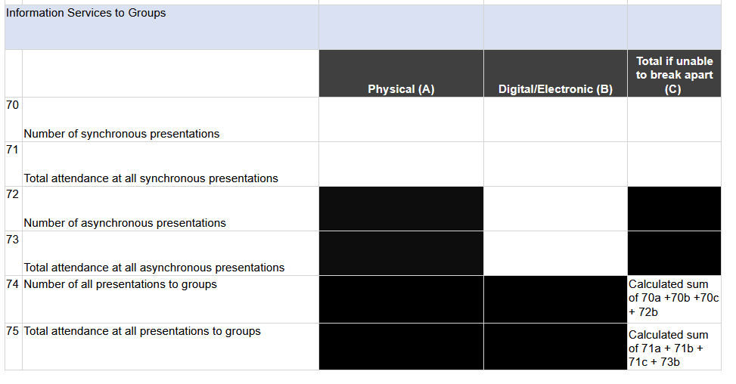

Interlibrary loan data: Shelly will generate the data for FY21

