Review Checklist for Free / Open Access Targets.
Why useful? Simplifying your local SFX instance means you’ll have less targets to maintain. And when it comes time to export the active full text targets from your local instance to Alma, there less collections to sort through, especially those not relevant to your campus and those that duplicate the Network Zone. The CARLI shared instance targets/collections will become part of the Alma Network Zone of Consortial wide collections.
Checklist: Which targets to activate (or keep active) in your local SFX instance that are also active in CARLI Shared Instance? If no significant differences we recommend deactivating your local target if also in shared instance.
Note: not apply to libraries that have completely opted out of shared instance: IIT, SIUC, and Wheaton. A few other libraries have opted out of specific targets. Please contact support@carli.illinois.edu for more information about your library’s status.
This checklist discusses Free/OA targets. Subscription targets are addressed in a separate document. Targets that are NOT full text collections are not discussed in this document, for example library catalog or “Ask a Question?” type targets.
What’s Active in CARLI Shared Instance, where’s a list?
1a. Go to https://www.carli.illinois.edu/free-and-open-access-targets-sfx to get list of free and open access targets as sorted and described by CARLI staff. Click on “…latest spreadsheet of free…” to down load the spreadsheet.
Tier 1 targets are active in CARLI shared instance.
Examining your Local SFX admin Active Targets
2. Go to your local SFX admin and examine your locally active free/Open Access targets.
Or alternately, you can export a list of active targets to aid examination or to share with colleagues for their input. Go to SFX admin, then to KB Tools → Export Tool → Export Active Targets. This allows generation of a file that includes the following fields from the target: #TARGET (target name), SERVICES, PUBLIC_NOTE, AUTHENTICATION_NOTE, PROXY, FREE and other factors. See https://www.youtube.com/embed/XEV_N4sKlwE?rel=0&autoplay=0&width=640&height=480&iframe=true for a video lesson on exporting an Active Targets list.

For each one that overlaps with 1a list consider:
a. Is this target customized in my local instance or identical to the shared instance target?
i. For example, do you have notes or localized date thresholds for your library getting year 19xx to 20zz for most active object portfolios/titles? Here’s examples of Target level note fields and a local threshold.
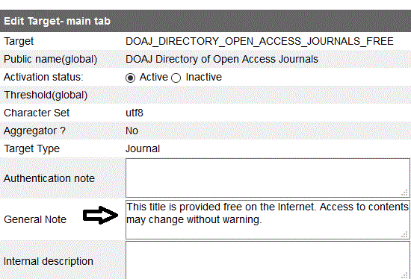
Local Note

Local Threshold
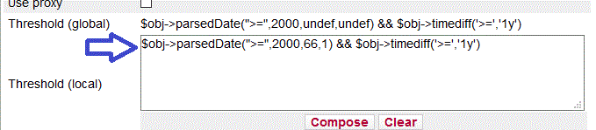

For libraries that were formerly part of the “Activate all Free Targets” program, you’ll see many free/OA targets active, especially in non-English languages. (Illustration of partial target list below). The activate-all-free option stopped in Sept. 2015.
For free/open access targets in foreign languages, see Tier 3 tab in the Free List spreadsheet. As the SFX committee said in 2015, “… demand for foreign language periodicals and eBooks varies widely across institutions. SFX administrators need to choose whether to activate these targets, based on local needs.” Choose which of the foreign language targets to activate based on your campus’ needs.
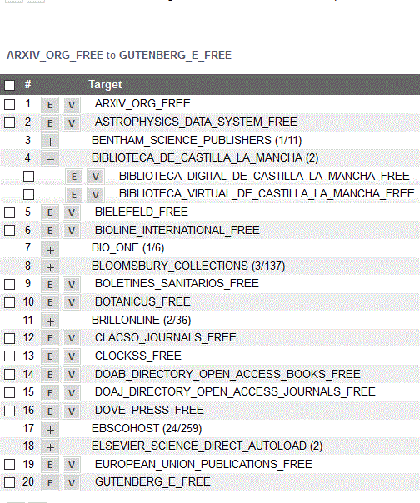
Note:
Factors to consider in activating free/OA targets: SFX System’s Committee criteria for higher Tier/quality judgement.
- All publications in the target from the same provider/publisher/platform.
- Publisher provides a reliable title list with valid linking.
- The target supports article- or chapter-level linking.
- The target does not duplicate other free targets.
- The target has a reputation for quality content.
- The primary language of the publications in the target is English.
Helpful Links:
Related Checklist for Licensed targets is at https://www.carli.illinois.edu/sites/files/files/Commercial%20Active%20Subscriptions%20Targets%20and%20local%20instance%20Examination%20Checklist.docx
Link to all instances page. https://www.carli.illinois.edu/products-services/link-resolver-sfx/sfx_compare
Ex. Rubric form to assist target review.
Rubric: Target Name _______________________________________________

Criteria | Notes
Content from same provider/publisher
Reliable title list and linking
Supports article- or chapter-level linking.
Does not substantially duplicate other free targets (defined as XX% of unique titles.)
Target has a reputation for quality content.
Primary language of the publications in the target is English.
Other?

