Elsevier Autoloader Implementation Instructions
1. Obtain authentication token from Elsevier:
a. Go to your Elsevier admin account
b. Find Admin Access
c. Find Trusted Partners
d. Create token for EXLIBRIS-SFX&ALMA

2. In KBManager, activate the dedicated targets and their getFullTxt target services:
- ELSEVIER_SCIENCE_DIRECT_ AUTOLOAD_JOURNALS
- ELSEVIER_SCIENCE_DIRECT_ AUTOLOAD_BOOKS
If you only get journals or only ebooks, then just activate the one appropriate target.

3. In the Edit Target Service window, click on the “Autoload” tab.
Edit Target Service Window
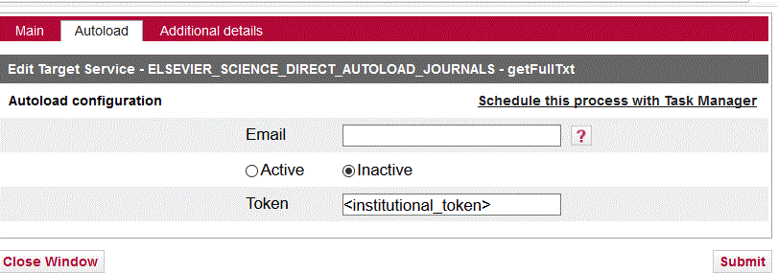
a. Add your email to the section “Email.”
b. Click on circle before “Active.”
c. Enter institutional token from Elsevier in Token field.
d. Click “Submit” to save.
e. While present, the “Schedule this process…” will do nothing. See #5.

4. Optional but recommended: Set up display logic rule:
If available: ELSEVIER_SD_DIRECT_AUTOLOAD_xxx getFullTxt
Do not show: ELSEVIER_SD getFullTxt
This rule prevents end users from seeing duplicate targets in the SFX menu during the transition period. XXX is for either the Journals or Books target (or both) you have activated.

5. Send to support@carli.edu a request to start the autoload process: Answer these questions:
a. Do you want the journals or books load or both?
b. How frequently do you want the loads after the first test load? Once a month is recommended.

6. CARLI staff will run autoload options from the Server Admin Utility. You will get log files of the run to help evaluate the results.

After testing, CARLI staff will set up a scheduled task to run the Automated load regularly.

Note: You can use KBTools > Collection tool from the SFX Admin Center to compare the activation and thresholds between the new autoload targets and the previously manually activated targets. This allows you to check that all activations are now in place in the new dedicated Elsevier targets.
Deactivate the old, manually activated targets and portfolios after successful testing and implementing the autoloading targets.

More info in: SFX General Users Guide, Target services editing starting on p. 59, as of 11/7/2018. Available at
https://knowledge.exlibrisgroup.com/SFX/Product_Documentation/01_Version_4.0

Or
https://knowledge.exlibrisgroup.com/SFX/Knowledge_Articles/Elsevier_ScienceDirect_Autoloader_automated_download_and_KB_loader

