Review Checklist for Subscription/Commercial Targets.
Why useful? Simplifying your local SFX instance means you’ll have less targets to maintain. And when it comes time to export a list of active full text targets from your local instance to Alma, there less collections to sort through, especially those not relevant to your campus and those that duplicate the Network Zone. The CARLI shared instance targets/collections will become part of the Alma Network Zone of Consortial wide collections.
Checklist: Which targets to activate (or keep active) in your local SFX instance that are also active in CARLI Shared Instance? If no significant differences we recommend deactivating your local target if also in shared instance.
Note: not apply to libraries that have completely opted out of shared instance: IIT, SIUC, and Wheaton. A few other libraries have opted out of specific targets. Please contact support@carli.illinois.edu for more information about your library’s status.
This checklist compares subscription targets. Free/Open Access targets are addressed in a separate document. Targets that are NOT full text collections are not discussed in this document, for example library catalog or “Ask a Question?” type targets.
What’s Active in CARLI Shared Instance, where’s a list?
1a. Go to https://www.carli.illinois.edu/products-services/link-resolver-sfx/secure/shared-targets
for CARLI consortially licensed and required targets currently active in the CARLI shared instance. Print or download a copy to compare with your locally active targets.

Examining your Local SFX admin Active Targets
2. Go to your local SFX admin and examine your locally active targets.
Or alternately, you can export a list of active targets to aid examination or to share with colleagues for their input. Go to SFX admin, then to KB Tools → Export Tool → Export Active Targets. This allows generation of a file that includes the following fields from the target: #TARGET (target name), SERVICES, PUBLIC_NOTE, AUTHENTICATION_NOTE, PROXY, FREE and other factors. See https://www.youtube.com/embed/XEV_N4sKlwE?rel=0&autoplay=0&width=640&height=480&iframe=true for a video lesson on exporting an Active Targets list.

For each one that overlaps with 1a list consider:
a. Is this target customized in my local instance or identical to the shared instance target?
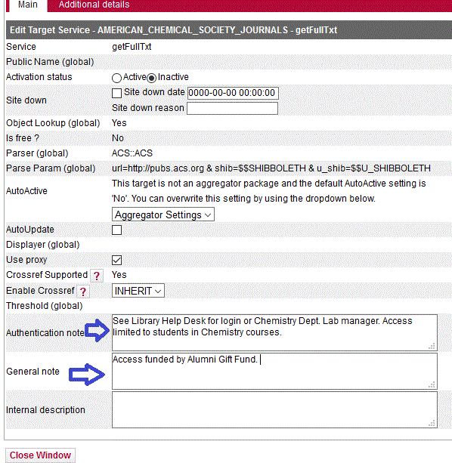
i. For example, do you have notes like “To Authenticate do xxx” or localized date thresholds for your library getting year 19xx to 20zz for most active object portfolios/titles? Here’s examples of Target level note fields and a local threshold.
Local Note:

Local Threshold
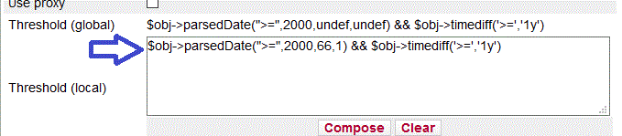
ii. Do you have unique public names for the target or target service that you prefer to the text on the CARLI shared instance? Ex. Of localized target and target service public name fields.
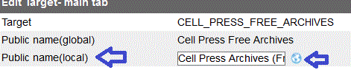

iii. Selective versus Aggregator collections targets.
Aggregator targets give the library access to 100% of the full text content. For ex. “EBSCOHost Academic Search Complete”. Chances are your local activation of “EBSCOHost Academic Search Complete” is not different that the CARLI shared instance subscription since by their nature aggregators are an all or nothing purchase.
Selective targets are collections that your library purchases access to a subset of titles. So any selective targets active in the CARLI shared instance will differ quite a lot from your local library’s subscription.
For example EBOOK_CENTRAL_ACADEMIC_COMPLETE in the CARLI shared instance has only the 4,000 or so titles active that have been purchased as part of various CARLI ebook cooperative projects. If your library has purchased ebook sets from EBook Central, your titles may overlap with CARLI’s 4,000 but are almost certainly mostly additional content not in the CARLI titles/object portfolios.
For targets where only a subset of object portfolios are activated in shared instance the library needs to check if the library has any additional object portfolios that should be activated for their own library (additional licensed content). If the library has additional content, does the vendor differentiate between the CARLI title list vs. individual library title list. Some vendors offers one holdings file (or entitlement list) via their vendor library admin account that includes both CARLI and individual library holdings. It may be easier to manage holdings in the local instance for that target. If the vendor offers different lists for CARLI title holdings vs individual library title holdings, then library can activate locally owned titles in local instance but still rely on the CARLI shared instance for CARLI licensed content. (Examples: Springer Medical ebooks, EBOOK_CENTRAL, SAGE DEEPFILE 2007, etc.)
iv. Other factors important to your library? Consult your colleagues.

Helpful Links:
Related Checklist for Free/Open Access targets is at
https://www.carli.illinois.edu/sites/files/files/Free_OA%20Examination%20steps%20local%20instance.docx
Link to all instances page. https://www.carli.illinois.edu/products-services/link-resolver-sfx/sfx_compare

