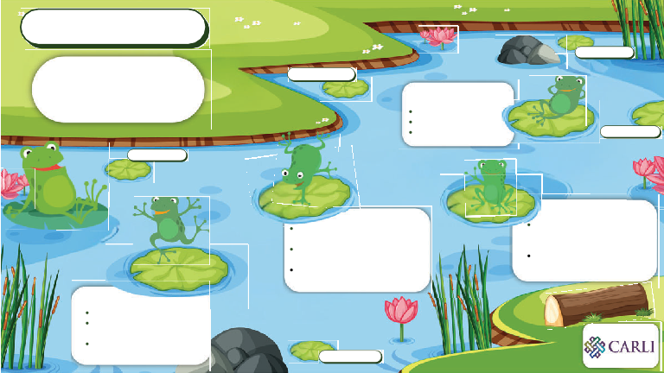
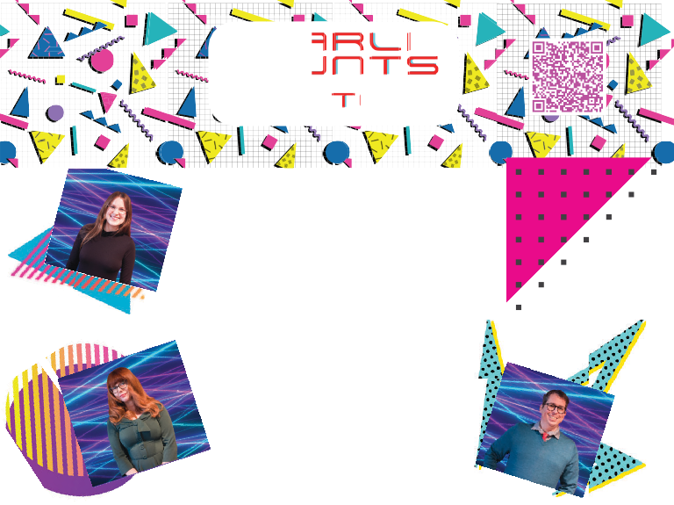
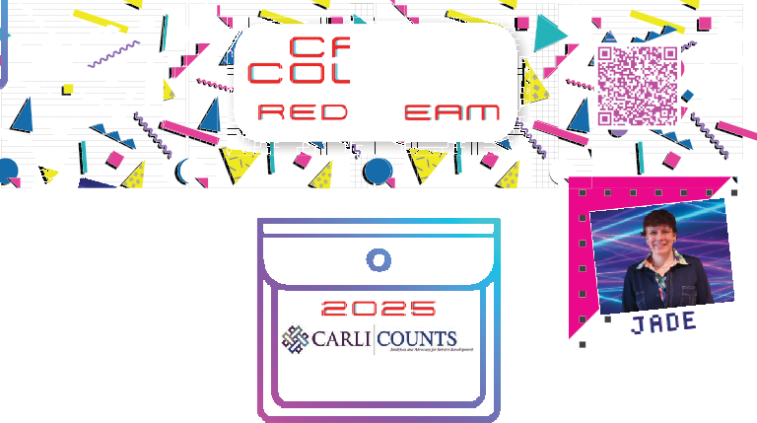
AC
ED
NT
LR
ET
Lea g into Library Assessment
Roadblocks
Sara Rizzo - National Louis University
Max
Hosford - Northeasteren Illinois University
Networking
Gavena Dahlman - Richland Community College Karen Cherone - Illinois Institute of Technology Kennedy Pasley - Knox College
Juggling Responsibilities
determine priorities delegate tasks
ask for help from others
Teamwork
Confidence
Pivoting
be ready and able to change when circumstances do (and they will!) don’t be too attached to any one project or plan
work with the IRB on revisions to research protocol
Institutional Needs
gather input from colleagues for direction that addresses key needs.
maintain ownership of the project, with a clear personal vision.
Faculty Buy-In
be direct and benefit-oriented minimize their workload by removing potential barriers plant seeds early and keep communication open
Clarification
pin
CCOCAUARNRLTLISIS
OUN
RED TEAM
2025
Keep Calm and Trapper on
( with Sources)
Devin
Tabitha
EVie
Jade
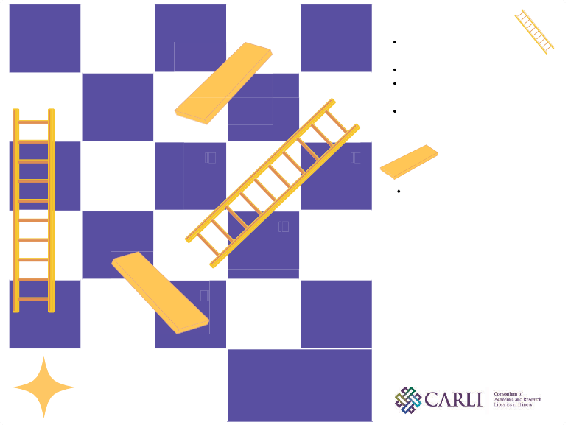
1
2
3
4
5
Start your project!

10
9
8
7
6
Wins
Working collaboratively with like-minded colleagues Guidance from experts Local application of
knowledge about assessment Support from CARLI
staff
11
12
13
14
15
20
19
18
17
16
Challenges
Finding time for the work Buy-in from institutional colleagues
Navigating the IRB process Balancing ethics with inquiry
21
22
23
24
25
Our Team
Anne Earel, Augustana College Jennifer Lau-Bond, Harper College Kylie Riordan, Illinois Tech Kimberly Shotick, Mentor, Northern Illinois University
CARLI Counts Slides and Ladders
Finish

