Overview
We have prepared social media posts that you can use to announce the availability of the 39 journals that are now part of the libraries collection due to the partnership between the Consortium of Academic and Research Libraries in Illinois (CARLI) and the University of Illinois Press. These posts come with accompanying graphics and alt text that you can use alongside them. Feel free to edit the posts as you wish to suit your needs, or if you prefer, you can use them as they are. We hope these resources help you effectively share this exciting news with your faculty, students, and researchers.

Twitter
Tweet 1 (Overview):
Our library now has access to 39 new humanities and social sciences journals from @IllinoisPress through the Consortium of Academic and Research Libraries in Illinois! Access them through our website or ask a librarian to learn more.
Graphic: CARLI All Journal Gif
Alt Text for Gif:
Gif showing the covers 39 humanities and social science journals from the University of Illinois Press.

Tweet 2 (Music, Arts Journals):
From Ethnomusicology to Visual Arts Research to Journal of Film and Video, the university library now has access to a variety of new music, art, and film journals. You can find them through our website or ask a librarian to learn more.
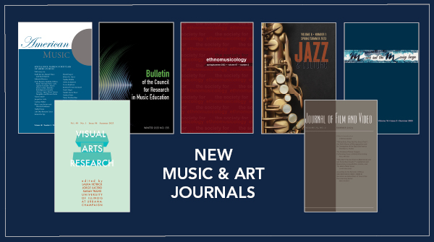
Graphic: CARLI Twitter Graphics – Music, Art
Alt Text for Graphic:
New Music and Art Journals
Covers of American Music, Bulletin of the Council for Research in Music Education, Ethnomusicology, Jazz and Culture, Music and the Moving Image, Visual Arts Research, Journal of Film and Video on a dark blue background with a white border.

Tweet 3 (Humanities, Philosophy Journals):
Calling all humanities and philosophy scholars! Our library now has access to new major journals on literature, philosophy, theology, classics, and more. Talk to a librarian for more information or access articles on our website. 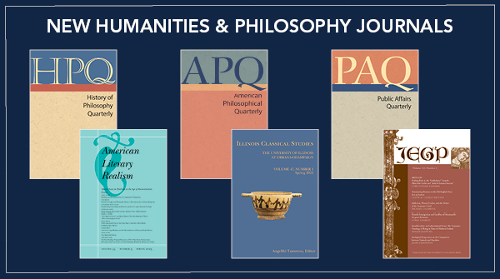
Graphic: CARLI Twitter Graphics – Humanities, Philosophy
Alt Text for Graphic:
New Humanities and Philosophy Journals
Covers of History of Philosophy Quarterly, American Philosophical Quarterly, Public Affairs Quarterly, American Literary Realism, Illinois Classical Studies, Journal of English and Germanic Philology on a dark blue background with a white border.

Tweet 4 (Cultural Studies Journals):
The university library's cultural studies journal offerings have expanded with new Italian, Polish, Finnish, American, and Mormon Studies journals! Explore these journals and more on our website, or ask a librarian.

Graphic: CARLI Twitter Graphics – Cultural Studies
Alt Text for Graphic:
New American Studies, European Studies, and Mormon Studies Journals
Covers of Journal of Mormon History, Journal of Finnish Studies, The Polish Review, Journal of American Folklore, Dialogue: A Journal of Mormon Thought, Italica, Journal of American Ethnic History, and Journal of Appalachian Studies on a dark blue background with a white border.

Tweet 5 (Education, Social Sciences Journals):
Whether you're looking for Journal of Aesthetic Education or American Journal of Psychology, you can now access new social science and education journals through our library's website or by talking to a librarian.
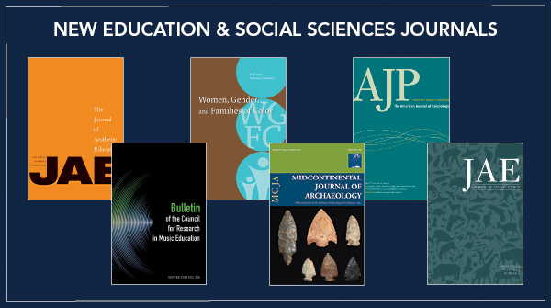
Graphic: CARLI Twitter Graphics – Education, Soc. Sci.
Alt Text for Graphic:
New Education and Social Sciences Journals
Covers of Journal of Aesthetic Education; Women, Gender, and Families of Color; American Journal of Psychology; Bulletin of the Council for Research of Music Education; Midcontinental Journal of Archaeology; and Journal of Animal Ethics on a dark blue background with a white border.

Facebook
Students and faculty now have full access to 39 new academic journals in disciplines like European Studies, philosophy, education, music, psychology, and more through the university library, thanks to a partnership between the University of Illinois Press and CARLI (the Consortium of Academic and Research Libraries in Illinois). Check out the expanded offerings on our website or talk to a librarian for assistance.
Graphic: CARLI All Journal Gif
Alt Text for Gif:
Gif showing the covers 39 humanities and social science journals from the University of Illinois Press.

Instagram
Our library now has 39 new humanities and social sciences journals due to a new partnership between the University of Illinois Press and the Consortium of Academic and Research Libraries in Illinois! Access the journals through our website or ask a librarian to learn more.
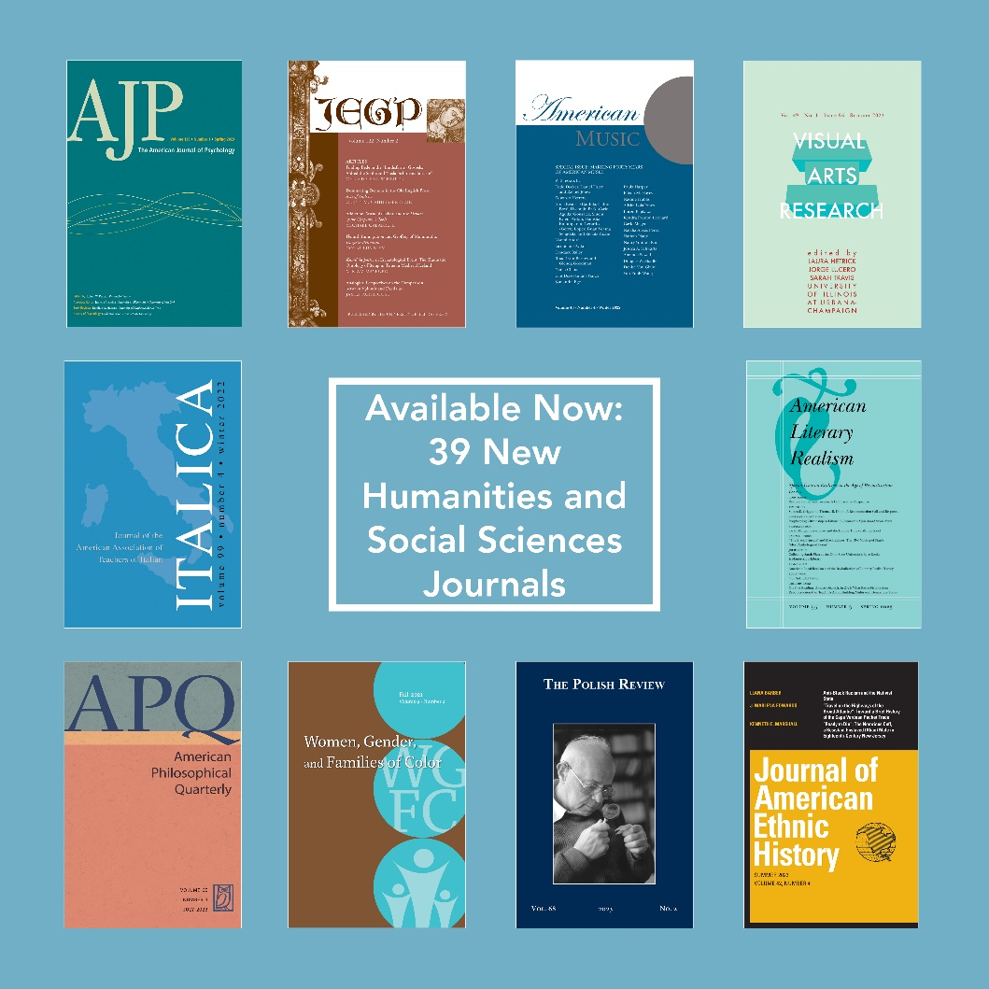
Alt Text for Graphic:
Available Now: 39 New Humanities and Social Sciences Journals
Covers of American Journal of Psychology; Journal of English and Germanic Philology; American Music; Visual Arts Research; Italica; American Literary Realism; American Philosophical Quarterly, Women, Gender and Families of Color; The Polish Review; Journal of American Ethnic History on a light blue background

