  2023 Illinois COurse Materials Survey  Student Perspective Report | Abstract  “Illinois Course Materials Survey: Student Perspective” identifies Illinois students’ needs regarding affordable course materials and interest in open educational resources or other affordable course material options.  Consortium of Academic and Research Libraries in Illinois (CARLI), March 2024

2023 Illinois Course Materials Survey: Student Perspective Report
In 2023 the Consortium of Academic and Research Libraries in Illinois (CARLI) and an advisory Subcommittee of the Open Educational Resources Committee developed the “Illinois Course Materials Survey: Student Perspective” to identify Illinois students’ needs regarding affordable course materials and interest in open educational resources or other affordable course material options. This survey was approved by the University of Illinois’ Office for the Protection of Research Subjects to be administered between April 5, 2023-December 31, 2023, to students attending not-for-profit institutions of higher education in Illinois. This report reflects the collective responses of 4,617 eligible student participants attending 52 Illinois institutions, including 22 community colleges, 21 private colleges and universities, and 9 public universities.
Contributors:
Nicole Swanson, Senior Coordinator, Library Services and Outreach, CARLI
Elizabeth Clarage, Director, Collections Services, CARLI
Dr. Michele Leigh, Senior Coordinator, Open Illinois, CARLI
Anne Craig, Senior Director, CARLI
Margaret Chambers, Director and Advisor, Membership and Communications, CARLI

Please send any questions to support@carli.illinois.edu
The “2023 Illinois Course Materials Survey: Student Perspective Report” created by CARLI © 2024 by the Board of Trustees of the University of Illinois System and is licensed under a CC-BY 4.0 International.

Acknowledgements:
We are grateful to all students who shared their course material experiences by participating in this survey and to the librarians and staff across Illinois who distributed this survey at their institutions.
Thank you to those whose advice helped make this survey a success:
CARLI Open Educational Resources Subcommittee:
Kim Hale, Columbia College Chicago
Mallory Jallas, Illinois State University
Lauren Kosrow, College of DuPage
Daniel Matthews, Moraine Valley Community College
Christina Norton, Bradley University
Dee Anna Phares, Northern Illinois University

University of Illinois Urbana Champaign, University Library staff:
Jen-chien Yu, Director of Library Assessment
Daniel Tracy, Head, Scholarly Communication & Publishing; Associate Professor
David Ward, Director, Library Teaching and Learning, Reference Librarian & Undergraduate Services Coordinator, Associate Professor

CARLI Governance Board
University of Illinois’ Office for the Protection of Research Subjects
University of Illinois Student Affairs:
Dr. Beth Hoag, Director for Assessment and Planning, Student Affairs
Ting Lu, Associate Director, Division of Management Information



TABLE OF CONTENTS
Executive Summary 4
Key Findings 6
Research Methodology 10
Full Results 11
- Participation 11
- Course Material Costs 14
- Costs Impacts 18
- Format Preferences 22
- Access Preferences 23
- Degrees and Areas of Study 24
- Funding Education 26
Conclusions 27
Appendices 28
Appendix A: Survey Instrument
Appendix B: Demographics
Appendix C: References

EXECUTIVE SUMMARY
The Consortium of Academic and Research Libraries in Illinois (CARLI) conducted the “Illinois Course Materials Survey: Student Perspective” between April 5, 2023-December 31, 2023, in order to identify Illinois students’ needs regarding affordable course materials and interest in Open Educational Resources or other affordable course material options. Specifically, we aimed to answer the following research questions:
- How much did students spend on course materials during the current term?
- How are students affected by the cost of college course materials?
- Which demographics of Illinois college students are most impacted by the cost of course materials?
- What are students’ interests in and experiences with Open Educational Resources (OER)?
- What are students’ interests in and experiences with other affordable material options?
- Do students have clear preferences for the formats and features of course materials?
The 21 main questions comprising the survey were modeled from other statewide course material surveys including those developed by the Florida Virtual Campus (FLVC) and the Virgina Academic Library Consortium (VIVA), as well as institutional surveys developed by CARLI-member libraries. A subcommittee of the CARLI Open Educational Resources Committee advised the CARLI Research Team on the questions included within the “Illinois Course Materials Survey: Student Perspective.”
4,617 eligible students participated in the survey from 52 Illinois not-for-profit institutions including 22 community colleges, 21 private colleges and universities, and 9 public universities. As CARLI is not a state agency that would have direct contact with students at all not-for-profit institutions in Illinois, we requested librarians at those institutions distribute the survey to their students through their local campus channels. Students shared their academic and personal struggles to afford course materials, the benefits of freely-available materials, and their preferences for course material formats.
All demographics of students expressed that the cost of course materials is adversely impacting their academic careers by increasing their time to degree completion, causing a failure to reach their potential when lacking the necessary learning materials, and impacting their decisions on course selections. Due to the cost, students shared how they are struggling financially to meet basic needs including going without food, medicine, and other necessities. Their debt increased, as did the number of hours they had to work to cover course material costs. Emotional stress increased as a result. Students were extremely frustrated by online paid-access code materials, referring to them as a “pay-to-grade” model. 60% of students considered low-cost materials as ranging from $0-$40.
When provided with freely available course materials, students experienced increased academic success, relief of lowering financial stress, and appreciation for the academic quality, inclusivity, equitability, and interoperability that freely available course materials provided. 74% of students indicated they would prefer digital course materials with no cost over traditionally published course materials with a cost. Over 75% of respondents identified an appreciation for course materials that were interactive, could be accessed from anywhere, incorporated assistive technologies, allowed use on a cell phone or other small device, provided digital and print formats, and provided lifetime access.
These results emphasize the need for equitable access to course materials for Illinois college students, and the need for CARLI to continue our efforts in supporting the creation and adoption of Open Educational Resources and other affordable options at CARLI-member and other Illinois not-for-profit institutions. This includes advocating for stable, recurring funding to support these efforts. Students’ responses from this survey will be used to support the need for such funding through state and federal legislation and grant opportunities. It is our intent to redistribute this survey periodically in the future to stay informed of students’ course material needs so we can continue to support students by sharing their concerns with the Illinois library and higher education community.
KEY FINDINGS

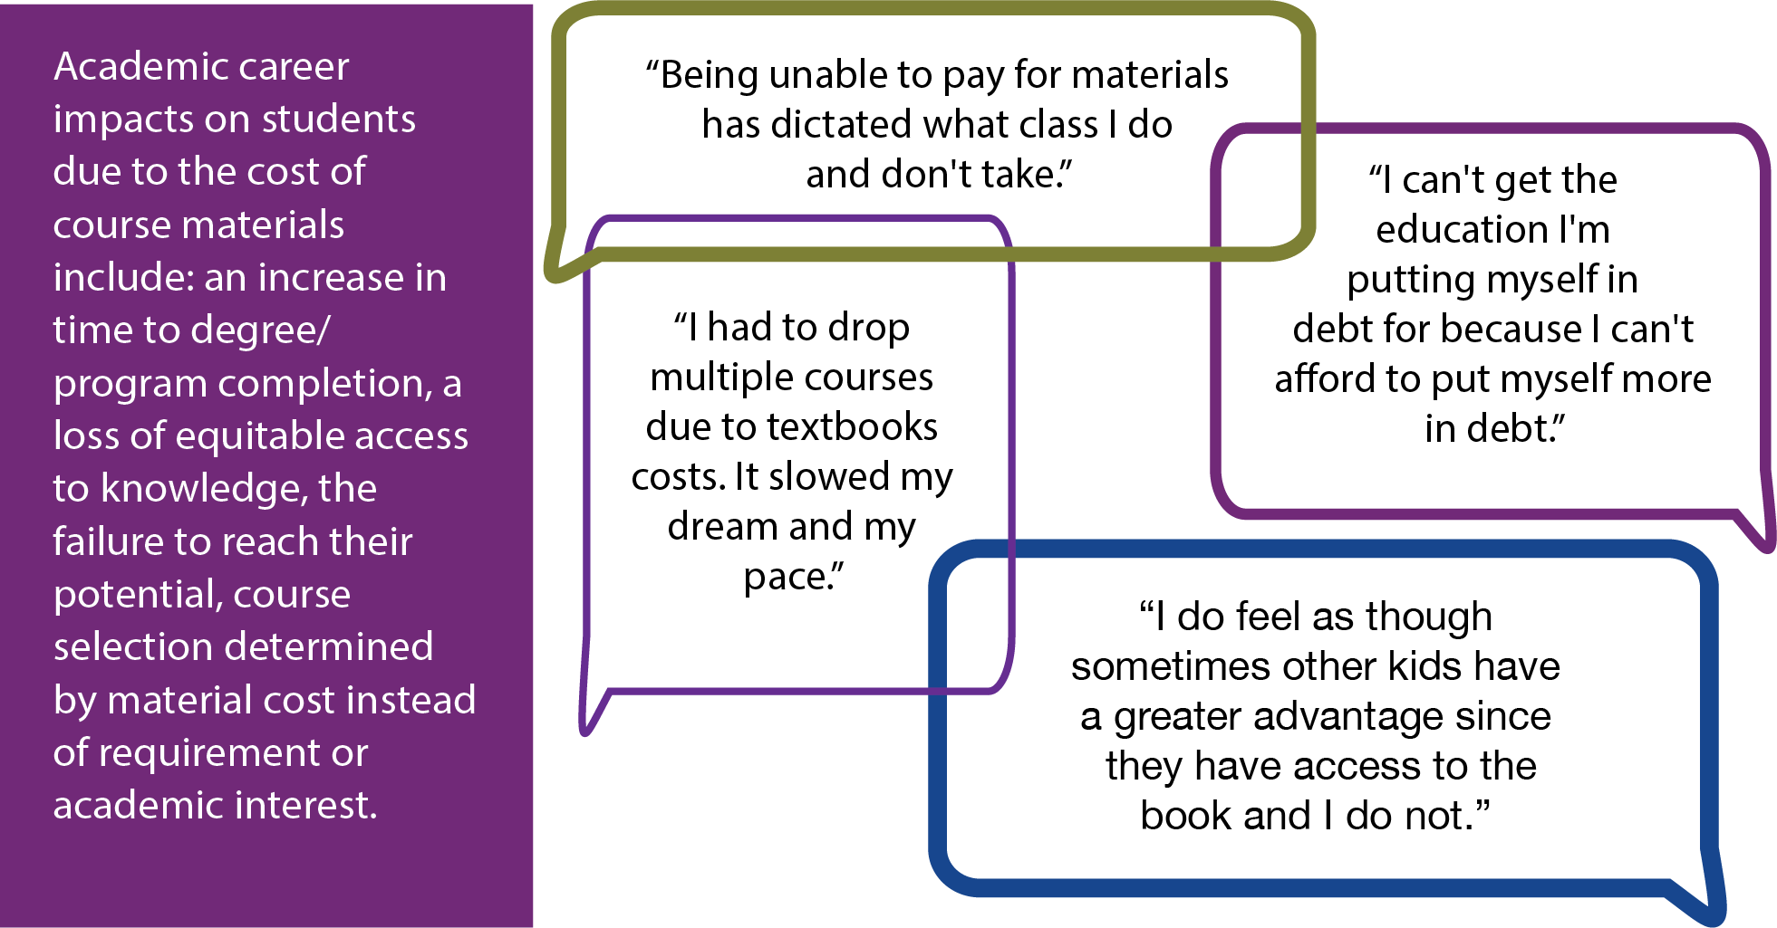

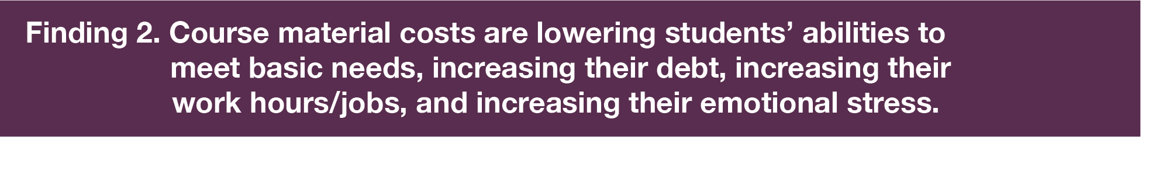
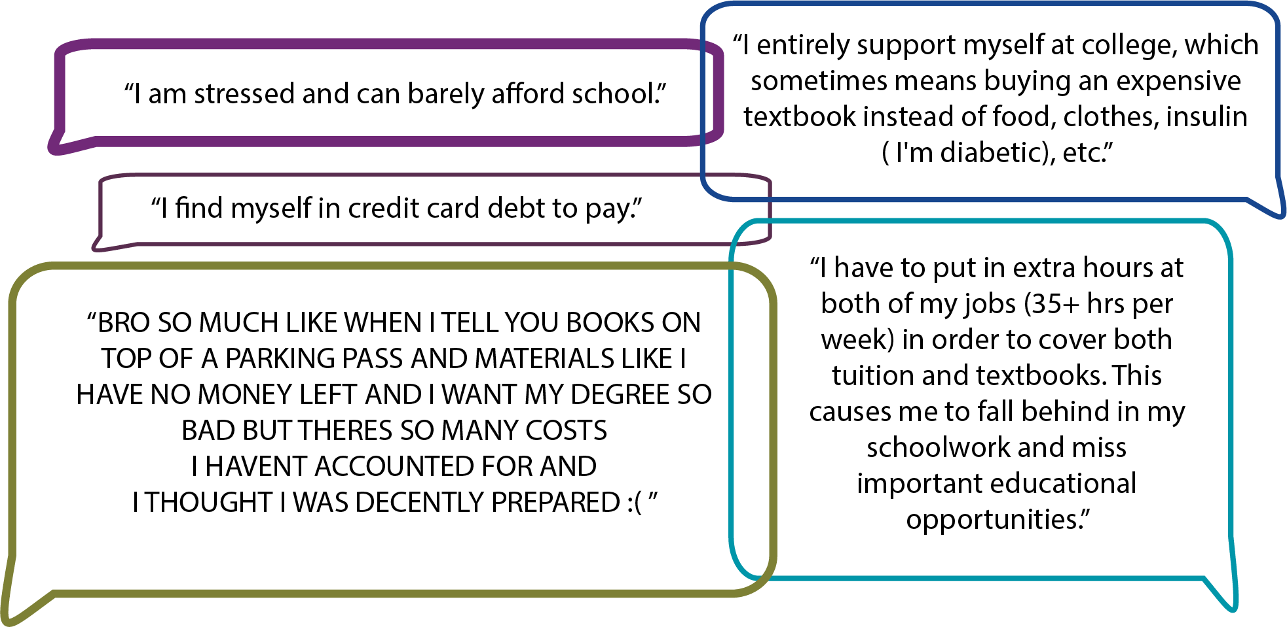

The average spent by all students on course materials for a term was $297.71. This average ranged from $227.28 for those taking one course to $445.83 for those taking seven courses. This includes 11.66% of students who noted they spent $0 for course materials.
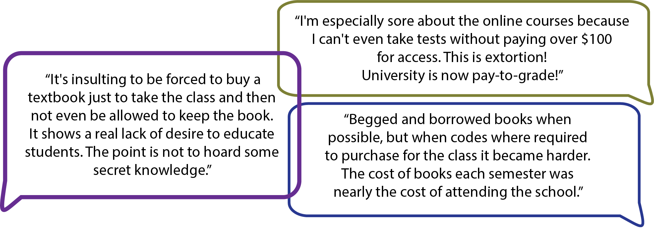
Students experienced increased academic success, relief of lowering financial stress, and appreciation for the academic quality, inclusivity, and equitability that freely available course materials provided. They respected faculty who provided access to freely available materials.
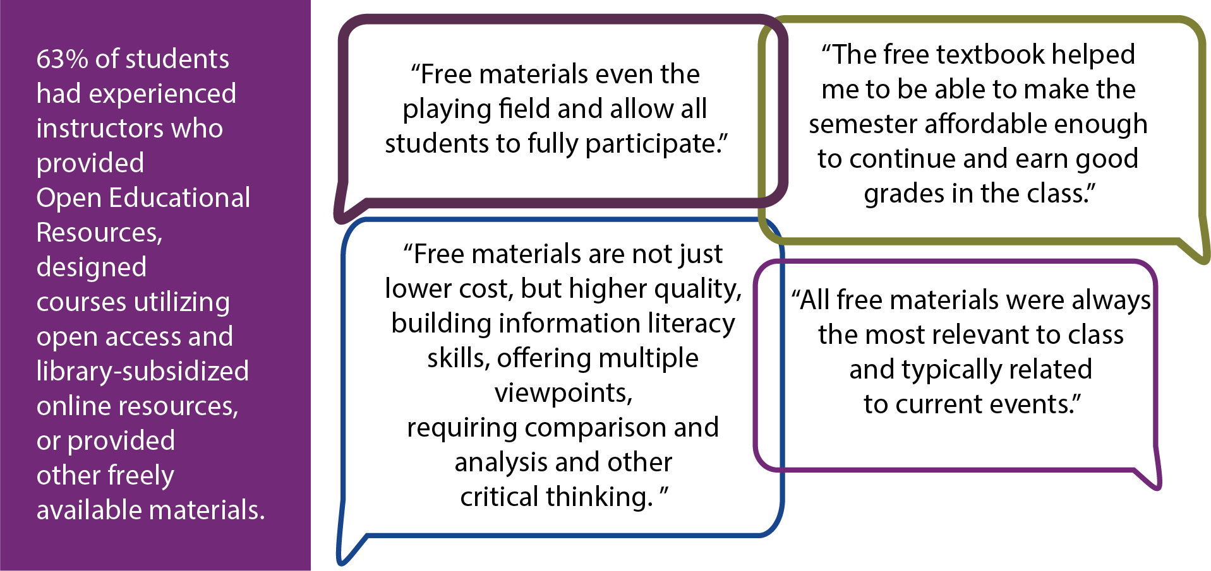

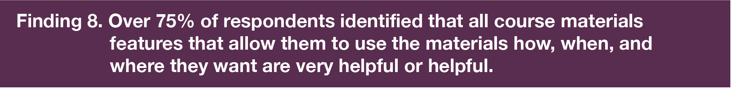Almost all students (96%) noted that having access from anywhere is very helpful or helpful.

RESEARCH METHODOLOGY

Creation
The “Illinois Course Materials Survey: Student Perspective,” was developed to identify Illinois students’ needs regarding affordable course materials and interest in Open Educational Resources or other affordable course material options. Specifically, the survey aimed to find answers to the following research questions:
- How much did students spend on course materials during the current term?
- How are students affected by the cost of college course materials?
- Which demographics of Illinois college students are most impacted by the cost of course materials?
- What are students’ interests in and experiences with Open Educational Resources (OER)?
- What are students’ interests in and experiences with other affordable material options?
- Do students have clear preferences for the formats and features of course materials?
Identifying answers to these questions helps CARLI identify future steps we can take to better support Illinois students’ required course material needs, including continued support for the creation of Open Educational Resources and advocacy for recurring funding.
Specific questions included within the survey were modeled from other statewide course material surveys including those developed by the Florida Virtual Campus (FLVC) and the Virgina Academic Library Consortium (VIVA) as well as CARLI-member surveys. A subcommittee of the CARLI Open Educational Resources Committee advised the CARLI Research Team on the questions included within this survey.
Protecting student privacy was of utmost importance as we developed this survey. Data was stored in the secure platform REDCap. No personally identifiable information such as names or email addresses were collected. Survey questions were optional with the exception of four, to allow students as much anonymity and protection as possible. Required questions included: provide your consent to participate, select an academic term, identify if you were 18 years of age or older when the term began, and indicate your institution name. Three of these questions were required to help ensure consent to participate and eligibility. Requiring indication of academic term allowed students to participate during more than one term in 2023.
Indicating institution name also allowed the possibility of individual institutions being able to request institution-specific aggregated responses to evaluate the survey results at the institution level in addition to our statewide findings.
- Distribution
This survey was approved by the University of Illinois’ Office for the Protection of Research Subjects with exempt determination category Exempt 2(ii) to be shared with students at not-for-profit institutions of higher education in Illinois between April 5, 2023-December 31, 2023. As CARLI is not a state agency that would have direct contact with students at all not-for-profit institutions in Illinois, we requested librarians at those institutions distribute the survey to their students through their local campus channels.
CARLI shared the survey with librarians across the state by announcing its launch not only to CARLI’s 128 members via email and regular Newsletter announcements, but also announcing it to partners across the state including the Illinois Library Association (ILA), the Illinois Association of College and Research Libraries (IACRL), the Illinois Community College Board (ICCB), and other Illinois library systems who kindly helped share the news about the survey via email lists and newsletters.
Gaining local permissions for librarians and staff to distribute this survey looked different at each institution, and often involved outreach to Institutional Review Board offices. Some librarians and staff were able to gain permissions quickly, sharing the survey across Spring, Summer, and Fall 2023 terms. Other campus permissions took longer, and distribution was in later terms. Some institutions generously allowed the sharing of this survey to their full student body, while others limited outreach to a specified percentage of students per term.
Institutions successfully distributed the survey to students through a combination of approaches: direct emails to students, sharing of the survey via their campus learning management system, emails to faculty and deans notifying them of the survey, encouraging participation in the survey at campus events, and reaching out to other campus groups to forward the survey to their members.
FULL RESULTS
- Participation
4,729 students participated in the Illinois Course Materials Survey: Student Perspective
April 5, 2023 through December 31, 2023. The survey results represent only eligible participants, totaling 4,617 students. Eligible participants included students attending not-for-profit institutions of higher education in Illinois, who were 18 years of age or older during the term selected, and who gave voluntary consent to participate in the survey. 110 ineligible participants (2%) were excluded from the study due to attending an institution outside of Illinois, not consenting to participate, or being younger than 18 years of age at the start of the term selected.
Students from 52 Illinois institutions were represented, including 22 community colleges, 21 private colleges and universities, and 9 public universities. Response rates by institution type included 2215 community college students (48%), 1070 students attending private colleges and universities (23%), and 1332 students attending public universities (29%). Some institutions had recently shared student surveys on their campuses and made the decision to not share the survey in 2023.

Participating Illinois Institutions and Number of Responses
22 Community Colleges
Black Hawk College | 157
Carl Sandburg College | 1
City Colleges of Chicago - Harold Washington College | 5
City Colleges of Chicago - Harry S Truman College | 3
City Colleges of Chicago - Malcolm X College | 2
City Colleges of Chicago - Olive-Harvey College | 1
City Colleges of Chicago - Wilbur Wright College | 11
College of DuPage | 213
College of Lake County | 281
Danville Area Community College | 63
Elgin Community College | 83
Illinois Valley Community College | 2
Kishwaukee College | 34
McHenry County College | 1
Lake Land College | 1
Lincoln Land Community College | 404
Oakton College | 558
Sauk Valley Community College | 112
South Suburban College | 55
Southwestern Illinois College | 2
Spoon River College | 23
Waubonsee Community College | 203

21 Private Colleges/Universities
Adler University | 34
American Academy of Art | 1
American Islamic College | 1
Benedictine University | 111
Columbia College Chicago | 23
Concordia University Chicago | 1
DePaul University | 275
Elmhurst University | 1
Illinois College | 5
Illinois Institute of Technology | 42
Illinois Wesleyan University | 42
Judson University | 30
Knox College | 21
Lake Forest College | 52
Lincoln Christian University | 14
Loyola University of Chicago | 2
Millikin University | 274
National Louis University | 1
Northwestern University | 95
Principia College | 1
Rockford University | 44

9 Public Universities
Chicago State University | 44
Illinois State University | 4
Northeastern Illinois University | 169
Northern Illinois University | 159
Southern Illinois University Carbondale | 407
Southern Illinois University Edwardsville | 163
University of Illinois Chicago | 85
University of Illinois Springfield | 173
University of Illinois Urbana-Champaign | 128

Response Rates by Institution Type
Of the 4617 eligible participants, 48% (2215) were attending community colleges, 23% (1070) were attending private colleges and universities, and 29% (1332) were attending public universities.

Participation Levels by Term
Of the 4617 eligible student participants, 82% (3823) completed the survey for the Fall 2023 term, 13% (580) participated for Spring 2023, and 5% (214) completed the survey for Summer 2023.

This increase in the Fall term reflects the longer approval process some librarians and staff needed to undergo at their institutions to gain permissions to distribute the survey to students. Other institutions were able to quickly acquire permissions to distribute the survey. Outreach to students also varied among institutions. Some were able to distribute the survey to their full student body, while others were restricted to a limited percentage of students. As previously mentioned, the ways in which the survey was able to be distributed also varied. Some institutions generously allowed the sharing of this survey to their full student body through direct emails and sharing via learning management systems. Others were more limited in their options for student outreach.
- Course Material Costs
Participants were asked both about the number of courses they took and how much they spent on textbooks and other required course materials such as access codes or course packets. Using the responses from these two questions, the average amount spent by course load was calculated. There were 3692 students that answered both questions. 28% of students took four classes. For all respondents, the overall average spent for course materials was $297.71. Full-time students on average spent $314.74. Average spent was calculated by using the middle value of each “amount spent” category. Interesting enough, those that took three classes spent more on average for their course materials than those that took four classes, but by far, those taking one course spent the most on a per-course basis at $227.28.*
All responses for students that identified the number of courses and amount spent:
Number of Courses | Number of Students (Percentage) | Average Amount Spent for Course Materials
1 | 335 ( 9%) | $227.28
2 | 603 (16%) | $276.84
3 | 515 (14%) | $295.46
4 | 1036 (28%) | $277.97
5 | 764 (21%) | $323.07
6 | 289 ( 8%) | $334.59
7 | 139 ( 4%) | $445.83

During the academic term, how many courses did you take?
Students identified that they were taking one to seven courses. 3716 students answered this question.
1 course, 336 students (9%)
2 courses, 607 students (16%)
3 courses, 523 students (14%)
4 courses, 1048 students (28%)
5 courses, 769 students (21%)
6 courses, 293 students (8%)
7 courses, 140 students (4%)
During the academic term, how much did you spend on all textbooks and other required course materials (access codes, course packets, etc.)?
Amount Spent | Number of Students | % of Students
$0 | 433 | 11.66%
$1-50 | 285 | 7.67%
$51-100 | 419 | 11.28%
$101-200 | 676 | 18.20%
$201-300 | 636 | 17.12%
$301-400 | 423 | 11.39%
$401-500 | 260 | 7.00%
$501-600 | 175 | 4.71%
$601-700 | 105 | 2.83%
$701-800 | 61 | 1.64%
$801-900 | 37 | 1.00%
$901-1000 | 60 | 1.62%
$1001-$1101 | 27 | 0.73%
$1101-1200 | 17 | 0.46%
$1201-1300 | 12 | 0.32%
$1301-1400 | 5 | 0.13%
$1401-1500 | 11 | 0.30%
$1501-1600 | 8 | 0.22%
$1601-1700 | 6 | 0.16%
$1701-1800 | 5 | 0.13%
$1801-1900 | 2 | 0.05%
$1901-2000 | 5 | 0.13%
$2001-2100 | 2 | 0.05%
$2101-2200 | 6 | 0.16%
$2201-2300 | 3 | 0.08%
$2301-2400 | 3 | 0.08%
$2401-2500 | 5 | 0.13%
$2501 or more | 27 | 0.73%

Financial Aid
Did you receive financial aid?
Of the 3688 participants, 52% (1918) said yes, they received financial aid, 42% (1560) said they received no financial aid, 6% (210) were unsure whether they had received aid.

Did the cost of your course materials exceed your financial aid award?
Of the 1902 students who responded to this question, 32% (612) said yes, 53% (1013) said no, 15% (277) were uncertain.

Select what you would consider to be low cost for the course materials used for just one course.
Of the 2693 students who responded to this question 15.4% (575) said $0; 22.5% (837) less than $20, 22.5% (838) less than $40; 14% (522) less than $60; 6.5% (242) less than $80; 11.5% (427) less than $100; 3.7% (138) less than $150, and 3.8% (142) said less than $200.
- Costs Impacts
In your academic career, has the cost of required course materials caused you to (select all that apply):
2693 students responded to one or more options within this question, indicating the cost of course materials have impacted students in all categories. Course material costs have caused 1865 students (69%) to not purchase the required course materials, 1095 (41%) to take fewer courses, 750 (28%) to not register for a specific course, 625 (23%) earn a poor grade because they could not afford to buy the course materials, 400 (15%) dropped a course, 316 (12%) withdrew from a course, and 169 (6%) failed a course because they could not afford to buy the course materials.
Detriment of Cost Impact
- The time it takes for students to complete their degree/program increases when students take fewer courses, drop, withdraw, or fail as a result of the cost of course materials. One student shared “I had to drop multiple courses due to textbooks costs. It slowed my dream and my pace.”
- Students fail to reach their potential when they earn a poorer grade because they could not afford to purchase the course materials. Expressed by one student participant, “I can't get the education I'm putting myself in debt for because I can't afford to put myself more in debt.”
- Equitable access to the resources and knowledge for students to be successful is lost. A student shared “I do feel as though sometimes other kids have a greater advantage since they have access to the book and I do not.”
- Course selection is impacted; even if a course may be the best option for a student’s education, students are choosing to not register for specific courses with high-cost materials. A student participant expressed “Being unable to pay for materials has dictated what class I do and don't take.”
How have the costs of textbooks and other course materials impacted you?
Below is a small sample highlighting themes found in the 2707 personal comments students shared about how the cost of textbooks have impacted them. Themes emerged as multiple students expressed similar impacts. Course material costs are causing students to struggle to meet basic needs, slow or stop their degree completion, earn lower grades, work additional hours and additional jobs, have emotional and mental stress, increase their debt, experience a lack of equity in access to knowledge, lose respect for professors using expensive materials, and select courses specifically based on textbook cost. Students are particularly upset about the price of paid publisher access codes sometimes required to take quizzes and tests.
- “I entirely support myself at college, which sometimes means buying an expensive textbook instead of food, clothes, insulin ( I'm diabetic), etc.”
- “I have been forced to skip meals in place of buying books because I felt they were necessary, but many cases this was untrue.”
- “I am a single parent to three children. If I buy textbooks that money comes out of their food and clothes budget. I am literally choosing between feeding my children and or buying books for college.”
- “I had to drop multiple courses due to textbooks costs. It slowed my dream and my pace.”
- “I had to become a half-time student to be able to afford going.”
- “Had to withdraw because the cost was too much.”
- “I put off going to college.”
- “It’s challenging to keep up when I don’t have all the materials.”
- “I can't get the education I'm putting myself in debt for because I can't afford to put myself more in debt.”
- “I find myself in credit card debt to pay.”
- “I do feel as though sometimes other kids have a greater advantage since they have access to the book and I do not.”
- “I failed … because I could not access my homework because I needed to spend $200 on an access code. This was for one class alone.”
- “I have to put in extra hours at both of my jobs (35+ hrs per week) in order to cover both tuition and textbooks. This causes me to fall behind in my schoolwork and miss important educational opportunities.”
- “Having to pay the cost of textbooks and other materials has caused me to pick up more hours at my job thus taking me away from my class work.”
- “I am stressed and can barely afford school.”
- “BRO SO MUCH LIKE WHEN I TELL YOU BOOKS ON TOP OF A PARKING PASS AND MATERIALS LIKE I HAVE NO MONEY LEFT AND I WANT MY DEGREE SO BAD BUT THERES SO MANY COSTS I HAVENT ACCOUNTED FOR AND I THOUGHT I WAS DECENTLY PREPARED :( “
- “As someone with a shoestring budget, any cost for materials is deeply impactful. [My college] advertises that one can use their financial aid to purchase their books in the campus bookstore, yet also upcharges those books because they know some students have no other choice but to pay with their financial aid. It's taking advantage of lower-income students specifically and it's disgusting.”
- “Adding hundreds of dollars of books and ESPECIALLY online access is a huge burden. I'm especially sore about the online courses because I can't even take tests without paying over $100 for access. This is extortion! University is now pay-to-grade!”
- “Beyond the simple fact that many of these textbooks are glorified quiz books, paying exorbitant fees for them feels especially ridiculous since the access we are provided expires after the course ends. It's insulting to be forced to buy a textbook just to take the class and then not even be allowed to keep the book. It shows a real lack of desire to educate students. The point is not to hoard some secret knowledge.
- Begged and borrowed books when possible, but when codes where required to purchase for the class it became harder. The cost of books each semester was nearly the cost of attending the school.”
- “I lose respect for the professor since he/she requires such an expensive book.”
- “As of fall 2023 I am able to say that all my professors did not ask for textbooks. We do use textbooks but the professors made sure they were free of cost.”
Have you had an instructor use materials that were completely free to you? (You did not pay for them and they were not included in your tuition or student fees bill via a campus rental program, flat-fee model, or inclusive access model.)

Of the 3652 students who participated in this question, 2291 (63%) had experienced an instructor who used materials that were completely free to them. 1070 (29%) students indicated they had not, and 291 (8%) were uncertain. Below are select quotes from the 1972 students who shared their experiences with free course materials. Their experiences included instructor-provided freely-available resources, courses utilizing open access and library-subsidized online resources, and open educational resources.
- “The free textbook helped me to be able to make the semester affordable enough to continue and earn good grades in the class.”
- “A big burden off my shoulders, a designated space to access the free materials as well. There was no barrier to entry.”
- “I can read them on my computer, highlight, underline, take notes, etc. like a normal textbook. And I loved that it was written by instructors and faculty because it's up to date and they made the book interesting to read.”
- “Free materials even the playing field and allow all students to fully participate.”
- “Everyone had the same book edition and the teacher and students were on the same page.”
- “Free materials are not just lower cost, but higher quality, building information literacy skills, offering multiple viewpoints, requiring comparison and analysis and other critical thinking. Students also build knowledge of how to find and use sources as a professional and in the future.”
- “All free materials were always the most relevant to class and typically related to current events.”
- “I felt much more included in the content.”
- “These materials show me that the professor cares about me as a human not just a student. I am more likely to actually use these resources when they are already provided for me.”
- “I appreciated that my school was taking my high tuition costs seriously and that my funds were put to good use. Free materials often show an instructor has taken the time to find relevant examples to work from.”
- “The material was just as good, and in more than one case, better than the textbooks I've had to pay for.”
- “The free materials allowed me to save money for future tuition payments. I was overwhelmingly happy to have access to expensive textbooks for free, thus allowing me to complete the necessary work and pass my classes.”
- “Amazing. All the information was there and I was able to learn well and complete the class with an A.”
- “I was very relieved that I was able to use the free materials rather than stress over the cost of textbooks and materials needed. Majority of the time, students spend money on textbooks that are barely used for the course itself.”
- “Great. I was able to access the material whenever I needed it.”
- “Awesome; I really appreciated it. They were all accessible via Canvas. Very cool move by my professor.”
- “Amazing, I wish all professors would do this!”

- Format Preferences:
If the cost is the same, which format do you prefer for your course materials?

Of the 3639 students who responded to this question, if course material costs were the same between print/physical and digital formats, 1432 (39%) preferred print/physical resources, compared with 728 (20%) who preferred digital. 1215 (33%) said It depends, and 264 (8%) had no preference.
Would you prefer to enroll in a course that used digital course materials with no cost to you or a course that used traditionally published course materials with a cost?

Of the 3641 students who responded to this question, 2681 (74%) of students indicated that they would prefer digital course materials with no cost, compared with 540 students (15%) who indicated they would prefer traditionally published materials with a cost, and 420 (11%) of students who didn’t have a preference. The impact of the cost of course materials significantly determined the 74% preference of students for digital course materials at no cost, even if they would have had a slight preference for print/ physical materials if the cost had been the same.
- Access Preferences:
How helpful to your learning are the following course material features?
Over three quarters of respondents identified that all course materials features that allow them to use the materials how, when, and where they want are very helpful or helpful. With almost all students noting that have access from anywhere is very helpful or helpful.
Access from anywhere, 96.3%
Ability to print content or access a print copy, 89.6%
Interactive technology and exercises, 87.2%
Effective display via a cell phone or other small device, 82.7%
Lifetime access, 79.5%
Compatible with assistive technologies, 78.5%

Feature | Very Helpful | Helpful | Not Helpful | N/A
Ability to access them from anywhere (respondents = 3502) | 2494 (71.2%) | 878 (25.1%) | 89 (2.5%) | 41 (1.2%)
Ability to print content or access a print copy (respondents = 3502) | 2020 (57.7%) | 1116 (31.9%) | 259 (7.4%) | 107 (3.1%)
Interactive technology and exercises (respondents = 3486) | 1685 (48.3%) | 1357 (38.9%) | 303 (8.7%) | 141 (4.0%)
Effective display via a cell phone or other small device (respondents = 3499) | 1726 (49.3%) | 1169 (33.4%) | 438 (12.5%) | 166 (4.7%)
Lifetime access (respondents = 3493) | 1627 (46.6%) | 1153 (33.0%) | 466 (13.3%) | 247 (7.1%)
Compatible with assistive technologies (respondents = 3477) | 1587 (45.6%) | 1144 (32.9%) | 215 (6.2%) | 531 (15.3%)

- Degrees and Areas of Study
What degree(s) are you currently seeking?
Associate degree 1343, 33.3%
Bachelor’s Degree 1689, 41.8%
Master’s Degree 457, 11.3%
Doctorate degree 170, 4.2%
Certificate or Diploma 277, 6.8%
Non-Degree/student at large 98, 2.4%

What is your program/primary area(s) of study? Select all that apply.
Business (Accounting; Business; Economics; Management; Marketing; Office Technology) | 523 students, 13.1%
Computer Science (Computer Aided Graphics; Computer Information Science and Information Technology; Cybersecurity; Operations and Information Management; Gaming) | 309 students, 7.7%
Career & Technical (Applied Technology; Automotive Service Technology; Construction Management; Cosmetology; Culinary; Fire Science and Safety; Heating, Air Conditioning and Refrigeration (HVACR); Hospitality; Manufacturing Technology; Mechanics; Paramedics; Transportation Logistics and Distribution; Welding Technology) | 99 students, 2.5%
Education (Early Childhood Education; Child Development; Education/Teacher Preparation; Educational Leadership; English as a Second Language (ESL); Physical Education; Special | 392 students, 9.8%
Engineering (Aerospace Engineering; Biomedical Engineering; Chemical Engineering; Civil Engineering; Electrical Engineering; Industrial Engineering) | 153 students, 3.8%
Fine & Applied Arts and Architecture (Animation/Motion Graphics; Architecture Art Education; Art History; Design; Fine Arts, Applied; Fashion Studies; Film; Interior Design; Theater; Music, Applied; Music Education; Music History and Theory; Photography) | 274 students, 6.8%
Health Sciences/Medical (Audiology; Clinical Laboratory; Dental; Medical Administration; Kinesiology; Nursing; Nutrition; Occupational Therapy; Physical Therapy; Physician; Physician Office Coding & Billing; Public Health; Radiology; Respiratory Care; Speech Pathology; Surgical; Veterinary | 875 students, 21.9%
Law including Paralegal Studies | 103 students, 2.6%
Liberal Arts & Communication (Creative Writing; Languages such as English, ASL, Spanish, etc.; Literature; Journalism & Communications; Philosophy; Social Media; Television | 218 Students, 5.4%
Library and Information Sciences | 15 students, 0.4%
Life Sciences and Physical Sciences (Agriculture; Astronomy; Biology; Chemistry; Environmental Science; Geology; Physics) | 268 students, 6.7%
Mathematics and Statistics | 73 Students, 1.8%
Social & Behavioral Sciences (Anthropology; Archeology; Criminal Justice; Human Services; History; Political Science; Psychology; Religious Studies/Theology; Sociology; Social Work) | 545 students, 13.6%
Undecided | 138 students, 3.4%
Own response | Of the seven students who checked this response, 1 person was a dual credit student, and 4 people said they were taking classes for the fun of it, knowledge for knowledge’s sake.

- Funding Education:
63% of students indicated that they received a grant, scholarship, or other assistance including 63% that received scholarships, 57% receiving federal grants, and 40% receiving state grants.
49% of students indicated that they worked to pay for college costs. Of those, 66% indicated that they had a part-time job of 30 hours or less a week, but 34% of students indicated they worked 31 hours or more each week.
40% of students indicated that they used personal or family contributions to fund their education.
31% of students took out either student loans, personal loans, or both.
Which of the following sources are you using to fund your education? Select all that apply.
Grant, Scholarship or Other Assistance: 2174 (63%)
Illinois State Grants (Illinois Monetary Award Program [MAP] or Silas Purnell Illinois Incentive for Access Program [IIAP], Other Illinois State Grant(s): 841 (40%)
Federal Grants (Federal Pell Grant, Federal Supplemental Educational Opportunity Grant, Other Federal Grant(s)): 1220 (57%)
Veteran Grants (Illinois National Guard Grant, Illinois Veteran Grant, GI Bill, Other Veteran Assistance): 67 (3%)
Scholarships: 1345 (63%)
Tuition Waiver: 202 (10%)
Employer-funded Assistance: 123 (6%)
I worked to help over the costs of attending school: 1713 (49%)
1 - 10 Hours: 233 (15%)
11 – 20 Hours: 489 (31%)
21 – 30 Hours: 329 (21%)
31 – 40 Hours: 321 (20%)
More than 40 Hours: 219 (14%)
I took out student loans to cover the cost of attending school:1007 (29%)
I took out personal loans to cover the cost of attending school: 197 (6%)
I fund my education with personal or family contributions: 1385 (40%)
I don’t know: 67 (2%)
Other: 67 (2%)
Please describe what other source(s) help fund your education.
Seven respondents indicated that they used credit cards to pay for their education, and one student noted that they sold their blood plasma.
CONCLUSIONS
Through participating in this survey, Illinois students expressed their concerns, struggles, and preferences regarding required course materials. All demographics of respondents shared how course material costs were adversely impacting their academic careers, their financial security, and their emotional stress. Due to the costs, students’ academic career impacts included an increase in their time to degree or program completion, a loss of equitable access to knowledge, the failure to reach their potential when lacking the necessary learning materials, and the cost of course materials determining their course selections instead of requirements or academic interests. Course material costs detrimentally impacted students’ financial ability to meet their basic needs; students expressed that they were going without food, medicine, and other necessities. Their debt increased, as did the number of hours they had to work to cover course material costs. Emotional stress increased as a result. Students were extremely frustrated by online paid-access code materials, referring to them as a “pay-to-grade” model. On average, full-time students are spending less than half what institutions are estimating they should budget for a term. 60% of students considered low-cost materials ranging from $0-$40.
When provided with freely available course materials, students experienced increased academic success, relief of lowering financial stress, and appreciation for the academic quality, inclusivity, equitability, and interoperability that freely available course materials provided. They respected faculty who provided access to freely available materials. 74% of students would prefer digital course materials with no cost over traditionally published course materials with a cost. Over 75% of respondents identified an appreciation for course materials that were interactive, could be accessed from anywhere, incorporated assistive technologies, allowed use on a cell phone or other small device, provided digital and print formats, and provided lifetime access.
Illinois students’ responses reinforce similar findings from course material affordability research in other states including the Florida Virtual Campus “Student Textbook and Instructional Materials Survey” and the “Virginia Course Materials Survey.” These results emphasize the need for CARLI’s continued support for the creation and adoption of Open Educational Resources and other affordable options at CARLI-member and other Illinois not-for-profit institutions in order to ensure students have equitable access to course materials. This includes the importance of advocating for stable, recurring funding to support these efforts. The data from Illinois students will be used to support the need for such funding through state and federal legislation and grant opportunities. It is our intent to share this survey periodically in the future to stay informed of students’ course material needs so we can continue to support students by sharing their concerns with the Illinois library and higher education community.

APPENDIX A: SURVEY INSTRUMENT


2023 Illinois Course Materials Survey: Student Perspective

Attribution:

 The “Illinois Course Materials Survey: Student Perspective” created by CARLI © 2023 by the Board of Trustees of the University of Illinois System and is licensed under a CC-BY 4.0.

This work created by CARLI is derived from the 2022 Student Textbook and Instructional Materials Survey ©️ 2022 by Florida Virtual Campus used under CC BY 4.0.

Questions “If the cost is the same, which format do you prefer for your course materials?” and “How helpful to your learning are the following course material features?” are from the Virginia Course Materials Survey Instrument ©️ 2021 by VIVA used under CC BY NC SA 4.0.

2023 Illinois Course Materials Survey: Student Perspective
You are being asked to voluntarily participate in a research study. The 2023 Illinois Course Materials Survey: Student Perspective provides a voice for you, the student, to share information about the cost of your textbooks and instructional materials, the impact that textbook costs are having on your education, your preferences for course material formats and qualities, and your experience with affordable course materials.

This research study is an effort of the Consortium of Academic and Research Libraries in Illinois (CARLI) and its Open Educational Resources Committee. CARLI is a unit of the University of Illinois System.

If you agree to participate and are 18 years of age or older attending a not-for-profit institution of higher education in Illinois, you will be asked to complete a brief online survey. The survey will take 10 minutes or less to complete. You will not be asked to identify yourself at any time. Only four questions require responses including: provide your consent to participate, select an academic term, identify if you were 18 years of age or older when the term began, and indicate your institution name. All other survey questions are optional. Your responses will be anonymous and aggregated together for analysis. You are free to withdraw at any time. All data will be stored in a secure electronic system.

CARLI staff collecting data in the research study will maintain confidentiality to the extent of federal and state laws and university policies. Personal identifiers will not be published or presented. Anonymous aggregated results may be shared with the institution that you attend. The results of this study may be published or presented using this anonymous data. Your anonymous responses could be used for future research without additional informed consent.

You will not be paid to take part in this study. However, your input will contribute to the body of knowledge on student textbook and instructional material costs and their impacts on Illinois college students.

If you have any questions about the research study, please contact Nicole Swanson via email at long20@uillinois.edu or CARLI Support at support@CARLI.illinois.edu. If you have questions or concerns about your rights as a participant please contact the University of Illinois Urbana-Champaign Office for the Protection of Research Subjects at
217-333-2670 or via email at irb@illinois.edu.

Voluntarily Consent and Eligibility
- Do you agree to participate in this survey? Yes No

- Please select an academic term. Spring 2023 Your responses in this survey should reflect the term Summer 2023 you select here. Fall 2023

- Were you 18 years of age or older when the academic Yes term selected in question 2 began? No

09-11-2023 8:44pm projectredcap.org

- Select your institution's name. (Institutions Adler University
included in this study are not-for-profit institutions American Academy of Art of higher education in Illinois.) American Islamic College
Augustana College Aurora University Benedictine University
Bexley Hall Seabury Western Theological Seminary Black Hawk College
Blackburn College
Blessing-Rieman College of Nursing Bradley University
Carl Sandburg College Catholic Theological Union Chicago Baptist Institute
Chicago Institute for Psychoanalysis Chicago State University
Chicago Theological Seminary
City Colleges of Chicago - Harold Washington College
City Colleges of Chicago - Harry S Truman College City Colleges of Chicago - Kennedy-King College City Colleges of Chicago - Malcolm X College
City Colleges of Chicago - Olive-Harvey College City Colleges of Chicago - Richard J. Daley College City Colleges of Chicago - Wilbur Wright College Christian Life College
College of DuPage College of Lake County Columbia College Chicago
Concordia University Chicago Danville Area Community College DePaul University
Dominican University Dural Qasim College Eastern Illinois University East-West University Elgin Community College Elmhurst University Erikson Institute
Eureka College
Garrett - Evangelical Theological Seminary Generations College
Governors State University Graham Hospital School of Nursing Greenville University
Harper College
Heartland Community College Hebrew Theological College Highland Community College Illinois Central College
Illinois College
Illinois College of Optometry
Illinois Eastern Community College - Frontier Community College
Illinois Eastern Community College - Lincoln Trail College
Illinois Eastern Community College - Olney Central College
Illinois Eastern Community College - Wabash Valley College
Illinois Institute of Technology Illinois State University
Illinois Valley Community College Illinois Wesleyan University Institute for Clinical Social Work Instituto College
John A. Logan College
John Wood Community College

09-11-2023 8:44pm
Joliet Junior Collepgroejectredcap.org

Kankakee Community College Kaskaskia College Kishwaukee College
Knox College
Lake Forest College
Lake Forest Graduate School of Management Lake Land College
Lakeview College of Nursing
Lewis and Clark Community College Lewis University
Lincoln Christian University Lincoln Land Community College Loyola University of Chicago
Lutheran School of Theology at Chicago McCormick Theological Seminary McHenry County College
McKendree University
Meadville - Lombard Theological School Methodist College
Midwestern University Millikin University Monmouth College Moody Bible Institute
Moraine Valley Community College Morrison Institute of Technology Morton College
National College of Naprapathic Medicine National Louis University
National University of Health Sciences North Central College
North Park University Northeastern Illinois University Northern Illinois University Northern Seminary
NorthShore University HealthSystem School of Nurse Anesthesia
Northwestern University Oak Point University Oakton College
Olivet Nazarene University Parkland College
Prairie State College Principia College Quincy University Rend Lake College
Richland Community College Rock Valley College Rockford University Roosevelt University
Rosalind Franklin University of Medicine & Science Rush University
Saint Anthony College of Nursing Saint Augustine College
Saint Francis Medical Center College of Nursing Saint John's College of Nursing
Saint Sava Serbian Orthodox School of Theology Saint Xavier University
Sauk Valley Community College School of the Art Institute of Chicago Shawnee Community College
South Suburban College Southeastern Illinois College
Southern Illinois University Carbondale Southern Illinois University Edwardsville Southern Illinois University School of Medicine Southwestern Illinois College
Spertus Institute for Jewish Learning and Leadership
Spoon River College Telshe Yeshiva

Trinity Christian College
Trinity College of Nursing & Health Sciences Trinity International University
Triton College University of Chicago
University of Illinois Chicago University of Illinois Springfield
University of Illinois Urbana-Champaign University of Saint Francis
University of Saint Mary of the Lake Urbana Theological Seminary VanderCook College of Music Walther Theological Seminary Waubonsee Community College Western Illinois University
Wheaton College
Institution not listed (add below)

If the response to Question 4 = “Institution not listed,” the following question appears:
Please share your institution's name that was not listed in question 4.

- Select your institution's type. Public University
Private College or University Community College
Other

Student Perspective of Course Materials
6. During the academic term, how many courses did you | 0
take? | 1
 | 2
 | 3
 | 4
 | 5
 | 6
 | 7
7. During the academic term, how much did you spend on | 0 $1-50 | $51-100
all textbooks and other required course materials | $101-200 | $201-300
(access codes, course packets, etc.)? | $301-400 | $401-500
 | $501-600 | $601-700
 | $701-800 | $801-900
 | $901-1000 | $1001-1100
 | $1101-1200 | $1201-1300
 | $1301-1400 | $1401-1500
 | $1501-1600 | $1601-1700
 | $1701-1800 | $1801-1900
 | $1901-2000 | $2001-2100
 | $2101-2200 | $2201-2300
 | $2301-2400 | $2401-2500
 | $2501 or more
8. Did you receive financial aid? | Yes No | Uncertain
If the response to Question 8 = “Yes,” the following question appears:  Did the cost of your course materials exceed your | Yes No | Uncertain
financial aid award?
9. Select what you would consider to be low cost for | Zero cost | less than $20
the course materials used for just one course. | less than $40 | less than $60
 | less than $80 | less than $100
 | less than $150 | less than $200

- In your academic career, has the cost of required course materials caused you to (select all that apply):

Take fewer courses
Not register for a specific course Drop a course
Withdraw from a course
Not purchase the required course materials
Earn a poor grade because you could not afford to buy the course materials
Fail a course because you could not afford to buy the course materials

- How have the costs of textbooks and other course materials impacted you?

- Have you had an instructor use materials that were Yes completely free to you? (You did not pay for them and No
they were not included in your tuition or student fees Uncertain bill via a campus rental program, flat-fee model, or
inclusive access model.)

If the response to Question 12 = “Yes,” the following question appears:
How was your experience with those free materials?

- If the cost is the same, which format do you Print/Physical
prefer for your course materials? Digital
It depends
No preference

- Would you prefer to enroll in a course that used I would prefer digital course materials with no digital course materials with no cost to you or a cost.
course that used traditionally published course I would prefer traditional published materials materials with a cost? with a cost.
No preference.

15. How helpful to your learning are the following course material features?
Very Helpful Helpful Not Helpful Not Applicable
Ability to access them from
anywhere
Effective display via a cell phone or other small device
Ability to print content or access a print copy
Lifetime access
Interactive technology and exercises
Compatible with assistive technologies

Degrees and Areas of Study

- What degree(s) are you currently seeking?
Associate Bachelor's Master's Doctorate
Certificate or Diploma
Non-degree seeking / Student at large

- What is your program/primary area(s) of study? Select all that apply.
Business (Accounting; Business; Economics; Management; Marketing; Office Technology Computer Science (Computer Aided Graphics; Computer Information Science and Information Technology; Cybersecurity; Operations and Information Management; Gaming)
Career & Technical (Applied Technology; Automotive Service Technology; Construction Management; Cosmetology; Culinary; Fire Science and Safety; Heating, Air Conditioning and Refrigeration (HVACR); Hospitality; Manufacturing Technology; Mechanics; Paramedics; Transportation Logistics and Distribution; Welding Technology) Education (Early Childhood Education; Child Development; Education/Teacher Preparation; Educational Leadership; English as a Second Language (ESL); Physical Education; Special Education)
Engineering (Aerospace Engineering; Biomedical Engineering; Chemical Engineering; Civil Engineering; Electrical Engineering; Industrial Engineering)
Fine & Applied Arts and Architecture (Animation/Motion Graphics; Architecture Art Education; Art History; Design; Fine Arts, Applied; Fashion Studies; Film; Interior Design; Theater; Music, Applied; Music Education; Music History and Theory; Photography)
Health Sciences/Medical (Audiology; Clinical Laboratory; Dental; Medical Administration; Kinesiology; Nursing; Nutrition; Occupational Therapy; Physical Therapy; Physician; Physician Office Coding & Billing; Public Health; Radiology; Respiratory Care; Speech Pathology; Surgical; Veterinary)
Law including Paralegal Studies
Liberal Arts & Communication (Creative Writing; Languages such as English, ASL, Spanish, etc.; Literature; Journalism & Communications; Philosophy; Social Media; Television Broadcasting) Library and Information Sciences
Life Sciences and Physical Sciences (Agriculture; Astronomy; Biology; Chemistry; Environmental Science; Geology; Physics)
Mathematics and Statistics
Social & Behavioral Sciences (Anthropology; Archeology; Criminal Justice; Human Services; History; Political Science; Psychology; Religious Studies/Theology; Sociology; Social Work) Undecided
Provide your own specific response

If the response to Question 17 = “Provide your own specific response,” the following question appears:

Provide your own response.

Funding Education

- Which of the following sources are you using to fund your education? Select all that apply.
I received a grant, scholarship, or other assistance.
I work to help cover costs of attending school. I took out student loans to cover the cost of attending school.
I took out personal loans to cover the cost of attending school.
I fund my education with personal or family contributions.
I don't know. Other.

If the response to Question 18 = “I received a grant, scholarship, or other assistance," the following question appears:

Please select all that apply.
Illinois State Grants (Illinois Monetary Award Program [MAP] or Silas Purnell Illinois Incentive for Access Program [IIAP], Other Illinois State Grant(s))
Federal Grants (Federal Pell Grant, Federal Supplemental Educational Opportunity Grant, Other Federal Grant(s))
Veteran Grants (Illinois National Guard Grant, Illinois Veteran Grant, GI Bill, Other Veteran Assistance)
Scholarship(s) Tuition Waiver(s)
Employer-funded Assistance

If the response to Question 18 = “I work to help cover costs of attending school.” the following question appears:
How many hours per week do you work on average? 1-10
11-20
21-30
31-40
More than 40 hours

If the response to Question 18 = “Other,” the following question appears:
Please describe what other source(s) help fund your education.

Demographics

- With which race/ethnicity do you identify? Select all that apply.
American Indian or Alaskan Native
American Arab, Middle Eastern, and North African Asian or Asian American
Desi American
Native Hawaiian or Other Pacific Islander Black or African American
Hispanic or Latine Multi-race
White
Another race or ethnicity not listed here Prefer to not answer

If the response to Question 19 = “Another race or ethnicity not listed here ” the following question appears:

Please add race or ethnicity not listed.

- To which gender identity do you most identify? Select all that apply.
Agender
Genderqueer or genderfluid Māhū
Man Muxe
Non-binary Questioning or unsure Two-spirit
Woman
Additional gender identity not listed Prefer not to answer

If the response to Question 20 = “Additional gender identity not listed” the following question appears:
Gender identity:

- Do you identify as any of the following? Select all that apply.
International Student DACA
Part-time student Full-time student
First Generation student, defined has having no parent or guardian who completed at least an Associate's degree or higher?
Veteran
Prefer not to answer

APPENDIX B: DEMOGRAPHICS

Students of all races equally struggled to afford their course materials. As such, survey results were not broken down by specific racial or gender identities.

With which race/ethnicity do you identify? Select all that apply.
American Indian or Alaskan Native: 53 (1.5%)
American Arab, Middle Eastern, and North African: 65 (1.9%)
Asian or Asian American: 323 (9.4%)
Desi American: 85 (2.5%)
Native Hawaiian or Other Pacific Islander: 11 (0.3%)
Black or African American: 434 (12.6%)
Hispanic or Latine: 618 (18.0%)
Multi-race: 144 (4.2%)
White: 2019 (58.7%)
Another race or ethnicity not listed here: 21 (0.6%)
Prefer to not answer: 144 (4.2%)

To which gender identity do you most identify? Select all that apply.
The majority of respondents identified as women (66.5%) or man (25.1%), 298 (8.7%) selected a different gender identity.
Agender: 26 (0.8%)
Genderqueer or genderfluid: 68 (2.0%)
Māhū: 4 (0.1%)
Man: 862 (25.1%)
Muxe: 4 (0.1%)
Non-binary: 151 (4.4%)
Questioning or unsure: 20 (0.6%)
Two-spirit: 11 (0.3%)
Woman: 2280 (66.5%)
Additional gender identity not listed: 14 (0.4%)
Prefer not to answer: 124 (3.6%)

Do you identify as any of the following? Select all that apply.
International Student: 145 (4.3%)
DACA: 12 (0.4%)
Part-time Student: 800 (23.6%)
Full-time Student: 2415 (71.2%)
First Generation: 937 (27.6%)
Veteran: 57 (1.7%)
Prefer Not to Answer: 85 (2.5%)

APPENDIX C: REFERENCES

Florida Virtual Campus. (2022). Student Textbook and Instructional Materials Survey: Results and Findings, https://assets.website-files.com/646e59f2d76c6e8c0c5223de/64de6132148ed7739bc186e4_FLVC%20Textbook%20Survey%20Report%20-%202022.pdf
Virgina Academic Library Consortium. (2021). Virginia Course Materials Survey. https://vivalib.org/va/open/survey
Study data were collected and managed using REDCap electronic data capture tools hosted at the University of Illinois Urbana Champaign.^{1,2} REDCap (Research Electronic Data Capture) is a secure, web-based software platform designed to support data capture for research studies, providing 1) an intuitive interface for validated data capture; 2) audit trails for tracking data manipulation and export procedures; 3) automated export procedures for seamless data downloads to common statistical packages; and 4) procedures for data integration and interoperability with external sources.
¹PA Harris, R Taylor, R Thielke, J Payne, N Gonzalez, JG. Conde. (2009). Research electronic data capture (REDCap) – A metadata-driven methodology and workflow process for providing translational research informatics support, J Biomed Inform, 2022 Apr;42(2), 377-381. https://doi.org/10.1016/j.jbi.2008.08.010
²PA Harris, R Taylor, BL Minor, V Elliott, M Fernandez, L O’Neal, L McLeod, G Delacqua, F Delacqua, J Kirby, SN Duda. (2019). REDCap Consortium, The REDCap consortium: Building an international community of software partners, J Biomed Inform, 2019 May 9. https://doi.org/10.1016/j.jbi.2019.103208
Gattis, Omar (2020). Water drop in water in grayscale photography. Unsplash. https://unsplash.com/photos/water-drop-in-water-in-grayscale-photography-Tf18kgGiop4

This statement was added 3/22/24.
This statement was added 3/22/24 to clarify the calculations in this section.
This text was removed 3/22/24, “The amount students are asked to budget for course materials varies by institution, but that amount is publicly available on institutions’ websites. Comparing these publicly available amounts to the amounts students reported spending, full-time students average spending on course materials was $314.74 which was less than half of the $682.10 (averaged) that they were asked to budget by their institution for course materials for a given term.” as after review, the budget figure includes items in addition to course materials. Both numbers are accurate; however, the comparison is not a like-for-like comparison.

